Unveiling the Nexus of Environmental Factors and Market Trends in Coffee Futures: An In-depth Time Series Forecasting Analysis

Amal Panwar
202275832
MSc Data Analytics
2023

I hereby affirm that all the work presented in this dissertation, including any accompanying appendices, is solely my own and was conducted by me as part of my MSc program. This work has not been previously submitted for assessment in any other academic setting. The material obtained from any other sources is appropriately referenced.

Signed:

Summary

Coffee is a highly esteemed tropical agricultural product that is globally traded and relied upon as a major export commodity by many coffee-producing countries. Approximately 80% of the total coffee production is exported, providing a stable source of income for over 25 million small coffee farmers worldwide. The coffee market revolves around primarily two bean varieties, namely Arabica and Robusta, which are actively traded through futures contracts at international commodity exchange platforms such as Intercontinental Exchange (ICE), New York, and ICE, Europe. Spot contracts, which refer to immediate delivery agreements, also provide an alternative trading option for the beans.

This project focuses on exploring the intricate relationship between environmental factors and market trends in the context of coffee futures. As a highly sensitive crop, coffee is influenced by various environmental conditions, making it an intriguing subject of study. Additionally, the coffee market is subject to fluctuating prices driven by various economic and market factors. By delving into these aspects, this project seeks to illuminate how environmental elements and market forces interact, providing valuable insights for stakeholders in the coffee industry.

This research begins by analysing the impact of temperature fluctuations on coffee farming, resulting in a reduction of arable land suitable for coffee crops. Nevertheless, coffee production has experienced a notable increase spanning 25 years, owing to a rise in the usage of fertilizers and a shift in production towards the southern region of Brazil. Additionally, during the critical ripening and harvesting phases of coffee, there exists an adverse correlation between precipitation and production, where higher precipitation leads to a decrease in yield, and vice versa.

In parallel, the study investigates the relationship between market dynamics and coffee futures using time series multivariable linear regression models. Furthermore, the project employs ARIMA models for price prediction. Notably, the hybrid model, which combines ARIMA and regression techniques, outperforms the individual regression and ARIMA models in terms of accuracy, as evidenced by its lower root mean square error (RMSE) and mean absolute percentage error (MAPE) values. Additionally, the study identifies the seasonal ARIMA(5,1,3)(1,1,1)12 model as the preferred option for univariate time series forecasting due to its lower Akaike Information Criterion (AIC), RMSE and MAPE compared to other seasonal ARIMA models.

Overall, this project serves as a comprehensive exploration of the interconnections between environmental factors and market trends in the context of coffee futures. By integrating environmental analysis, market research, and time series forecasting, it offers a holistic understanding of the factors influencing coffee production and future prices.
Acknowledgement

I would like to express my sincere gratitude to my supervisor, Dr. Susan Harrington for her invaluable guidance, support, and expertise throughout the entire process of conducting this research and writing my MSc dissertation. Her insightful feedback, constructive criticism, and continuous encouragement have been instrumental in shaping this project and enhancing its quality.

I would also like to extend my heartfelt thanks to the founder and CEO of Caribbean Goods, Javier Gutierrez, who provided me with access to the necessary data and resources for this study. His cooperation, collaboration, and willingness to share his domain knowledge have been immensely helpful in carrying out the research effectively and obtaining meaningful results.

Table of Contents
Project Context......................................................................................................................................... i
Client Background .............................................................................................................................. i
Research Questions ............................................................................................................................... ii
Project Plan .......................................................................................................................................... iii
References ……………………………………………………………………………………………. v
Client Report ...........................................................................................................................................1
1. Introduction ................................................................................................................................. 4
2. Literature Review ........................................................................................................................ 6
3. Methodology ............................................................................................................................. 14
3.1. Data Collection and The Dataset ...................................................................................... 14
3.2. Data Pre-Processing........................................................................................................... 16
3.3. Data Visualisation and Exploratory Analysis.................................................................... 17
3.4. Time series Modelling....................................................................................................... 27
3.5. Data Partitioning and Model Building................................................................................30
3.6. Software .............................................................................................................................32
4. Diagnostic Test and Forecasting.................................................................................................33
4.1. Multivariable time series linear regression .........................................................................33
4.3. ARIMA ...............................................................................................................................37
4.2. Hybrid .................................................................................................................................40
5. Conclusions ................................................................................................................................42
5.1. Future Work ........................................................................................................................43
6. References ..................................................................................................................................44
7. Appendices ................................................................................................................................ 52

PROJECT CONTEXT

Client Background

Caribbean Goods, a start-up based at Strathclyde Inspire on Richmond Street in Glasgow, specializes in the import of green coffee to the United Kingdom. Their main objective is to foster transparent trading practices and promote ethically sourced coffee. To achieve this, they directly source coffee from farmers whom they have personally met, enabling them to address the challenges commonly faced by farmers in the industry. By establishing direct relationships with these farmers, Caribbean Goods ensures fair working conditions and appropriate compensation for their efforts, recognizing the importance of supporting and empowering coffee producers.

Javier Gutiérrez Abril, the founder, was born and raised in Guatemala and attended school with several of the growers from whom Caribbean Goods purchases their coffee. In pursuit of a greener and more educated world, he volunteered for several movements that sought to make the world a better place, such as “Techo para mi Pais” (Techo Guatemala, 2023) and “Soñar Despierto” (Soñar Despierto, 2023). With extensive experience and expertise in the field, Javier possessed a deep understanding of the industry dynamics, market trends, and the factors influencing the pricing and trading of commodities, including coffee futures.

Caribbean Goods supplies green coffee to more than 30 Roasters throughout the UK. They are focused on gaining insights into the interplay between environmental factors and market trends for coffee futures. By understanding how climate conditions and commodity prices impact coffee production and future prices, the client aims to make informed decisions in their import business. They are particularly interested in developing accurate time series forecasting models that can help them anticipate future market trends and effectively manage their operations. The client's goal is to leverage this knowledge to enhance their import strategies, optimize pricing decisions, and ensure the sustainability of their business. By addressing these requirements, the project aims to provide the client with valuable insights and actionable recommendations to support their mission of promoting transparent and ethical trading practices in the coffee industry.

Research objective

After thorough discussions with the client and supervisor, the research objectives for this project have been formulated as follows:
- To investigate the interplay between environmental factors and coffee production, specifically examining the impact of temperature and precipitation on coffee yields.
- To analyse the influence of market trends and factors, including commodity prices and exchange rates, on the pricing of coffee futures. This includes identifying the key drivers of coffee futures pricing and understanding their implications for coffee growers, traders, and investors. Furthermore, to develop reliable forecasting models for predicting future coffee prices based on these market trends and factors.

With an emphasis on the creation of forecasting models to improve prediction accuracy, these research objectives cover the investigation of the interaction between environmental factors, market trends, and coffee futures. By focusing on these goals, the study hopes to offer insightful information and useful forecasting strategies for stakeholders. The analysis and statistical modelling for this project will be conducted using the R programming language, a powerful tool widely used in data analysis and statistical modelling.

Project Plan

Initial Plan: Gantt chart

Improvised Plan: Gantt chart

References

- CG (2023). Available at: https://www.caribbeangoods.co.uk/.
- Christensen, T. (2023) Coffee Roasters. Available at: https://www.delightedcooking.com/what-are-coffee-roasters.htm (Accessed: 14/07/2023.
- Pradeepa Babu, B. N. and Muniyappa, A. (2021) 'The interdependence of coffee futures and spot markets-An econometric analysis', Journal of Plantation Crops, 49(1), pp. 56-66.
- Wulandari, F. (2023) Coffee economics. Available at: https://capital.com/coffee-price-forecast.
- Soñar Despierto (2023) https://www.sdespierto.es/. Available at: https://www.sdespierto.es/ (Accessed: 24 August 2023).
- Techo Guatemala (2023) TECHO Guatemala. Available at: https://guatemala.techo.org/ (Accessed: 24 August 2023).

Unveiling the Nexus of Environmental Factors and Market Trends in Coffee Futures: An In-depth Time Series Forecasting Analysis

Client Report

Amal Panwar
202275832
MSc Data Analytics
2023
Table of Contents
1. Introduction ................................................................................................................................. 4
2. Literature Review ........................................................................................................................ 6
3. Methodology .............................................................................................................................. 14
3.1. Data Collection and The Dataset ....................................................................................... 14
3.2. Data Pre-processing ........................................................................................................... 16
3.3. Data Visualisation and Exploratory Analysis..................................................................... 20
3.4. Time series Modelling....................................................................................................... 27
3.5. Data Partitioning and Model Building................................................................................ 30
3.6. Software ............................................................................................................................. 32
4. Diagnostic Test and Forecasting................................................................................................. 33
4.1. Multivariable time series linear regression ......................................................................... 33
4.3. ARIMA ............................................................................................................................... 37
4.2. Hybrid ................................................................................................................................. 40
5. Conclusions ................................................................................................................................ 42
5.1. Future Work ........................................................................................................................ 43
6. References .................................................................................................................................. 44
7. Appendices ................................................................................................................................. 52

List of Figures
Figure 1: Phenology of Coffea arabica.................................................................................................16
Figure 2: Coffee Harvest period .......................................................................................................... 17
Figure 3: Commodity and market data ................................................................................................ 17
Figure 4: Coffee Future and its three additive components................................................................. 18
Figure 5: Differenced commodities data at d=1(1st Difference) ........................................................ 20
Figure 6: Average Annual Temperature (in °C), Total Annual Precipitation (in mm), and Total Yearly Coffee Production (in tons) for the years 1991 and 2016, representing a span of 25 years apart ..... 21
Figure 7: Coffee production (in tons) vs. temperature (in °C) and precipitation (in mm) during different phenological stages in Minas Gerais (1974-2019................................................................................ 22
Figure 8: Coffee production (in tons) vs. temperature (in °C) and precipitation (in mm) during different phenological stages in Sao Paulo (1974-2019) .................................................................................. 24
Figure 9: The Spearman correlation chart shows the relationships between coffee production, temperature (TavgBR_mean), precipitation (PrecipBR_total), and fertiliser consumption in Brazil ............................................................................................................................................................. 25
Figure 10: A matrix of scatterplots and density plots with the upper matrix displaying the correlation coefficients between variables in the dataset ...................................................................................... 26
Figure 11: Cross-correlation on different lag..................................................................................... 27
Figure 12: Correlogram of First-differenced Coffee Future .............................................................. 32
Figure 13: Residuals vs. Fitted plot..................................................................................................... 34
Figure 14: Residual plot against the predictor.................................................................................... 35
Figure 15: Analysing the residuals from a regression model for Coffee Future................................. 35
Figure 16: Box-Ljung test statistics (R-output) ................................................................................... 36
Figure 17: Forecasting from the Multivariable time series linear regression model for Coffee Future test data ................................................................................................................................................ 37
Figure 18: Analysing the residual from the selected ARIMA model...................................................... 39
Figure 19: Box-Ljung test statistics for ARIMA ................................................................................... 39
Figure 20: Forecasting of Coffee Futures for Test Data using the ARIMA Model................................ 40
Figure 21: Coffee Future prediction for the next 3 years under 95% Confidence interval.....................40
Figure 22: Analysis of residuals from Arima with an exogenous regression model............................. 41
Figure 23: Coffee Future Forecasting for Test Data from Hybrid Model .............................................41
List of Tables
Table 1: KPSS test results .................................................................................................................... 19
Table 2: Predictive precision of different regression models .............................................................. 33
Table 3: Predictive precision of different Arima models...................................................................... 38

1. Introduction

Coffee is the most popular beverage that holds a significant place in daily routines globally. A staggering 2.25 billion coffee cups are enjoyed daily, further solidifying its position as one of the world's most cherished beverages (Ponte, 2002; Watson & Achinelli, 2008). Beyond its popularity, coffee has a substantial impact on economies, cultures, and the lives of countless individuals involved in its production and trade (Eakin et al., 2006).

Coffee cultivation is an essential livelihood source for millions of individuals worldwide. Brazil, the largest economy in Latin America and a leading coffee producer contributes 40% of global production and boasts flourishing coffee plantations (Watson & Achinelli, 2008). Picturesque farms in Colombia, Vietnam, and Ethiopia also play a significant role in the industry. The coffee industry generates billions of dollars in annual revenue and offers employment opportunities across the entire coffee value chain (Murphy & Dowding, 2017).

The coffee industry is experiencing a significant growth trajectory and is projected to reach a market value of approximately $126 billion by 2023, according to the Coffee Market Share, Size, Trends & Industry Analysis report by Mordor Intelligence (2023). However, this market is not without its challenges. Fluctuating coffee prices emerge due to a range of influences, including weather patterns, crop diseases, supply and demand, and market speculation (Hernandez et al., 2020). These fluctuations can considerably impact coffee farmers' and traders' income and profitability. As such, it is crucial to have a comprehensive understanding of market dynamics and the ability to predict future price trends to mitigate these challenges effectively.

The global coffee culture continues to evolve as coffee lovers indulge in their preferred brewing methods and savour the diverse flavours offered by Arabica, Robusta, and speciality coffees. Consumer preferences for coffee vary across regions, contributing to a rich tapestry of coffee traditions and rituals worldwide.

Coffee production goes beyond just its economic and cultural importance, as it also has an impact on the environment. To preserve biodiversity and protect natural resources, sustainable farming practices like shade-grown and organic methods are becoming more popular. The SMART-farm tool is used to assess sustainable performance (Melo, 2023; Winter et al., 2020).

Ongoing scientific research exploring the potential health benefits of coffee consumption. Chen et al. (2020) uncovered compelling evidence that moderate coffee intake can significantly improve cognitive function and may even reduce the risk of certain diseases. Notably, caffeine consumption, particularly through coffee or green tea, has been shown to lower the risk of developing dementia and cognitive decline, particularly among women. Additionally, it may even enhance cognitive function in individuals already experiencing cognitive decline. These findings strongly suggest that moderate coffee intake can have a significant positive impact on our overall well-being.

This research project aims to better understand the factors affecting coffee prices by conducting exploratory data analysis (EDA) on Brazil and Colombia, two significant coffee-producing regions according to ICO (2023). The EDA will study the correlation between weather patterns (such as temperature and precipitation) and coffee production. Moreover, the impact of fertilizer usage on coffee yield and quality will also be investigated.

In conjunction with the EDA, advanced statistical modelling techniques will be employed to forecast future coffee prices. This project will utilize a hybrid approach, combining time series regression and ARIMA modelling, to capture the complex interplay of market trends, commodity spot prices, and other variables affecting coffee futures. To gain a deeper understanding of future coffee price trends, this research project will utilize the ICE (Intercontinental Exchange) coffee futures market as a valuable resource. The ICE coffee futures market provides standardized coffee C contract for the buying and selling of coffee at predetermined prices and future delivery dates. By analysing historical ICE coffee futures data and incorporating it into the modelling framework, this research aims to improve the accuracy of price forecasting and provide valuable insights for Caribbean Goods.

With coffee as our focal point, this research delves into the complexities of a global commodity that tantalizes our taste buds, fuels our mornings, and weaves together economic, cultural, and environmental threads from around the world.

2. Literature Review

Climate impact:
In the novel "The Sun Also Rises" by Ernest Hemingway, a character is questioned about his bankruptcy, and he replies that it occurred in two ways – “Gradually, then suddenly”. This same notion can be applied to climate change, where the harm is becoming less gradual and could ultimately reach a point of no return if no action is taken. It is widely acknowledged in the literature that weather and climate are important factors in explaining economics (Dell et al., 2012). The impact of climate on various facets of our lives, such as economic performance, labour productivity, political outcomes, and human health, is a fascinating subject of study. The existing literature highlights the crucial role that weather and climate have played in economic explanations over an extended period. It is imperative to continue investigating the influence of climate on society to understand its effects and develop appropriate responses (Darwin, 2017; Kumar & Raj Gautam, 2014; Burgess et al., 2017).

According to research conducted by Schlenker and Lobell (2010), Sub-Saharan Africa's agricultural production suffers from detrimental impacts brought about by elevated temperatures. Similarly, the study conducted by Kumar and Raj Gautam (2014) found that higher temperatures also cause negative effects on agricultural production in India. According to studies conducted by Gay et al. (2006) and Sachs et al. (2019), coffee is highly affected by uncertain weather conditions. The research suggests that with a 2 °C rise in temperature, Mexico may experience productivity losses of up to 34%, while Brazil may experience up to 20% losses by 2020. In the case of Colombia and Ethiopia, Sachs et al. (2019) predict that yields may increase by 4-24% by 2050 if the temperature increase stays below 2 °C.
Ceballos-Sierra and Dall'Erba (2021) have criticised the research conducted by Gay et al. (2006) for its lack of consideration of the sub-national level. Their observations align with those of Sachs et al. (2019), who noted that coffee producers at lower altitudes have migrated to higher altitudes due to extreme heat. By implementing suitable environmental measures and reintroducing coffee to its previously occupied regions, global coffee production could potentially increase by 60%. According to Nguyen's (2017) hedonic regression analysis, precipitation in Brazil and Colombia did not have a significant impact on coffee futures at the national level. This reinforces the reliability of the research put forth by Ceballos-Sierra and Dall'Erba (2021).

When it comes to analysing the effect of weather patterns on coffee crop yields, there are several different approaches that researchers can take. Some prefer to utilize statistical methods to evaluate the data, while others may opt for process-based models that take into account the latest findings on plant growth and development (Rodríguez et al., 2011; Vezy et al., 2020). Koh et al. (2020) investigated the impact of weather fluctuations on coffee plants across different phenological stages. The study specifically concentrated on the blooming stage occurring between September and November, the ripening stage from December to May and harvesting periods spanning from June to August (CAMARGO & CAMARGO, 2001; Koh et al., 2020). According to Koh et al. (2020), the blooming period of coffee flowers is susceptible to damage from hot weather and insufficient rainfall. Furthermore, Koh et al. (2020) note that temperatures exceeding 23 °C during the maturation and harvesting phases can have negative impacts on both the yield and quality of the coffee beans.

Coffee, a highly sensitive crop, is at risk of being impacted by changes in the climate. Professor Jefferey Sachs has highlighted that coffee is cultivated in regions where climate change can quickly render the land unsuitable for its growth. Sachs et al. (2019) further highlighted, “As temperatures continue to rise, the production of coffee will need to shift towards the poles and higher elevations. If the current warming trend persists at a rate of 0.2 °C per decade, coffee production will need to relocate approximately 58 km per decade towards the poles or 37 meters higher per decade. By the mid-century, when global warming is expected to reach 2-2.5 °C, it is predicted that the minimum altitude suitable for coffee production in Central America and Kenya will rise by around 400 meters”.

Shifting has been observed in the past when smallholder farmers were compelled to migrate to higher altitudes in response to rising temperatures. However, this shift also had adverse consequences, leading to deforestation. According to Bunn et al. (2017), “Honduras has experienced one of the highest deforestation rates globally, primarily driven by the expansion of coffee plantations. Since 1990, approximately 45% of natural forests have disappeared, giving way to other land uses. By 2015, forests covered only about 40% of the Honduran territory, a drastic decline from over 70% in 1990. It is estimated that around 20% of the remaining forested areas, approximately 1.1 million hectares, have experienced reduced canopy cover due to the expansion of coffee cultivation. Remarkably, in certain regions, up to 50% of the land use following deforestation is dedicated to coffee production. As a result, Honduras’s share of world Arabica coffee exports rose from 2.3% in the 1990s to 4% over the last decade”.

According to Sachs et al. (2019), World Coffee Research (WCR) is a committed organization focused on promoting the sustainable development of coffee plantations through the study of coffee plant genetics and varieties. By carrying out extensive agricultural research, WCR strives to advance the field of agricultural science for coffee producers globally, addressing critical issues such as climate, diseases, and quality. Ultimately, the work of WCR aims to empower producers with valuable insights that enhance their production choices and ensure a thriving future supply of coffee.
Other Commodities and currencies impact:
As indicated in Jordan Montgomery's (2023) article, the complex world of coffee presents double-edged swords and the reliance on the US dollar has some particularly jagged edges. Currently, coffee is frequently valued in US dollars (USD) due to the significant coffee consumption and importation by the US, coupled with the global dominance of the USD as a widely accepted currency in the financial world. This status ensures a stable and reliable exchange rate for coffee traders and producers, offering a sense of security. Nevertheless, the extensive use of the USD in coffee trading also brings forth distinct complexities, especially for local markets in coffee-producing nations (Montgomery, 2023). Lusinyan et al. (2020) conducted research revealing that approximately 40% of global transactions occur in USD, irrespective of whether the US is directly involved or not. Consequently, producers and traders are exposed to currency exchange fluctuations that are beyond their control. According to Vijayakumar (2022), the US dollar index (USDI) exerts a more pronounced long-term influence on Indian Arabica compared to Robusta.

In recent years, there has been a notable surge in commodity prices. The dynamics of commodity price fluctuations underwent significant changes during the period between 2006 and 2009, marked by rapid growth in prices followed by a subsequent downtrend in the commodity market (Huchet-Bourdon, 2011). As per Jacks et al. (2009), developing nations heavily rely on agriculture and mineral commodities as their primary or export goods, which renders them more susceptible to price volatility compared to manufactured or service-based commodities.

Continual concern surrounds the volatility of agricultural commodity prices, making it a matter of interest for policymakers and all stakeholders. Understanding the projected future developments is essential. Previously, certain risks faced by farmers were managed through market and price support policies, but now, they bear the responsibility (Matthews, 2010). The OECD (2009) has emphasised that agriculture remains susceptible to various risks, including production, market, institutional, personal, and financial risks. Notably, market risk, involving uncertainties about product prices and input costs, is among the most significant challenges.

Revenue generated from commodity exports is a significant source of income for many governments (Dehn et al., 2005). When addressing market instability, it is important to consider the differing perspectives of producers and consumers. As noted by Huchet-Bourdon (2011), producers may be concerned about downward fluctuations in commodity prices and the impact on their farm revenue. Conversely, consumers may be apprehensive about upward price movements and the potential effect on their food expenses. Policymakers must carefully evaluate both viewpoints and take into account significant fluctuations in both directions (Huchet-Bourdon, 2011).

The primary intergovernmental body responsible for gathering and disseminating coffee-related data and fostering international collaboration within the coffee sector is the International Coffee Organization -ICO (ICO-Partnerships & Projects 2023). Its involvement in the Coffee Exchange of New York in 1882 led to increased volatility in coffee prices (Noemie & Davis, 2011). Serrão (2015) discovered that negative shocks have a more pronounced impact on the volatility of coffee futures returns than positive shocks. Moreover, Silva and Ferreira (2019) and Silveira et al. (2016) observed that both positive and negative shocks exhibit strong signs of asymmetry in their effects on return volatility. Additionally, Silveira et al. (2016) confirmed that ICO reports have a broader influence on futures price volatility compared to CONAB or USDA reports.

As stated in the OECD Annual Report (2008), “The significance of oil prices and the demand for feedstock in biofuel production remains crucial in shaping the recent patterns of agricultural commodity prices. These factors are expected to continue playing a vital role in influencing the demand for agricultural products and subsequently impacting agricultural prices in the long term”. Likewise, Nazlioglu and Soytas (2012) illustrated how both oil and the dollar exert influence on particular agricultural products, uncovering a favourable connection between prices and a depreciating dollar. Gokmenoglu et al. (2020) detected a fluctuating correlation between oil and agricultural commodity prices, such as cocoa, coffee, wheat, palm oil, and soybeans, highlighting the considerable impact of oil prices on the values of these agricultural goods. Kebede (1993) observed a bi-directional causal relationship between spot (representing the current coffee price for immediate delivery) and futures prices (representing contractual agreements to purchase the commodity at a future date), with a stronger relationship observed as the time to maturity decreases. In the course of their regression analysis, Mohan and Love (2004) noted a significant interplay between spot and futures prices, with both variables exhibiting a bi-directional relationship. Notably, however, their findings also indicated that futures prices were not a reliable predictor of subsequent spot prices. Similarly, Babu & Muniyappa (2021) identified co-integration between coffee futures and spot prices, implying that both price series are subject to the same market information and share a common stochastic factor. Consequently, it can be inferred that these two prices are interdependent and tend to move in unison based on similar market influences.

Time-Series Modelling:
Like other economic time series, forecasting agricultural price series has traditionally been accomplished through two main approaches. One involves the development of econometric models, which use statistical techniques to analyse the relationships between economic variables. The second approach employs methods tailored for analysing stationary time series, where statistical properties remain constant over time (Chaudhari, 2022).

Forecasting time series presents substantial difficulties in real-world scenarios like analysing stock prices, palm oil prices, natural rubber prices, electricity prices, and flood forecasting (Assis et al., 2010). This type of forecasting aims to predict the values of a continuous variable (referred to as the response variable or output variable) using historical data and a forecasting model. By studying past patterns and trends, these models make predictions about future values, offering valuable insights for decision-making across various industries and domains.

Time series forecasting comprises two main modelling methods: univariate and multivariate. Univariate modelling involves using time as the sole input variable without incorporating external explanatory variables (Frank et al., 2003). This technique is commonly referred to as univariate time series modelling. According to Elham et al. (2010), some frequently utilized techniques within univariate time series models include exponential smoothing, autoregressive-integrated-moving average (ARIMA), and Autoregressive Conditional Heteroscedastic (ARCH) methods.

The Auto-Regressive Integrated Moving Average (ARIMA) model is a prominent and extensively used approach for analysing time series data. Its popularity is due to its robust statistical characteristics and the incorporation of the well-regarded Box-Jenkins methodology during model development (Box et al., 2016). Researchers have applied the ARIMA methodology in agricultural forecasting tasks, such as predicting prices (Assis et al., 2010) and projecting demand for agricultural machinery like tractors, transplanters, and combine harvesters (Kim et al., 2013). The ARIMA model has been utilized in forecasting pulse prices such as motor, mash, and mung in Bangladesh (Hossian et al., 2006), pigeon pea production (Sarika et al., 2011), and sugarcane production (Mandal, 2005) in India. Moreover, it has been applied to forecast wheat production in Pakistan (Masood et al., 2019), natural rubber prices in the world market (Khin et al., 2008), the wholesale vegetable market in Ahmedabad (Shukla and Jharkharia, 2013), palm oil prices in Thailand (Nochai and Nochai, 2006), and world Soybean productions (Masuda and Goldsmith, 2009). However, it is worth noting that the application of the ARIMA model for forecasting agricultural products has some limitations. Padhan (2012) underscores the lack of research in this field, primarily stemming from the absence of necessary data and the intricate characteristics of agricultural commodities. These commodities frequently rely on variables such as monsoon patterns and external factors like market indicators, which the ARIMA model might not comprehensively encompass.

Critics of ARIMA models argue that their general framework is overly simplistic, subjective, and atheoretical, as they do not incorporate explanatory variables like econometric models do. ARIMA models rely solely on the dependent variable's past values and present and past moving average terms to make forecasts. However, these perceived limitations are precisely what makes ARIMA models equally, if not more, valuable than econometric models for short-term forecasting. Econometric models can sometimes be limited by inflexible theoretical frameworks, which can make it challenging to accurately represent the dynamic nature of the data. This can result in restrictions and specifications being placed on structural variables that may not be appropriate or effective.

In contrast, ARIMA models possess the advantage of flexibility, as they do not have such restrictions, allowing them to effectively capture the dynamic properties of the data and be proficient in short-term prediction. Encouraged by the optimistic outcomes seen in ARIMA research, Saz (2011) adopted a Seasonal Autoregressive Integrated Moving Average (SARIMA) model to predict Turkey's inflation rate. This analysis substantiated the model's capability to effectively portray the inflationary trends within the Turkish context.

This project will showcase another method known as a time series linear model with multiple predictor variables. Similar to the standard linear model, this approach offers additional capabilities to handle time series data. Alashari et al. (2022) previously developed a multivariate linear regression (MLR) model to predict the annual maintenance costs of EPDM roofing systems, incorporating correlated weather variables. However, there is limited research in the field of time series linear modelling according to the author's knowledge. To delve further into this area, the author will adopt the Box-Jenkins methodologies such as Autoregressive (AR), Moving Average (MA) and both seasonal and non-seasonal Autoregressive Integrated Moving Average (ARIMA) discussed in the literature proposed by Hyndman & Athanasopoulos (2021).

Hybrid Modelling:
Forecasting short-term prices in commodity markets is a complex task, especially for agricultural commodities, as their data series often exhibit non-stationary behaviour and high volatility (Jacks et al., 2009). Traditional forecasting methods like linear regression (LR), moving averages (MA), and exponential smoothing (ES) may not be well-suited for robust price forecasting due to these challenges (Hyndman & Athanasopoulos, 2018).

In response to these challenges, the Auto-Regressive Integrated Moving Average (ARIMA) technique has surfaced as a more advanced and extensively employed strategy. ARIMA integrates historical values of the target variable for auto-regression and employs a moving average of the target value to make predictions (Hyndman & Athanasopoulos, 2018). ARIMA is often considered a benchmark for comparing newer forecasting models (de Marcos et al., 2017).

In the context of Iberian electricity markets, (Angamuthu Chinnathambi et al., 2018) explore various forecasting methods using multiple variables. By adopting a two-step methodology, (Angamuthu Chinnathambi et al., 2018) commenced with ARIMA in the initial stage and utilised the resultant residuals as inputs for the second stage. In this subsequent stage, the authors employ Locally Weighted Scatterplot Smoothing (LOWESS), Support Vector Machines (SVM), Random Forest (RF), and Generalized Linear Model (GLM) to further refine the predictive accuracy. This two-stage approach allows for more sophisticated and accurate predictions, taking advantage of the strengths of different forecasting methods to handle the complexities of commodity price forecasting effectively.

Bissing et al. (2019) found that the multiple regression model effectively captures the shape of the actual day-ahead electricity price but tends to overfit the magnitude of the price. On the other hand, the ARIMA method performs well in maintaining the magnitude within the appropriate range but struggles to accurately capture the shape. However, when both methods are combined, the forecast achieves a balanced magnitude and shape on a price vs. hour plot, resulting in a more accurate overall forecast.

As Katriend (2023) outlined in the EFICO Press publication, apart from the previously mentioned factors, there exist additional elements that play a role in the instability observed within coffee prices. These additional factors encompass:
• Plant disease: One such disease is 'Coffee leaf rust,' caused by a fungus that can cause significant damage to coffee crops. For instance, in 2013, global coffee prices experienced a sharp increase when coffee leaf rust devastated crops in Central America, leading to a reduction in supply. Guatemala, for example, reported that around 70% of its coffee production was affected.
• Geopolitics: Given that over 90% of coffee is produced in developing countries, social unrest or political instability in these regions can disrupt coffee production and impact market sentiment. Geopolitical events in major coffee-producing nations can quickly influence futures prices.
• Technical speculation: There are two primary types of speculation. First is 'fundamental speculation,' which pertains to the physical supply and demand dynamics within a specific market, such as the coffee market. The second is 'technical speculation,' where traders base their decisions on market chart patterns formed by the actions of other traders. Much of the technical speculation is executed by computer algorithms in milliseconds. While market liquidity typically smooths out volatility, the involvement of high-frequency trading can lead to unpredictable fluctuations.
In conclusion, the literature review has provided valuable insights into the field of time series forecasting, with a particular focus on agricultural commodity prices, including coffee futures. The review highlighted the significance of forecasting in real-world applications, such as stock prices, natural rubber prices, and electricity prices, underscoring the importance of accurate predictions in various economic sectors.

Throughout the literature, different forecasting methods have been explored, ranging from univariate models like ARIMA to multivariate models like multiple linear regression. Each method has its strengths and limitations, making them suitable for specific scenarios. Notably, the ARIMA model emerged as a widely utilized and effective tool in time series forecasting due to its robust statistical properties and flexibility in capturing dynamic properties.

Furthermore, the literature review shed light on the challenges of forecasting agricultural commodity prices, such as non-stationary and volatile data series. The complexity of agricultural commodities poses unique obstacles for traditional forecasting methods like linear regression, requiring more sophisticated approaches to achieve accurate results.

The review also revealed the potential benefits of combining different forecasting techniques to enhance predictions. By leveraging the strengths of multiple models, researchers have achieved improved forecast accuracy and better representation of price dynamics. The concept of using dynamic regression - a hybrid approach that incorporates both ARIMA and multiple regression models emerged as a promising avenue for this project.

Overall, the literature review has set the foundation for this research by providing a comprehensive understanding of various time series forecasting methods and their applications in the context of agricultural commodity prices. Building upon these findings, the subsequent sections of the dissertation will delve into the specific methodologies and data analysis employed to forecast coffee futures and explore the interplay of environmental factors and market trends for coffee futures. The goal is to develop robust forecasting models that can support coffee growers, traders, and Caribbean Goods in making informed decisions and managing risks in the dynamic coffee market.

3. Methodology

The methodology section of this research project outlines the systematic approach adopted to explore the interrelationship between weather data, coffee yield, and the application of time series modelling techniques. This section aims to provide a comprehensive understanding of the data collection process, the exploratory data analysis (EDA) conducted, and the implementation of time series modelling with a focus on diagnostics. By employing a rigorous methodology, this study seeks to uncover valuable insights into the impact of environmental factors on coffee yield and forecast future trends in the coffee industry.

3.1. Data Collection

Data has been gathered from diverse sources to support the scope of this study. For instance, weather and fertilizer data have been acquired to analyse coffee yield in the selected region, while financial and commodity data have been collected to investigate the interplay between markets and conduct time series modelling of coffee futures.

Weather Data Collection
Climate data for Brazil and Colombia were gathered from several weather stations located in key coffee-producing regions. In Brazil, the data were collected from states like Minas Gerais, Espirito Santo, and Sao Paulo, which collectively contribute to around 80% of the country's Arabica coffee production (IBGE, 2023). For Colombia, weather data were obtained from various states. The variables recorded in the weather data encompass temperature and precipitation. The sources of Brazil's weather data were (INMET, 2023), while for Colombia, data were collected from (NOAA, 2023), both of which are reputable meteorological sources. The data span a period between Jan 1974 and Dec 2019. Notably, the weather data was collected on a daily basis, enabling the capture of finer temporal fluctuations in climate patterns.

Financial Market Data Collection
Financial market data, including historical ICE US coffee futures prices, the US Dollar Index (USDI), and GBP to USD exchange rates, were gathered from reputable financial data providers. Specifically, data for ICE coffee futures were obtained from Investing.com (2023), a leading financial website known for providing up-to-date commodity futures prices. The USDI and GBP to USD exchange rates were also sourced from the same reliable website.

The financial market data covers a relevant period from Jan 1974 to May 2023, with the exception of ICE coffee futures data, which was collected from Nasdaq (2023) and covers the time range between 1974 and 1980. To ensure consistency and comparability with other market indicators, the data collected for coffee futures focuses on the front-month contract, represented in monthly intervals.

During discussions with Caribbean Goods, it was observed that farmers primarily rely on the nearest month's contract when selling their coffee. Their goal is to sell their produce as soon as possible. On the other hand, traders, who are more profit-oriented and not involved in physical coffee transactions, tend to opt for the 3rd and 4th position future month contracts.

By obtaining and analysing this diverse set of financial market data, including coffee futures prices, exchange rates, and the US Dollar Index, this study aims to explore the intricate relationship between these variables and their impact on the coffee market, facilitating informed decision-making for stakeholders in the coffee industry.

Commodity Data Collection
Data on commodity prices for cocoa, coffee spot price, tea, crude oil, urea, and DAP were gathered from the World Bank's Commodity Price Data (CPD) platform (2023). The CPD database is a reliable source that provides comprehensive commodity prices from diverse global markets. The data collected span the desired period from January 1974 to May 2023 and are available on a monthly basis, allowing for in-depth analysis of commodity price dynamics during this time frame.

Fertilizer Data Collection
Information regarding fertilizer consumption was gathered from the World Development Indicators (WDI) database, which is managed by the World Bank. The WDI database contains extensive data on diverse socio-economic indicators, including agricultural-related information. The fertilizer data retrieved from this database are relevant to the study's objectives and cover the period from 1974 to 2019, with data available on an annual basis.

Coffee Yield Data Collection
Coffee yield data for the study was collected from two reputable sources: IBGE for Brazil and the National Federation of Coffee Growers of Colombia (FNC) for Colombia. These organizations are recognized for their reliable and comprehensive data on coffee production and yield. The data spans a relevant time range from 1974 to 2019, capturing crucial historical patterns in annual coffee yield for the selected regions.

Overall, the data collection process involved gathering information from diverse sources, ensuring that the datasets were reliable, relevant, and consistent with the study's research questions. Proper citations and references to the original data sources have been included to acknowledge the contributions of the respective organizations and platforms. The data were then appropriately cleaned and pre-processed to suit the required analysis and forecasting methods.

3.2. Data Pre-processing

Data cleansing
In the data cleansing step, rigorous efforts were made to ensure the integrity and consistency of the dataset. Date and numerical columns were meticulously formatted to adhere to a standardized and unambiguous format. Missing or null records were identified and promptly removed from the weather data, guaranteeing the completeness and accuracy of the information. Moreover, to facilitate meaningful analysis and comparison across different datasets, a meticulous time alignment process was executed. This entailed aggregating and aligning the data on a uniform time scale, such as monthly averages, enabling seamless integration of relevant variables for further examination.

Data Transformation
Alternatively, data transformation centred on converting the monthly weather data for Brazil into phenological life cycles, encompassing distinct phases of coffee plant growth and development. According to Aparecido & Rolim (2018), these stages include blooming (September to November), ripening (December to May), and harvesting (June to August), with productive growth occurring during the 2nd phenological year (y) of the coffee plant, as illustrated in Figure 1. This transformation enabled a focused analysis of how weather conditions impact coffee yield during various growth stages.

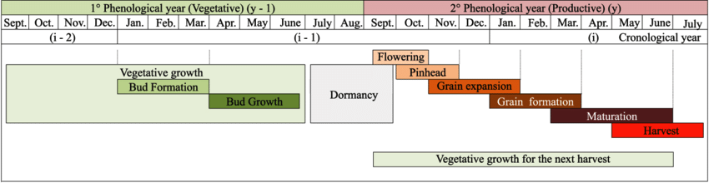
Figure 1. Phenology of Coffea arabica; Source: (Aparecido & Rolim, 2018) and (CAMARGO & CAMARGO, 2001)

The meteorological data has been segregated into quarters to gain a more comprehensive understanding of the seasonal trends and climatic influences on coffee cultivation in Colombia. This approach is necessitated by Colombia's unique system of two harvesting cycles, as opposed to Brazil's single harvest cycle, as depicted in Figure 2.
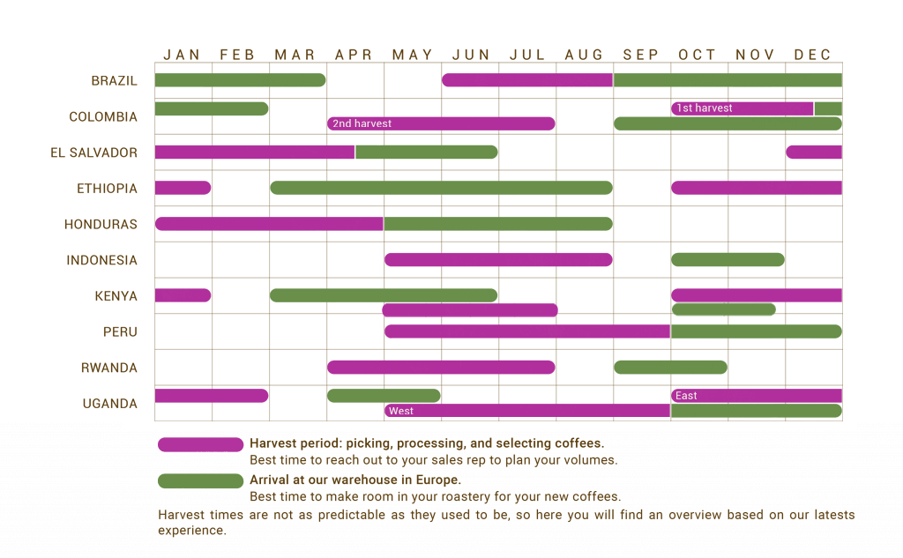
Figure 2. Coffee Harvest period; Source: (Coffee calendar 2023)

In addition, the data on commodities was converted from price per kilogram to price per pound by dividing with a conversion rate of 2.20462. The merged time series data is presented in a single dataframe at level, as illustrated in Figure 3. See Appendix 1 for commodity data description.

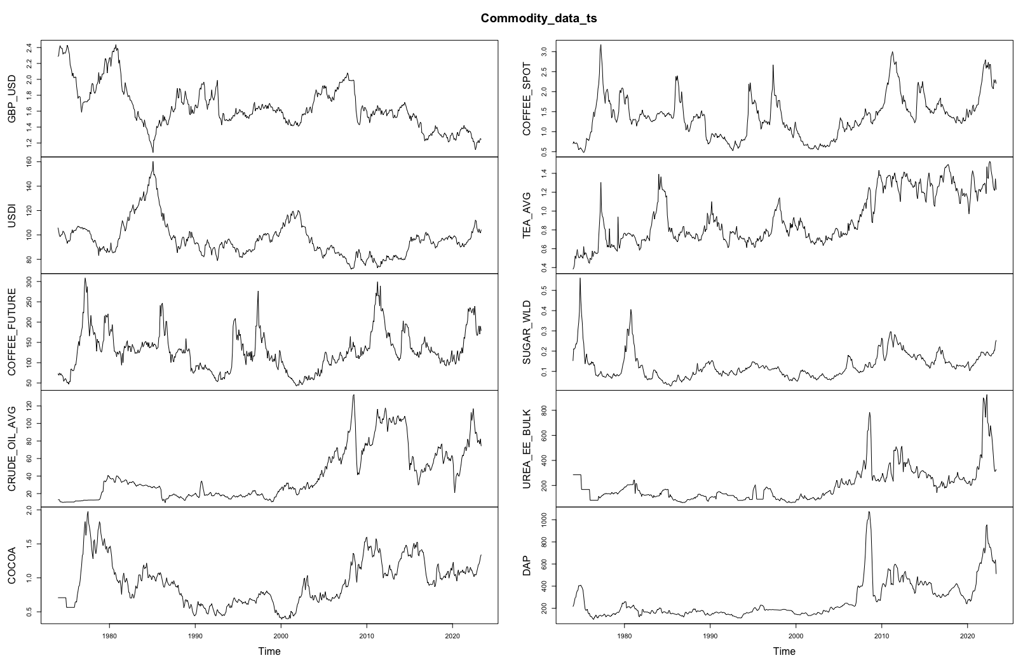
Figure 3. Commodity and market data
As shown in Figure 3, the dependent variable "COFFEE FUTURE" and the independent variables (other commodities) exhibit clear signs of trend and seasonality, indicating that the data is non-stationary. To verify the presence of trend and seasonality in the dependent variable, a time series decomposition can be employed. According to Hyndman & Athanasopoulos (2021), the decomposition will take a multiplicative form:
yt = St × Tt × Rt
Alternatively, additive decomposition can be written as :
yt = St + Tt + Rt
where yt is the data, St is the seasonal component, Tt is the trend-cycle component, and Rt is the remainder component, all at period t.

As stated by Hyndman & Athanasopoulos (2021), “the additive decomposition method is suitable when the seasonal fluctuations or variations around the trend cycle do not change with the level of the time series. On the other hand, if the variation in the seasonal pattern or the variations around the trend cycle appear to be proportional to the level of the time series, then a multiplicative decomposition is more appropriate. Multiplicative decompositions are commonly used for economic time series”. Figure 4 illustrates an example of an STL decomposition applied over the Coffee Future series.

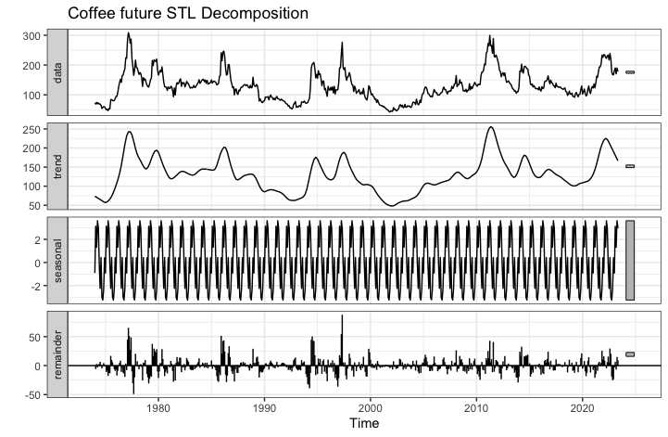
Figure 4. Coffee Future and its three additive components.

Stationarity check
To check the stationarity of time series data Dickey & Fuller (1979) propose an Augmented Dickey-Fuller test (ADF Test). It utilizes a higher-order autoregressive model and optimizes an information criterion using various lag values. As implied by its name, the ADF test is an enhanced version of the original Dickey-Fuller test, expanding the equation for a more comprehensive analysis.
y_{t}= c_{t} + β_{t} + αy_{t-1} + φ₁Δy_{t-1} + φ₂Δy_{t-2} ...+ φ_{p}Δy_{t-p} + e_{t}
where Δ represents the first difference of the series at the given time t until pth order, φ representing the autoregression coefficient, while {e_{t}} is a sequence of the independent normal random variable with mean 0 and variance σ² (N ~ (0, σ²)). Given that the null hypothesis posits the existence of a unit root, represented by α=1, the obtained p-value should be lower than the chosen significance level (e.g., 0.05) to reject the null hypothesis (G, 2023). Thus, indicating that the series is stationary.

However, Myers (1994) has raised concerns about the limitations of the ADF test, as it does not fully address autocorrelation in the residual and may exhibit low power against stable autoregressive alternatives with roots close to unity. As an alternative, Myers (1994) endorsed the Kwiatkowski, Phillips, Schmidt, and Shin test (KPSS test), which evaluates the null hypothesis of stationarity against the alternative hypothesis that the series possesses a stochastic trend (Kwiatkowski et al., 1992).

Both ADF and KPSS tests confirm that the dependent variable is level stationary, and the independent variables are trend stationary. However, increasing the lag order of the dependent variable shows the existence of unit root means series is non-stationary at higher lag. To overcome these challenges first-order difference is introduced to both dependent and independent variables. Table 1 shows the result of the KPSS test and please refer to Appendix 2 to see the result from the ADF test.

KPSS Test
 |  | Level |  | 1st Difference
S.no | Variable | Test_Statistic | P_Value | Test_Statistic | P_Value
1 | GBP_USD | 2.817675675 | 0.01 | 0.049555357 | 0.1
2 | USDI | 1.626528193 | 0.01 | 0.065711738 | 0.1
3 | COFFEE_FUTURE | 0.432934542 | 0.06295925 | 0.023730332 | 0.1
4 | CRUDE_OIL_AVG | 5.087539891 | 0.01 | 0.027992773 | 0.1
5 | COCOA | 1.318617299 | 0.01 | 0.048360382 | 0.1
6 | COFFEE_SPOT | 1.03455118 | 0.01 | 0.028916217 | 0.1
7 | TEA_AVG | 5.333050098 | 0.01 | 0.026953052 | 0.1
8 | SUGAR_WLD | 0.977430873 | 0.01 | 0.040261829 | 0.1
9 | UREA_EE_BULK | 3.498121823 | 0.01 | 0.035807552 | 0.1
10 | DAP | 4.036188752 | 0.01 | 0.024141449 | 0.1
Table 1. KPSS test results; accepting H₀ means the series is stationary (p-value > 0.05).
In Figure 5, the 1st difference applies to the time series of commodities data in order to remove the trend and seasonality, making the series stationary.
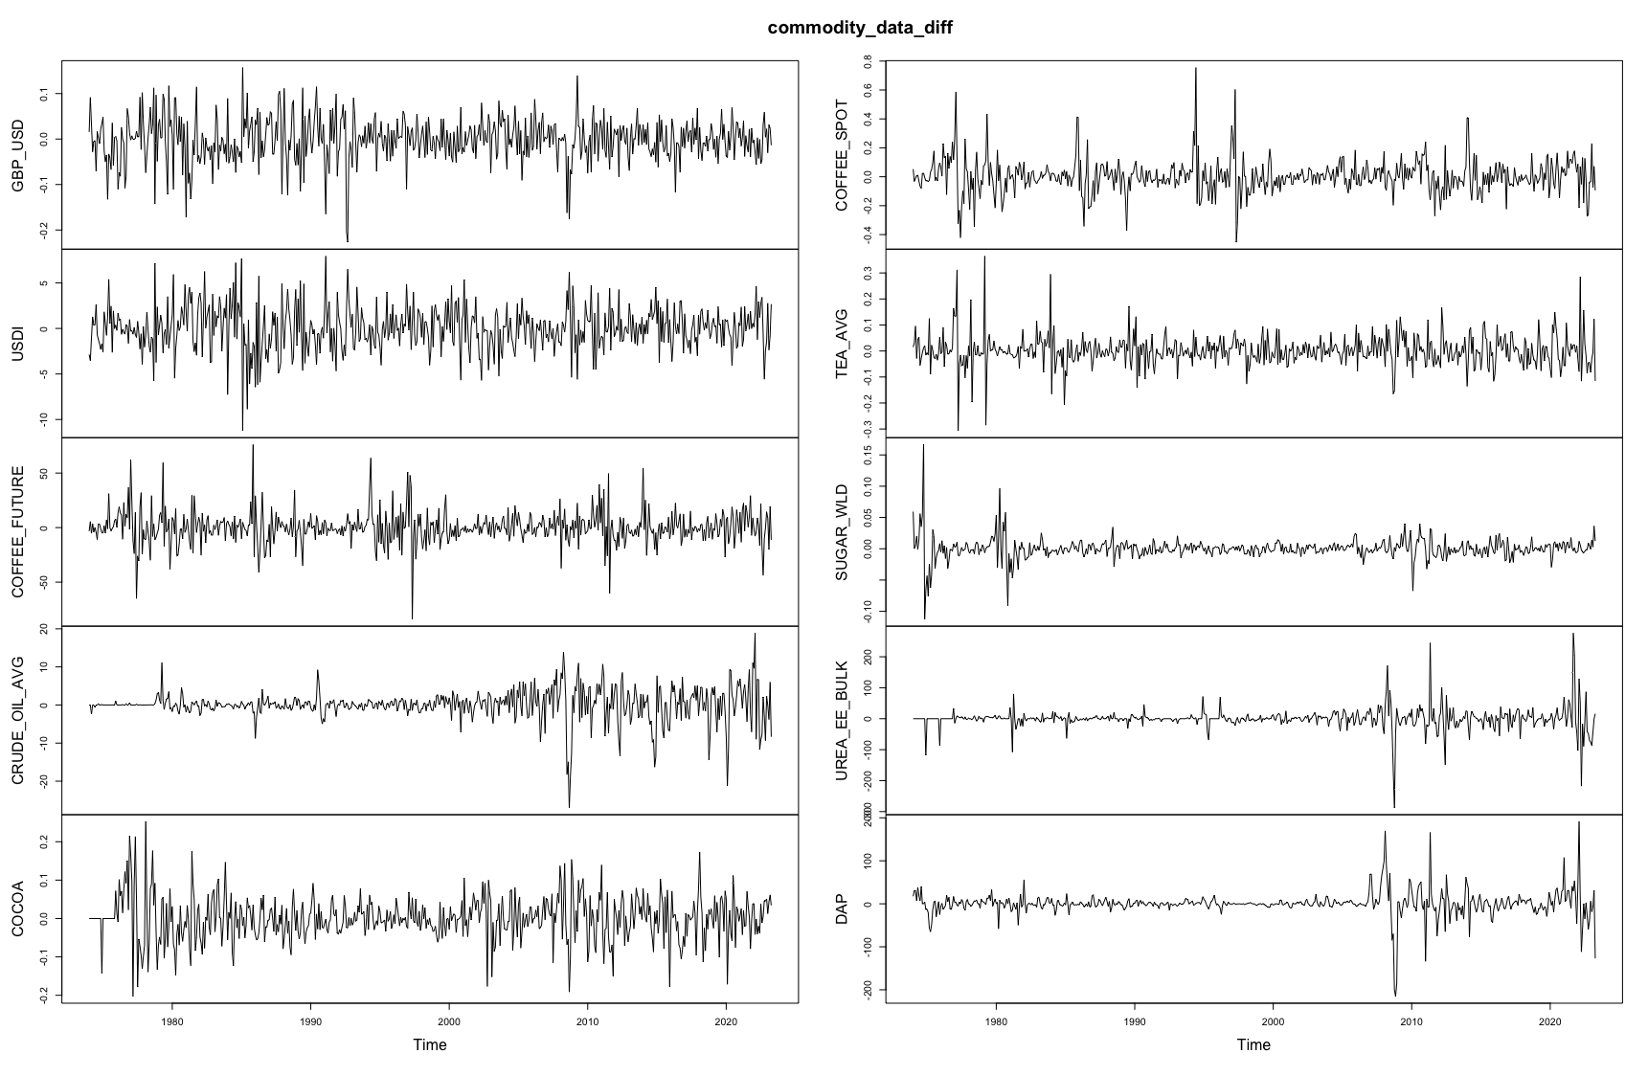
Figure 5. Differenced commodities data at d=1(1st Difference)

3.3. Data Visualisation and Exploratory Analysis

This section addresses the first research objective, which is to assess the influence of climate on coffee yield, based on findings from the literature review. The analysis is focused on the major coffee-producing regions of Brazil, namely Minas Gerais, Espirito Santo, and Sao Paulo, which are expected to experience significant climate changes. According to the RCP 8.5 emissions scenario, “the mean annual temperature in these regions is projected to rise by 4 °C in the summer and 2 °C to 5 °C in the winter by the year 2100” (Pachauri et al., 2014). Figure 6 provides supporting evidence, indicating a substantial increase in temperature over the past 25 years (1991-2016).

According to (Koh et al., 2020), the rising temperatures may adversely impact on the quality of coffee beans and could also lead to more conducive environments for pests and diseases. They further demonstrated, the impact is expected to be more pronounced in states where coffee cultivation occupies a significant proportion of their total area compared to states where coffee production occupies only a minor fraction of the agricultural expanse.

However, interestingly, coffee production in Minas Gerais has increased, partly due to the shift from the northern region, as shown in Figure 6. On the other hand, production in Sao Paulo has declined, despite its history of being a major exporter during the 1970s-80s, as illustrated in Figure 8.

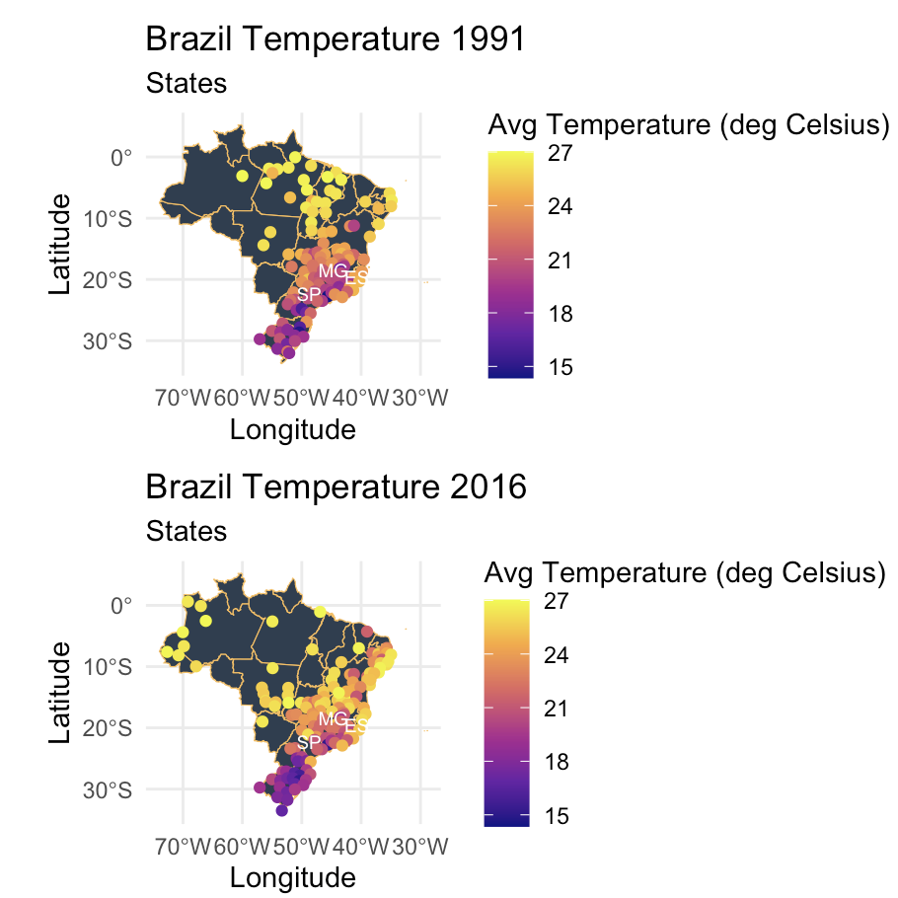 | 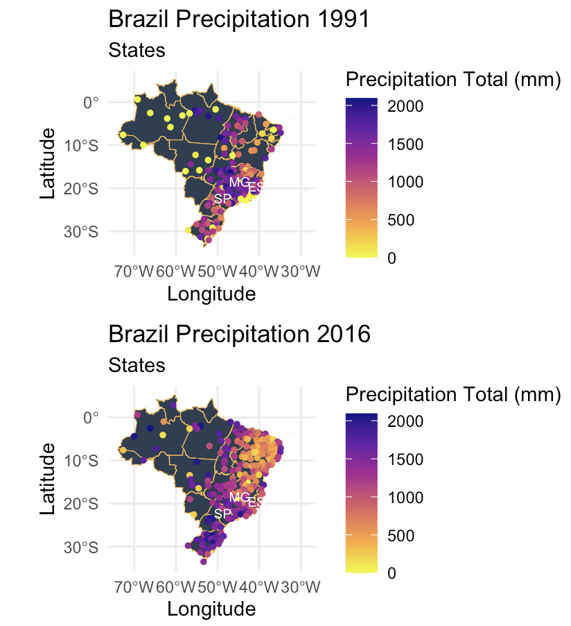
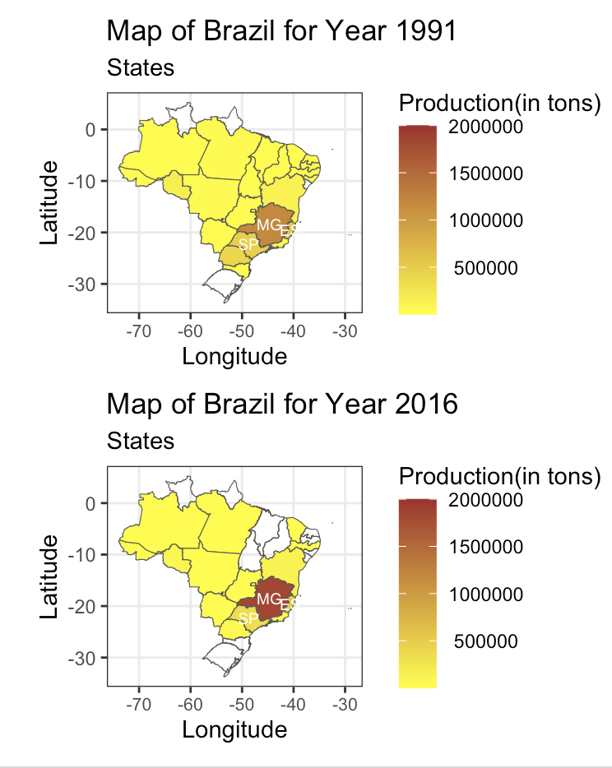
Figure 6. Average Annual Temperature (in °C), Total Annual Precipitation (in mm), and Total Yearly Coffee Production (in tons) for the years 1991 and 2016, representing a span of 25 years apart.
In Figure 6, each point represents a weather station where weather data has been recorded. However, it is important to note that some weather stations were inactive in 2016, while others were not established in 1991. Additionally, the yellow points in the precipitation data indicate the unavailability of precipitation data for certain weather stations. However, for the three regions of interest in this research (Minas Gerais (MG), Espirito Santo (ES), and Sao Paulo (SP)), data was collected from various environmental sources to ensure comprehensive coverage and reliable data for analysis.

Weather-related hazards pose a continuous threat to the livelihoods of coffee farmers and their families. From frost incidents like the one in 1976 to the severe drought in 2007 that adversely affected coffee plantations in the southern regions of Minas Gerais and Sao Paulo.

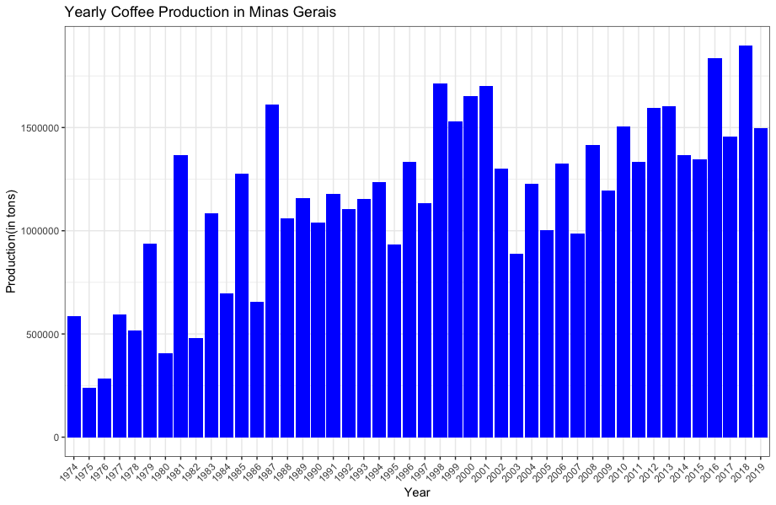
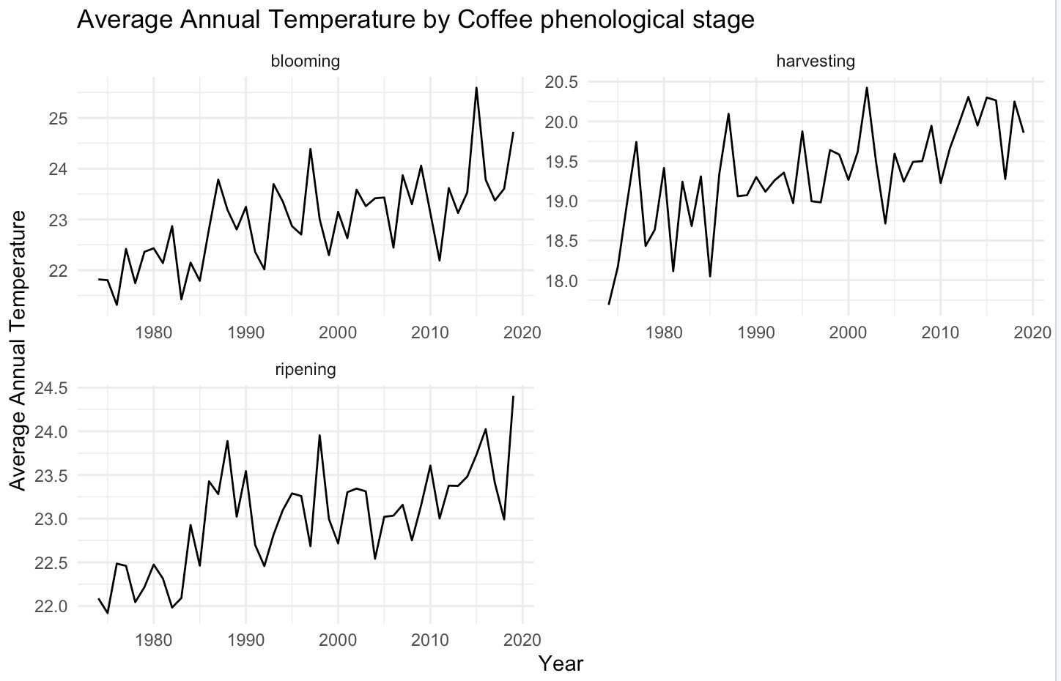 | 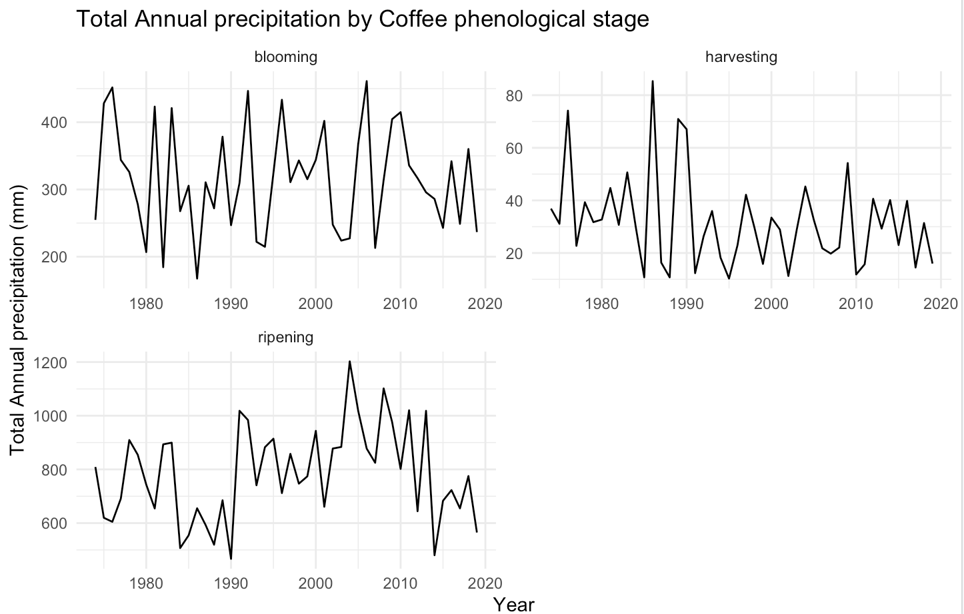
Figure 7. Coffee production (in tons) vs. temperature (in °C) and precipitation (in mm) during different phenological stages in Minas Gerais (1974-2019).
In Brazil, Arabica coffee thrives in temperatures between 18 to 22.5°C per year, as stated by Camargo (2010). Coffee cultivation is limited to regions with average annual temperatures ranging from 22.5 to 24°C. When temperatures surpass 24°C, coffee fruits mature earlier and it usually falls in the rainy season, making it challenging to harvest and dry the coffee due to frequent rainfall.

Located in the southeastern region of Brazil, Minas Gerais holds the position of the country's fourth-largest state and contributes 55% of Brazil's coffee production, equating to approximately 18% of the world's coffee output (IBGE, 2023). As stated by Camargo (2010), climatic variations, particularly in the context of climate change, stand as the primary determinant of fluctuations and challenges faced by coffee yield in Brazil.

Figure 7 examines the alterations in local climate concerning coffee's phenological stages, providing valuable insights into how climate change influences coffee production in Minas Gerais. Confirming the trends seen in Figure 6, Figure 7 exhibits a positive trend in temperature over the past two decades in the region. Insufficient rainfall alone may not significantly impact the yield; however, when coupled with rising temperatures, it leads to adverse effects on coffee buds and seed maturation during the blooming and ripening seasons, respectively, unless proper irrigation is implemented. Additionally, the figure reveals a significant increase in production during alternative years within the time frame of 1980 to 1990 and 2002 to 2013 due to higher fluctuations in rainfall during the blooming phenological stage. Notably, it is crucial to consider the preceding year's bud formation as it directly affects the current year's production. During the harvesting period, precipitation consistently shows a positive impact on yield.

On the other hand, Sao Paulo has a rich historical background in coffee cultivation, with its Economic History significantly influenced by this commodity. Moreover, it hosts the Port of Santos, which serves as the primary coffee exporting port. However, according to Colistete (2015), the state's prominence in coffee production has diminished over time, and during the 2014/15 biennium, it contributed only 12.12% to the national coffee production. Figure 8 illustrates a notable decline in coffee yield after 1990, attributed not only to adverse weather conditions (such as mean temperature dropping below 17 °C during June-August) but also to historical factors. During the 19th century, coffee production was inexpensive due to the practice of slavery, while the early 20th century saw Sao Paulo emerge as a major industrial city, attracting European and Asian immigrants who contributed to the transition to a market economy based on wage labour (Font, 1987). The decline in coffee cultivation during the 1990s was influenced by factors such as deregulation, historical reliance on labour-intensive methods, and extreme weather conditions, including frequent frosts in July, which collectively contributed to the decrease in coffee yield and ultimately impacted coffee cultivation in Sao Paulo. Please see Appendix 3 for an analysis of Espirito Santo.

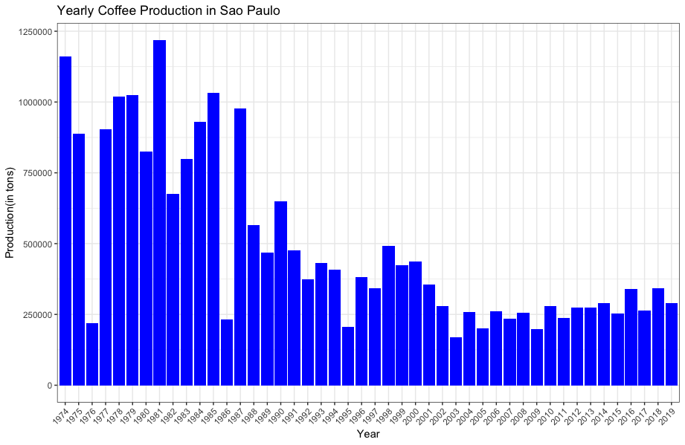
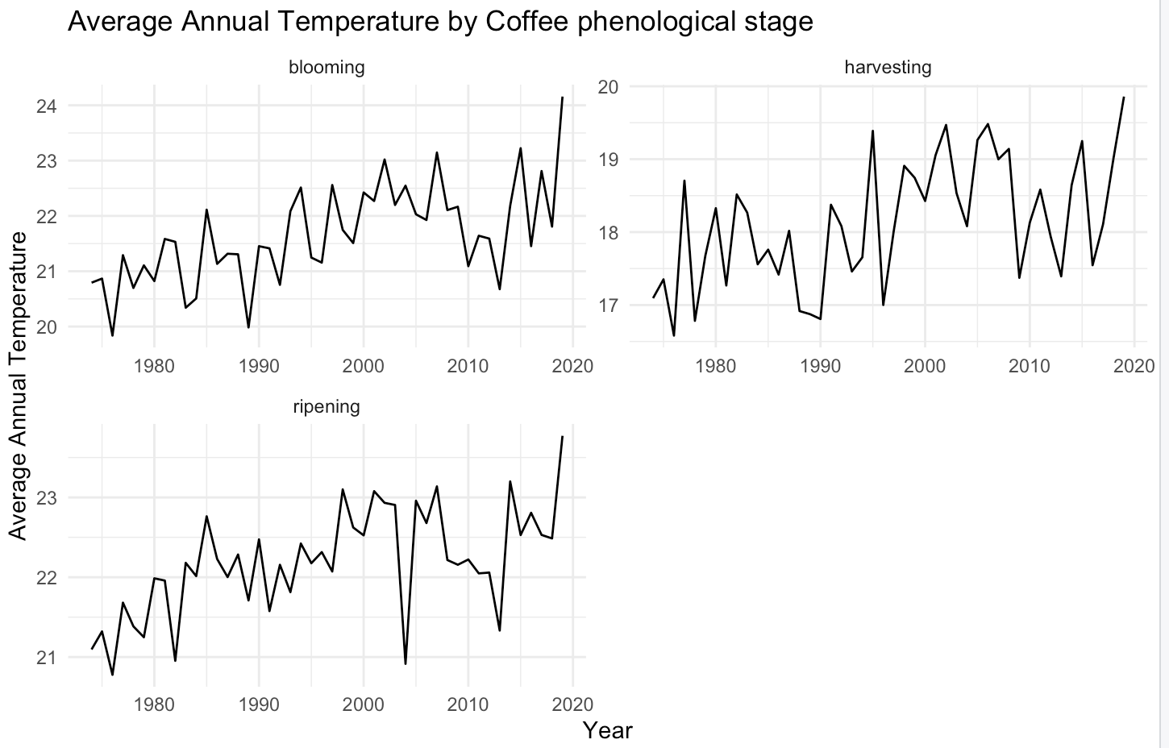 | 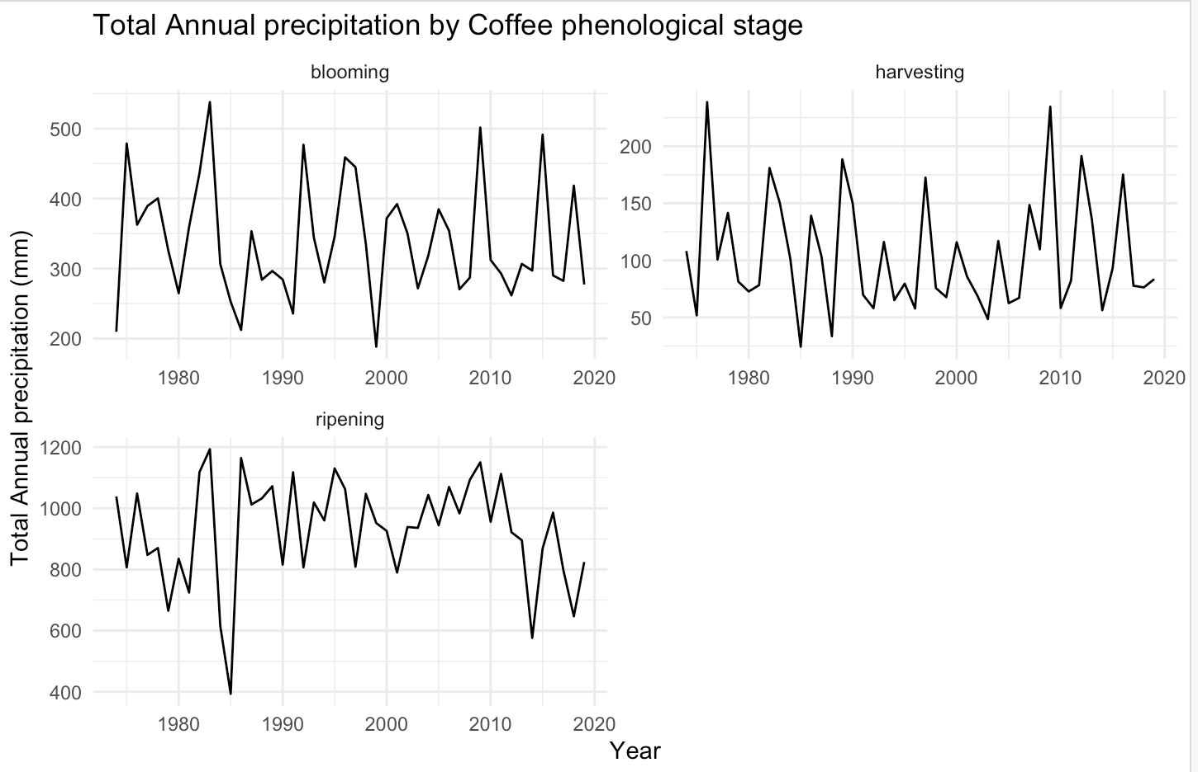

Figure 8. Coffee production (in tons) vs. temperature (in °C) and precipitation (in mm) during different phenological stages in Sao Paulo (1974-2019).

Nitrogen (N) stands as the primary nutrient for coffee cultivation in both Brazil and Colombia. Guaranteeing a sufficient nitrogen supply is especially crucial during the vegetative and reproductive growth stages, as any insufficiency during these critical periods can have long-term repercussions on the subsequent coffee bean production (Salamanca-Jimenez et al., 2017). Despite the global area harvested for coffee witnessing no significant increase since the 1960s, global yields have more than doubled, largely attributed to the effective use of chemical fertilizers. This trend has led farmers to increasingly rely on fertilizers to boost yields per hectare. The consumption of fertilizers in Brazil and Colombia has seen a significant upsurge, as depicted in Appendix 6. In Figure 9, the correlation matrix showcases the relationship between coffee yield and weather variables during different phenological stages, alongside the annual consumption of fertilizers (Kg per hectare) in Minas Gerais (MG), Espirito Santo (ES), and Sao Paulo (SP) regions of Brazil.

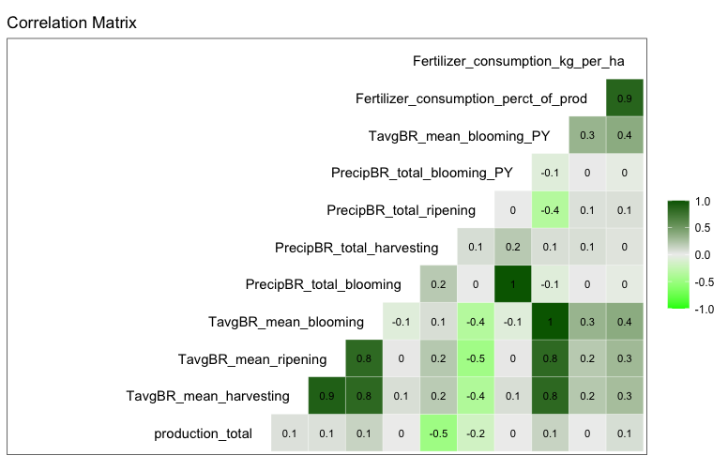
Figure 9. The Spearman correlation chart shows the relationships between coffee production, temperature (TavgBR_mean), precipitation (PrecipBR_total), and fertiliser consumption in Brazil.

The Spearman correlation coefficient ranges from -1 to +1, demonstrating the strength and direction of the relationships between the variables, as shown in Figure 9. A value closer to +1 signifies a strong positive correlation, while a value closer to -1 indicates a strong negative correlation. Among the variables, only precipitation during the harvesting period exhibits a significant negative correlation with coffee production, while the other variables show weaker relationships with the coffee yield. However, weather is not the sole factor influencing yield fluctuations; other factors, such as fertiliser consumption, share similar correlation coefficients with production. The impact of monthly weather on coffee production is also investigated, as detailed in Appendix 4.

An examination of the literature on Colombia's coffee production reveals that climate does not appear to exert a significant influence on the industry. Additional details can be found in Appendix 5.

After detrending the commodity data using the first difference, Figure 10 displays the correlation matrix alongside density and scatter plots to gain deeper insights. The lower matrix exhibits scatter plots for all variables in the dataset against one another, while the diagonal cells show density plots for individual variables. The upper matrix represents the correlations among the variables.
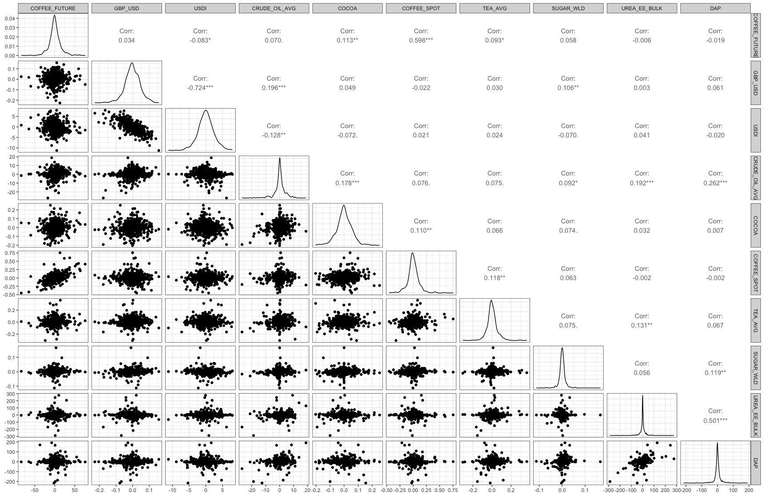
Figure 10. A matrix of scatterplots and density plots with the upper matrix displaying the correlation coefficients between variables in the dataset. ’.’,’*’,’**’, and’***’ shows a significant level of correlation between variables.

The scatter plot in the lower matrix of Figure 10 visualizes the relationships between pairs of variables in the dataset. Each scatter plot represents the connection between two variables, with one variable on the x-axis and the other on the y-axis. Data points in the scatter plot represent individual data observations for both variables. Meanwhile, the density plot for coffee futures indicates that it follows a roughly normal distribution, with a slight right skew and a heavy-tailed distribution.

The correlation coefficient displayed in the upper right matrix quantifies the strength of the relationship between two variables, similar to what is observed in the scatter plots. Notably, coffee spot prices exhibit a highly significant positive correlation with coffee futures, aligning with the literature review findings. It's essential to note that low correlations between variables do not necessarily imply the absence of relationships. Non-significant correlations could be due to the influence of relationships between different time scales, as highlighted by Yuan et al. (2016). Figure 11 illustrates the impact of Crude Oil on Coffee futures at different lags using the cross-correlation approach. For cross-correlation results involving other variables with coffee futures, kindly refer to Appendix 7.

The sample cross-correlation function (CCF) serves to detect potential lags of the x-variable that could act as predictors for y_{t}. The sample CCF entails calculating sample correlations between x_{t+h} and y_{t} for h = 0, ±1, ±2, ±3, and so on. When h is negative, the correlation signifies the relationship between the x-variable at a time preceding t and the y-variable at time t. For instance, consider the case of h = -2; in this context, the CCF value depicts the correlation between x_{t-2} and y_{t} (STAT 510, 2023).
- When one or more x_{t+h}, with ℎ negative, are predictors of y_{t}, it can be noted that x leads y.
- When one or more x_{t+h}, with ℎ positive, are predictors of y_{t}, it can be noted that x lags y.

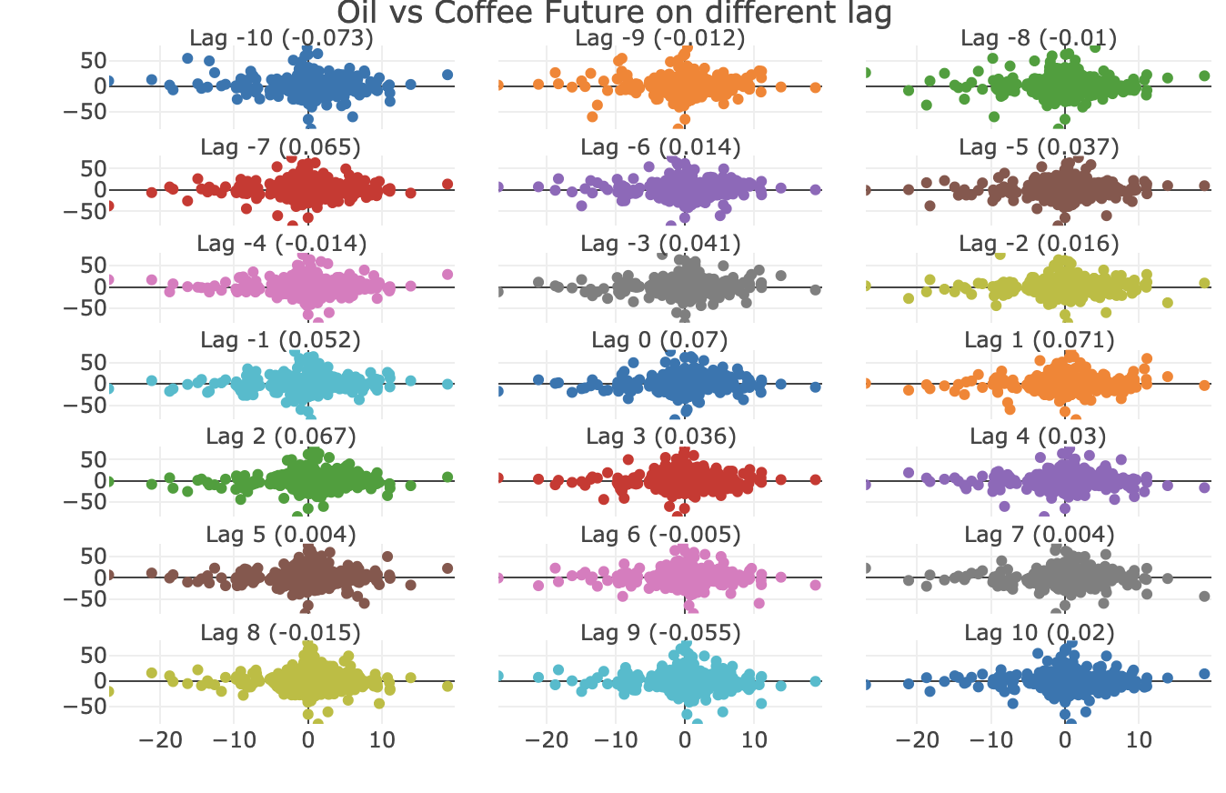
Figure 11. Cross-correlation on different lag

The CCF plot in Figure 11 shows the correlation between the two variables at different time lags. Positive lag values indicate that "COFFEE FUTURE" follows "CRUDE_OIL_AVG" by that number of time units, and negative lag values indicate that "COFFEE FUTURE" leads "CRUDE_OIL_AVG" by that number of time units.

3.4. Time Series Modelling

In the intricate landscape of financial markets, precision in predictions and informed decision-making stands paramount. This holds especially true in the realm of coffee futures, where an array of factors plays their part. Ensuring precise forecasting is of utmost significance for individuals engaged in the respective industry. Following a comprehensive examination of data through the process of Exploratory Data Analysis (EDA) and the identification of critical factors, it is now appropriate to explore the captivating realm of time series analysis. Using statistical methodologies, the intricate patterns, trends, and correlations interwoven within the data are revealed. The exploration begins by providing a comprehensive overview of the time series multivariable linear regression technique, intricately examining its subtleties. This presentation will explore the essential concepts and potential of the ARIMA method, a pivotal instrument in forecasting coffee futures. This investigation will reach its apex with the introduction of an exceptionally potent hybrid ARIMA-regression model. This innovative fusion combines the strengths of both techniques, offering a unique perspective on the intricacies of forecasting coffee futures. In the course of this analysis, the objective is to illuminate the dynamic interplay between temporal dynamics and external influences that shape this intricate endeavour. This section will reveal the enigmatic mechanisms that form the foundation of the art of predicting coffee futures.

Multivariable Time series Linear Regression model:
When there are two or more predictor variables, the model is called a multiple regression model. Hyndman & Athanasopoulos (2018) stated general form of a multiple regression model is:

Y_{t} = β₀ + β₁x_{1, t} + β₂x_{2, t} + ⋯ + β_{k}x_{k,t} + ε_{t}.

where Y_{t} is the variable to be forecast and x₁, …, x_{k} are the k predictor variables. Each of the predictor variables must be numerical. The coefficients β₁, …, β_{k} determine the impact of each predictor while taking into account the impact of all other predictors in the model.

When utilizing a linear regression model, it is crucial to consider several underlying assumptions. One such assumption involves the reliability of the model as a faithful representation of reality. This requires that the linear equation employed to establish the relationship between predictor variables and the forecast variable is valid and accurately reflects the underlying data. Following assumptions were made about the errors (ε₁ … ε_{T}):
- They possess mean zero; otherwise, the predictions would exhibit systematic bias.
- They lack autocorrelation; otherwise, the predictions would lack efficiency, considering the additional information inherent in the data.
- They demonstrate no connection to the predictor variables; otherwise, there would be unutilized information that merits inclusion in the model's systematic aspect.
Furthermore, it proves beneficial for the errors to adhere to a normal distribution with a constant variance σ², facilitating the straightforward production of prediction intervals.

ARIMA model:
The concept of ARIMA methodology was introduced by Box and Jenkins in 1976. This methodology, also known as the Box-Jenkins model, comprises three key components: Autoregressive elements, Moving Average, and White noise. To apply the Box-Jenkins model effectively, the time series data under consideration should exhibit stationarity.

The method of Moving Average models was proposed by Slutsky (1927) and Wold (1938). The series of Moving Average can be written as:

Y_{t} = c + ε_{t} + θ₁ε_{t−1} + θ₂ε_{t−2} + ⋯ + θ_{q}ε_{t−q} (1)

Moving Average in the order q, also known as MA(q), refers to Equation 1, here Y_{t} is the original time series data and ε_{t} (white noise) is the error term of the series.

The equation presented in the Auto-Regressive process proposal by Yule (1926) is crucial to understanding this regressive process:

Y_{t} =c+ϕ₁ Y_{t-1} + ϕ₂ Y_{t-2} + ⋯ +ϕ_{p} Y_{t-p} + ε_{t} (2)

The Y_{t} value in equation 2 represents a linear combination within the context of order p, often referred to as AR(p) and ε_{t} denotes the assumption of independence from Y_{t-1} + Y_{t-2} + Y_{t-3} ⋯ + Y_{t-p}.

By combining differencing with Autoregression and a Moving Average model, a non-seasonal ARIMA model is obtained. ARIMA is an acronym for Autoregressive Integrated Moving Average (in this context, “integration” is the reverse of differencing). The full model can be written as

ΔY_{t} = c + ϕ₁ΔY_{t-1} + ⋯ + ϕ_{p}ΔY_{t-p} + θ₁ε_{t−1} + ⋯ + θ_{q}ε_{t−q} + ε_{t} (3)

where ΔY_{t} is the differenced series (it may have been differenced more than once). The “predictors” on the right-hand side include both lagged values of Y_{t} and lagged errors. This is a Univariate Box-Jenkins (UBJ) Model used to forecast univariate time-series data. The basic ARIMA Model is specified as:
ARIMA (p, d, q),
p = order of the autoregressive part; d = degree of first differencing involved; q = order of the moving average part.

A seasonal ARIMA model is comprised of seasonal terms added to ARIMA models. It is written as follows:
ARIMA (p, d, q) (P, D, Q)_{m}
P = seasonal autoregressive order; D = seasonal differencing order; Q = seasonal moving average order; m = seasonal period (e.g., number of observations per year).

Hybrid Model:
The ARIMA model incorporates past observations of a series but does not consider other relevant information. Conversely, regression models consider a wide range of relevant information from predictor variables, but cannot handle the intricate time series dynamics that ARIMA models can. The hybrid model is expanded to include ARIMA models, which incorporate additional data as an exogenous regressor into the models. This is achieved by using regression models of the following form:

Y_{t} = β₀ + β₁x_{1, t} + β₂x_{2, t} + ⋯ + β_{k}x_{k,t} + ε_{t} (4)

Where Y_{t} is a linear function of the k predictor variables (x₁, …, x_{k,t}), and ε_{t} is usually assumed to be an uncorrelated error term (i.e., it is white noise). The Ljung-Box test is performed to evaluate any autocorrelation present in the residuals obtained.

The hybrid model allows the inclusion of autocorrelation within the regression errors. To underscore this shift in viewpoint, the notation ε_{t} will be substituted with η_{t} in equation (4). It is postulated that the error sequence η_{t} conforms to an ARIMA model. For instance, if η_{t} adheres to an ARIMA(1,1,1) model, it can be represented as:

Y_{t} =β₀+β₁x_{1, t} + ⋯ + β_{k}x_{k,t}+ η_{t}
(1−ϕ₁B)(1−B) η_{t} = (1+θ₁B) ε_{t}

where ε_{t} is a white noise series, and B is the backshift notation means shifting the data back one period.
Upon review of the model, it has been observed that there exist two error terms: η_{t} representing the error from the regression model and ε_{t} representing the error from the ARIMA model. It is noteworthy that only the ARIMA model errors are considered to be white noise.

3.5 Data Partitioning and Model Building

In order to build robust and reliable forecasting models for coffee futures, careful data partitioning is essential. The goal is to train the models on historical data and then evaluate their performance on unseen future data. Given the time series nature of the data, a time-based split is employed. The training set constitutes the initial portion of the dataset. It includes historical coffee futures prices and relevant predictor variables leading up to December 2021. This historical information is used to train the forecasting models. The test set encompasses the data beyond the chosen time point. It represents the future time periods that need to be forecasted. The test set remains untouched during model training and is utilized solely for evaluating the models' forecasting accuracy. A critical consideration during data partitioning is to prevent data leakage. This involves ensuring that information from the test set does not inadvertently influence model training. All feature engineering, transformations, and model selection decisions are based solely on the training set.
The initial selection of features for the regression model was guided by the correlation matrix detailed in the preceding section. Upon addressing potential multicollinearity concerns (high correlation among independent variables), the optimal subset is determined using criteria such as AIC (Akaike's Information Criterion), BIC (Schwarz's Bayesian Information Criterion), and adjusted R2 (R-squared). The best subset model is determined by using a backward stepwise regression technique suggested by Hyndman & Athanasopoulos (2018) as follows:
- Begin with the model encompassing all potential predictors.
- Gradually eliminate one predictor at a time, retaining the model if it enhances the predictive accuracy metric.
- Repeat this process iteratively until no further enhancements are achieved.

According to the article by Kassambara (2018), the main idea behind AIC is to avoid including unnecessary variables in a model by penalizing the introduction of additional terms, which increases the error. A lower AIC score indicates a better model, while BIC is an enhanced variant of the AIC that imposes a more stringent penalty for including additional variables in the statistical model. Kassambara (2018) also defined the coefficient of determination, or R2 represents the proportion of the variance in the dependent variable that can be explained by the independent variables.

To determine the ARIMA model's order, the time series' correlogram is generated, depicted in Figure 12. Analysing the ACF and PACF plots of the first-differenced coffee futures time series aids in identifying suitable values for p and q.

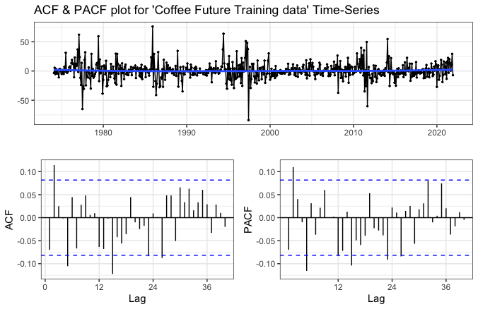
Figure 12. Correlogram of First-differenced Coffee Future.

3.6 Software

The analysis and building of models were performed using R studio Version 2023.06.1+524 (2023.06.1+524). Data cleansing and transformations were undertaken through Power Query in Microsoft Excel (2023).

4. Diagnostic Test and Forecasting

In time series analysis, diagnostic examinations encompass a range of evaluations and tests designed to appraise the effectiveness, dependability, and appropriateness of the predictive models. These assessments assist in pinpointing potential concerns, confirming underlying assumptions, and guaranteeing the delivery of precise and significant forecasts.

Multivariable time series Linear regression model:
After excluding the GBP_USD exchange rate and DAP column, which exhibited significant multicollinearity in the initial analysis (Figure 10), a backward stepwise regression technique was employed to determine the optimal subset of variables. In accordance with Hyndman & Athanasopoulos (2018), the conventional practice of conducting multiple linear regression and discarding variables with p-values exceeding 0.05 is deemed unsatisfactory. Instead, the focus shifts to a measure of predictive precision, as demonstrated in Table 2.

S.No | Model | adj.r.squared | sigma | statistic | df | AIC | BIC | rmse | mape
1 | CF ~ COFFEE_SPOT + USDI + COCOA + CRUDE_OIL_AVG + TEA_AVG + UREA_EE_BULK + SUGAR_WLD | 0.3556 | 12.0122 | 46.25 | 7 | 4500.53 | 4539.72 | 10.72 | 0.046
2 | CF ~ COFFEE_SPOT + USDI + COCOA + CRUDE_OIL_AVG + TEA_AVG + SUGAR_WLD | 0.3567 | 12.0016 | 54.06 | 6 | 4498.54 | 4533.37 | 10.80 | 0.046
3 | CF ~ COFFEE_SPOT + USDI + COCOA + CRUDE_OIL_AVG + TEA_AVG | 0.3578 | 11.9918 | 64.96 | 5 | 4496.60 | 4527.08 | 10.72 | 0.046
4 | CF ~ COFFEE_SPOT + USDI + COCOA + TEA_AVG | 0.3589 | 11.9819 | 81.32 | 4 | 4494.67 | 4520.79 | 10.45 | 0.044
5 | CF ~ COFFEE_SPOT + USDI + COCOA | 0.3593 | 11.9775 | 108.31 | 3 | 4493.25 | 4515.02 | 10.62 | 0.046
6 | CF ~ COFFEE_SPOT + USDI | 0.3589 | 11.9817 | 161.65 | 2 | 4492.66 | 4510.08 | 10.17 | 0.042
7 | CF ~ COFFEE_SPOT | 0.3519 | 12.0465 | 312.70 | 1 | 4497.87 | 4510.93 | 11.41 | 0.047
Table 2. Predictive precision of different regression models
Comparing these metrics against those derived from an alternative model aid in the identification of the most suitable predictor set. The model with the lowest AIC, BIC, RMSE, MAPE, and the highest Adj. R2 is selected as the best model (highlighted in green in Table 2). This model will then undergo further diagnosis and serve as the foundation for subsequent forecasting endeavours.

The differences between the actual y values and the corresponding fitted $\hat{y}$values are commonly referred to as the training-fitted errors or "residuals", defined as:

e_{t} = y_{t} – $\hat{y}$_{t}

As per the assumptions outlined in the preceding section, it is anticipated that the residuals exhibit an average of zero and maintain consistent variance, as depicted in Figure 13. If the plot shows any discernible pattern there may be the presence of “heteroscedasticity” in the errors which means that the variance of the residuals may not be constant.

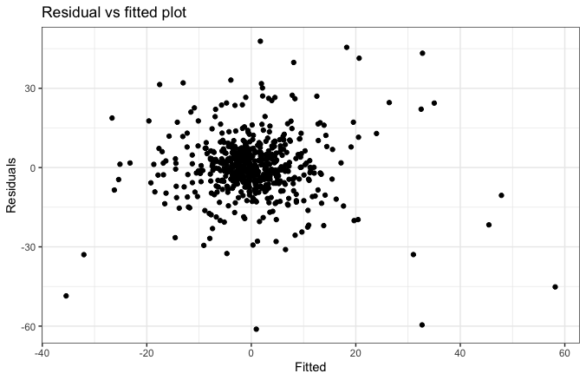
Figure 13. Residuals vs. Fitted plot.

Figure 14 confirms residuals from the selected regression models for forecasting coffee futures plotted against each predictor are randomly scattered means there is no non-linear relationship hence no heteroscedasticity.

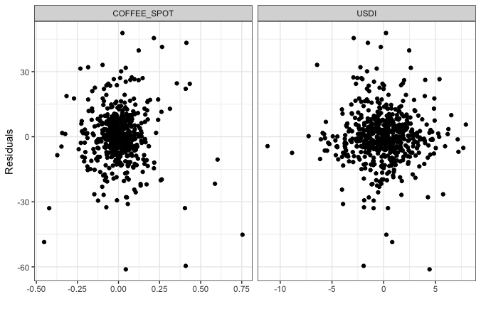

Figure 14. Residual plot against the predictor

Furthermore, it is essential that the residuals manifest minimal autocorrelation and adhere to the normality presumption. It's crucial to consider that when applying a regression model to time series data, there might arise situations where the residuals exhibit autocorrelation. In such cases, the estimated model could potentially deviate from the assumption of zero autocorrelation within the errors, as noted by Hyndman & Athanasopoulos (2018). However, Hyndman & Athanasopoulos (2018) further stated that forecasts derived from a model with autocorrelated errors remain unbiased, yet they typically yield wider prediction intervals than necessary. As a result, it is prudent to consistently assess an Autocorrelation Function (ACF) plot of the residuals to ascertain the presence of autocorrelation.

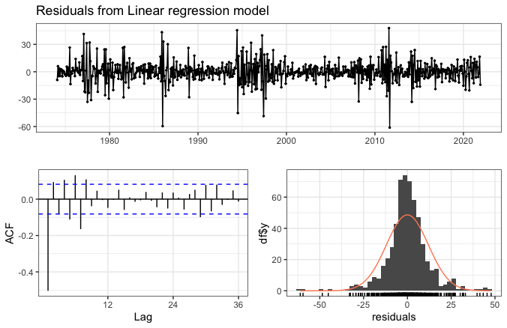
Figure 15. Analysing the residuals from a regression model for Coffee Future

The time plot depicted in Figure 15 reveals evident fluctuations that shift over time. This non-uniform variance, or heteroscedasticity, can potentially introduce inaccuracies in the coverage of prediction intervals. Additionally, the histogram showcases a subtle leftward skew in the distribution of residuals, which could further impact the reliability of prediction interval coverage. The Jarque-Bera (JB) test is a statistical tool utilized to assess the similarity of skewness and kurtosis of sample data to that of a normal distribution. Researchers Thadewald & Büning (2007) have noted that the JB test may not yield optimal results for distributions with short tails or a bimodal shape, and may even introduce bias in certain cases. Etuk (2017) stated that normality is not a prerequisite assumption, but rather, stationarity is of greater significance. In this particular instance, the JB test p-value (X-squared = 397.78, df = 2, p-value < 2.2e-16) of the selected model was less than 0.05, indicating rejection of the null hypothesis of normality. Meanwhile, the autocorrelation plot indicates a prominent spike at the initial lag, gradually diminishing to zero later. This pattern suggests that residual information remains to be accounted for.

In Figure 16, the findings of the Box-Ljung test align with the autocorrelation observations. The null hypothesis (H₀) posits that residuals are distributed independently. However, the p-value falling below the significance level of 0.05 necessitates the rejection of H₀, affirming the presence of autocorrelation and accepting the alternative hypothesis (H_{A}).

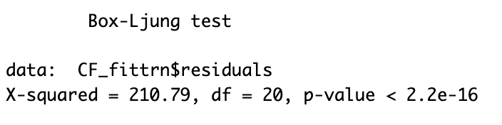

Figure 16. Box-Ljung test statistics (R-output)

The last stage involves forecasting using the fitted model. As there are no future predictor values accessible, dividing the data into training and testing subsets aids in generating an ex-ante forecast, given that the model is trained on the training data. As shown in Figure 17, the Coffee Future is forecasted with a 95% confidence interval, aligning closely with the actual test outcomes.

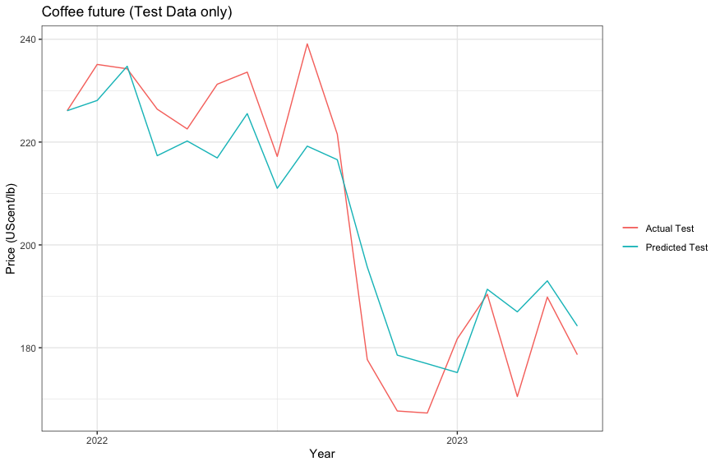

Figure 17. Forecasting from the Multivariable time series linear regression model for Coffee Future test data under 95% Confidence Interval.

ARIMA model:
In Figure 12, the autocorrelation functions provide insight into determining the order of the moving average process (q), while partial autocorrelations aid in selecting the autoregressive order (p). The ACF reveals autocorrelation coefficients across various lag lengths, accompanied by a 95% confidence interval to ascertain their statistical significance from zero. Thus, Figure 12's analysis highlights a notable peak at lag 5 in the PACF, indicating a non-seasonal AR (5) component. This inference is supported by the observation that the ACF diminishes to zero after lag 3, suggesting a non-seasonal MA (3) element. However, a minor yet significant spike at lag 12 cannot dismiss the potential presence of a seasonal AR (1) factor, particularly considering coffee's agricultural nature. Consequently, the author proposes the optimal model as ARIMA (5,1,3) (1,0,0)12. Alongside this primary model, It is recommended to consider evaluating various model variations based on predictive measures such as the lowest AIC, BIC, RMSE, MAPE, and maximum log-likelihood, as detailed in Table 3.

S.no | Model | sigma | logLik | AIC | BIC | nobs | rmse | mape
1 | ARIMA(5,1,3)(1,0,0)12 | 14.44119 | -2352.767 | 4725.534 | 4769.078 | 575 | 19.04059 | 0.0823064
2 | ARIMA(5,1,3)(1,1,0)12 | 17.57397 | -2416.914 | 4853.829 | 4897.161 | 563 | 28.39597 | 0.126361
3 | ARIMA(5,1,3)(1,1,1)12 | 14.43759 | -2328.827 | 4679.654 | 4727.32 | 563 | 17.08386 | 0.06913174
4 | ARIMA(5,1,3)(0,0,1)12 | 14.44183 | -2352.79 | 4725.58 | 4769.123 | 575 | 18.99448 | 0.08212778
5 | ARIMA(5,1,3)(0,1,1)12 | 14.47289 | -2329.385 | 4678.771 | 4722.103 | 563 | 17.43478 | 0.07108785
6 | ARIMA(5,1,3) | 14.45342 | -2353.257 | 4724.515 | 4763.704 | 575 | 18.91512 | 0.08213743
7 | Auto.ARIMA(1,0,3) non zero mean | 14.59502 | -2362.636 | 4737.272 | 4763.409 | 576 | 20.58391 | 0.09032586
8 | ARIMA(5,1,0) | 14.71313 | -2361.966 | 4735.932 | 4762.058 | 575 | 33.20771 | 0.1125486
9 | ARIMA(2,0,3) non zero mean | 14.59379 | -2362.589 | 4739.179 | 4769.671 | 576 | 20.85521 | 0.09191093
10 | ARIMA(2,1,3)(0,1,1)12 | 14.73886 | -2336.917 | 4687.835 | 4718.168 | 563 | 36.27473 | 0.119993
11 | ARIMA(5,1,3)(0,1,1)12 with Boxcox transformation ($λ$= -0.2799426) | 0.02 | 1214.83 | -2409.66 | -2366.32 | 563 | 19.40795 | 0.08263629

Table 3. Predictive precision of different Arima model

The optimal model chosen from Table 3 is ARIMA (5,1,3) (1,1,1)12, incorporating seasonal differencing. This model provides the lowest AIC value compared to other models with seasonal differencing. Similarly, the most favourable non-seasonal model is ARIMA (5,1,3) outperforming other non-seasonal models. It even surpasses the performance of the automated ARIMA (1,0,3) model, which is also non-seasonal.

Once the best model is determined, the subsequent stage involves examining the model's diagnosis to ascertain whether the residuals display any form of autocorrelation. This diagnostic process mirrors the analysis conducted in the preceding section. Following this, the residuals undergo a portmanteau test, commonly referred to as the Box-Ljung Test. This test is conducted to validate whether the residuals adhere to the properties of white noise.

The ACF plot of the residuals from the ARIMA (5,1,3) (1,1,1)12 model in Figure 18 indicates that all autocorrelations are within the threshold limits. This observation suggests that the residuals share characteristics similar to white noise. Furthermore, the Box-Ljung test results displayed in Figure 19 for the ARIMA (5,1,3) (1,1,1)12 model corroborate this conclusion. The null hypothesis (H0) has been accepted, demonstrating that the residuals are independently distributed. The histogram shows that the residuals are very slightly right-skewed, which means they exhibit approximately normality assumptions. To attain normality, the statistical method employed by the author involved the application of a box-cox transformation. However, this technique resulted in an increase in the root mean square error (RMSE), as indicated in Table 3, in serial number 11 and according to Hyndman & Athanasopoulos (2018), “while transformations may not always significantly impact point forecasts, they can have a substantial effect on prediction intervals”. The residual plot and forecasting from the transformed model can be seen in Appendix 9.

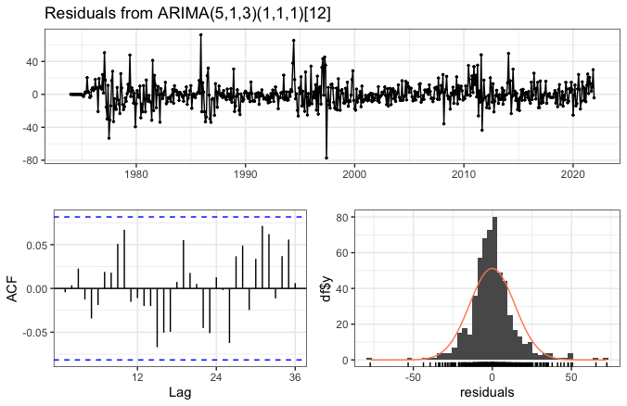
Figure 18. Analysing the residual from the selected ARIMA model.

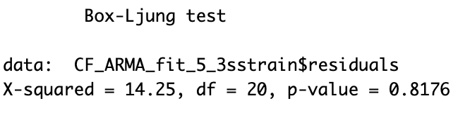
Figure 19. Box-Ljung test statistics for ARIMA (5,1,3) (1,1,1)12 model (R-output)

The forecast generated by the selected ARIMA (5,1,3) (1,1,1)12 model, depicted in Figure 20 within a 95% confidence interval, is compared with the Test dataset. However, the point forecast fails to capture any variations in volatility due to the absence of external factors, such as those present in the regression model. Consequently, the forecast exhibits a linear pattern, indicating a consistent upward or downward trend. Since the ARIMA model relies solely on past values and residuals, predictions for the entire future coffee dataset, without partitioning, were conducted as per the specific requirements set forth by the client, as illustrated in Figure 21 and the point forecast value in Appendix 10.

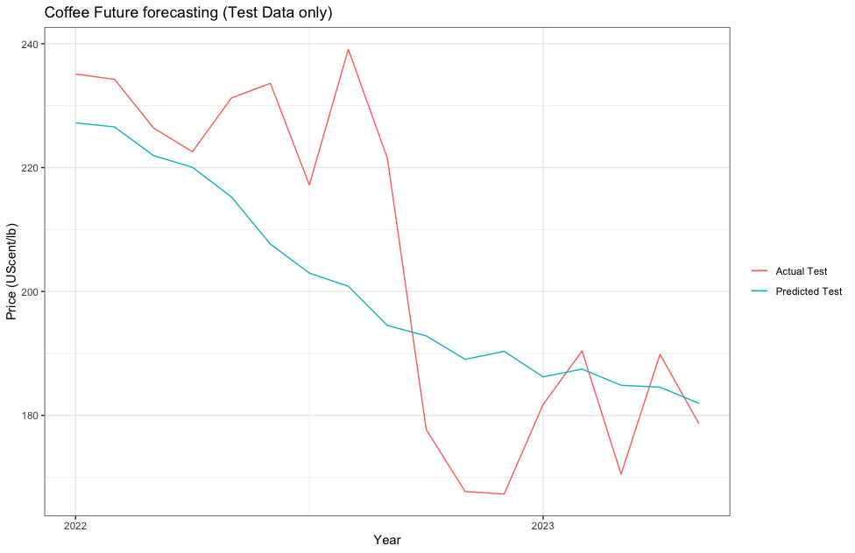
Figure 20. Forecasting of Coffee Futures for Test Data using the ARIMA Model.

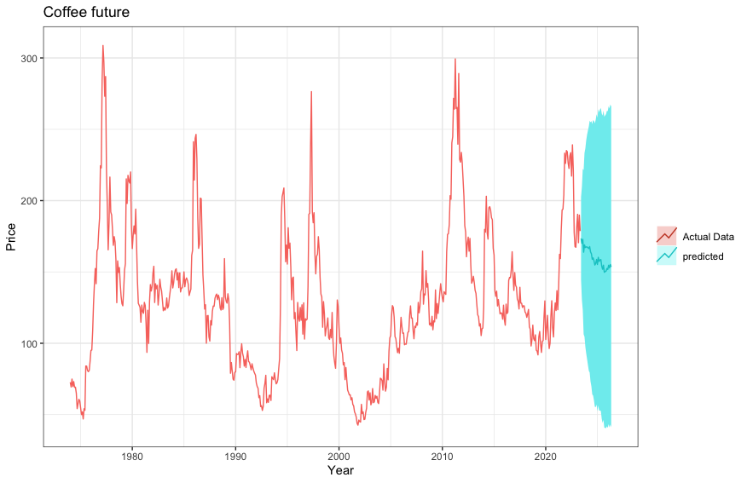
Figure 21: Coffee Future prediction for the next 3 years under 95% Confidence interval (highlighted in blue shade)

Hybrid Model:
Integrating multiple regressors into the ARIMA model not only enhances the RMSE (9.312515) and MAPE (0.038) but also yields residuals that exhibit an independent distribution. Figure 21 illustrates the absence of noteworthy autocorrelation within the estimated errors of the ARIMA model, often referred to as innovation residuals. The Box-Ljung test also shows a p-value (0.7433) greater than the significant level of 0.05. Nonetheless, the histogram reveals a minor rightward skewness. Please find the ARIMA vs. Regression residual plot in Appendix 8.

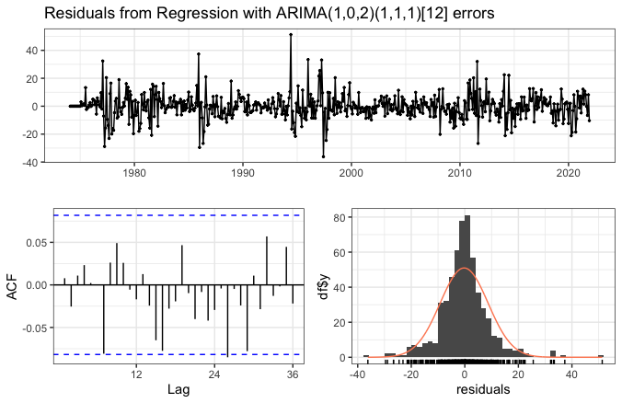
Figure 22. Analysis of residuals from Arima with an exogenous regression model.

Unlike ARIMA this hybrid model captures the fluctuation in the data that are influenced by the regressor variables, and Figure 22 shows the forecasting plot of the Actual Test vs. Predicted Test.

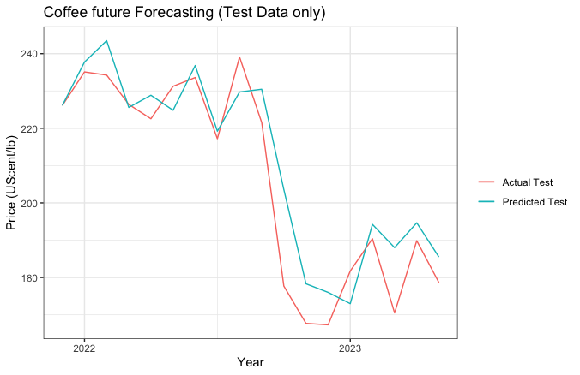
Figure 23. Coffee Future Forecasting for Test Data from Hybrid
(Arima + regression) model.

5. Conclusion

As this exploration comes to an end, attention turns beyond the confines of coffee markets and predictive models, venturing into the delicate interplay of climate and coffee cultivation. This journey, enriched by insights from time series analysis, ARIMA modelling, and regression techniques, leads to an intricate pathway where financial trends interlace with the dynamic cadence of climate patterns. Beyond the world of numbers and forecasts, the revelations resonate not only with the client but also with the coffee-growing communities nestled within Brazil's Minas Gerais, Sao Paulo, and Espirito Santo regions.

The initial objective of this research was to conduct a meticulous Exploratory Data Analysis (EDA) to unravel the subtle threads connecting climate patterns and coffee yield. A notable discovery was the significant rise in temperature that tropical regions have experienced over the past 25 years. This warming trend is having a profound impact on coffee agriculture and altering the delicate balance between temperature, precipitation, altitude, and coffee yield. To adapt to these changes, coffee farming is moving to higher elevations, demonstrating the resilience and adaptability of the farming community. Brazil's coffee belt is experiencing a transformation, with farming operations relocating to cooler altitudes in response to rising temperatures. While this poses new challenges for farmers, the milder temperatures at higher elevations present opportunities for improved harvest quality.

Furthermore, Exploratory Data Analysis (EDA) provides insights into the phenological cycle of coffee. The natural elements intricately affect the flowering, fruit development, and harvesting period. Higher precipitation during the dry period, a critical stage in coffee's life cycle, negatively impacts yield. This highlights the profound influence of climate shifts on coffee cultivation.

Venturing deeper, this investigation encompassed market dynamics beyond coffee itself. The secondary aim was to evaluate the pervasive influence of commodities and market indicators on the trajectory of coffee futures. In this narrative, two formidable models take centre stage, shedding light on this phenomenon—the regression model and the pioneering hybrid model, fusing ARIMA and regression methodologies.

The regression model revealed intriguing insights into potential price shifts and trends driven by these indicators. Interestingly, two important factors emerged as significant regressors in this context: the USD index (USDI) and coffee spot prices. These variables played a critical role in unravelling the complex interplay of variables that impact coffee futures. Moreover, the hybrid model, which fused ARIMA and regression, integrated these key variables alongside the historical values of coffee futures. This hybrid model, specifically ARMA (1,2) (1,1,1) [12] with regressor, proved to be highly effective in capturing both the temporal patterns and external factors that influence Coffee Future prices. This model provides valuable insights into the multifaceted dynamics of the coffee futures market, making it easier to make informed decisions. The ARIMA model also proved to be an effective predictor of coffee futures, with the ARIMA (5,1,3) (1,1,1) [12] configuration emerging as a robust contender. By leveraging historical coffee futures data, this model accurately captures patterns and intricacies to provide insightful forecasts. However, the hybrid model takes this a step further, incorporating both financial market trends and external determinants.

However, a pivotal realization comes to the forefront that the effectiveness of the hybrid model for horizon forecasting is heavily reliant on the availability of future exogenous data. In its absence, the model’s prowess diminishes, emphasizing the reliance on the ARIMA model. This highlights the intrinsic connection between data availability and model effectiveness, a reminder that predictive potential is deeply entwined with the information at hand.

In this concluding narrative, a pivotal connection emerges—the dance between climate and coffee. The research extends beyond predictive horizons, finding resonance within the landscapes where coffee cherries mature. The warming trends within Brazil's heartlands mark a new era and demonstrate the changing relationship between agriculture and climate. As this journey draws to a close, it empowers not only the client with insights but also stands in solidarity with the farmers who shape the very essence of the coffee we treasure. The tale of shifting temperatures becomes an intrinsic thread woven into the fabric of findings—a reminder that knowledge extends beyond numbers, reaching into the heart of the land and the lives it touches.

5.1 Future Work
Anticipating the road ahead, there lie promising avenues to extend the impact of this research on the client, Caribbean Goods, and coffee farmers in tropical regions. Exploring GARCH (Generalized Autoregressive Conditional Heteroskedasticity) modelling could offer valuable insights into the volatility of coffee futures, enabling the client to better navigate market uncertainties and make informed risk management decisions. Exploring deep learning Neural Network models such as Long short-term memory (LSTM) may improve univariate time series forecasting. Furthermore, collecting primary data on production costs could empower the client to engage with farmers in crafting strategies to enhance productivity while optimizing expenses. This collaboration, rooted in data-driven decisions, could significantly impact the livelihoods of coffee farmers by potentially increasing their profit margins. Additionally, focusing on coffee farms excelling in competitions such as the Cup of Excellence could foster knowledge sharing between the client and exceptional farmers, promoting sustainable practices, and elevating the quality of coffee cultivation.

6. References
- 8.2 cross correlation functions and lagged regressions: Stat 510 (2023) PennState: Statistics Online Courses. Available at: https://online.stat.psu.edu/stat510/lesson/8/8.2 (Accessed: 28 August 2023).
- Alashari, M. et al. (2022) ‘Multivariate time series and regression models for forecasting annual maintenance costs of EPDM Roofing Systems’, Journal of Building Engineering, 54, p. 104618. doi:10.1016/j.jobe.2022.104618.
- Angamuthu Chinnathambi, R. et al. (2018) ‘A multi-stage price forecasting model for day-Ahead Electricity Markets’, Forecasting, 1(1), pp. 26–46. doi:10.3390/forecast1010003.
- Aparecido, L.E. and Rolim, G. de (2018) ‘Forecasting of the annual yield of Arabic coffee using water deficiency’, Pesquisa Agropecuária Brasileira, 53(12), pp. 1299–1310. doi:10.1590/s0100-204x2018001200002.
- Assis, K. et al. (2010) ‘A comparison of univariate time series methods for forecasting cocoa bean prices’, Trends in Agricultural Economics, 3(4), pp. 207–215. doi:10.3923/tae.2010.207.215.
- Babu, B.N.P. and Muniyappa, A. (2021) ‘The interdependence of coffee futures and spot markets - an econometric analysis’, Journal of Plantation Crops, pp. 56–66. doi:10.25081/jpc.2021.v49.i1.7061.
- Bissing, D. et al. (2019) ‘A hybrid regression model for day-Ahead Energy Price forecasting’, IEEE Access, 7, pp. 36833–36842. doi:10.1109/access.2019.2904432.
- Box, G.E.P. et al. (2016) Time Series Analysis: Forecasting and Control. Hoboken: Wiley.

Brazil - the coffee giant! (2023). Available at: https://www.sidewalkcoffee.co.uk/blogs/news/country-profile-brazil (Accessed: 15 July 2023).
- Bunn, C. et al. (2017) Climate smart coffee in honduras - cgspace.cgiar.org, Climate smart coffee in honduras. Available at: https://cgspace.cgiar.org/handle/10568/97530 (Accessed: 19 July 2023).
- Burgess, R., Deschenes, O. and Donaldson, D. (2017) Weather, climate change and death in India - epic. Available at: https://epic-staging.uchicago.edu/wp-content/uploads/2019/07/Publication-9.pdf (Accessed: 17 July 2023).
- CAMARGO, Â.P. and CAMARGO, M.B. (2001) ‘Definição e Esquematização das fases fenológicas do Cafeeiro Arábica NAS Condições Tropicais do Brasil’, Bragantia, 60(1), pp. 65–68. doi:10.1590/s0006-87052001000100008.
- Camargo, M.B. (2010) ‘The impact of climatic variability and climate change on Arabic coffee crop in Brazil’, Bragantia, 69(1), pp. 239–247. doi:10.1590/s0006-87052010000100030.
- Ceballos-Sierra, F. and Dall’Erba, S. (2021) ‘The effect of climate variability on Colombian coffee productivity: A Dynamic Panel Model Approach’, Agricultural Systems, 190, p. 103126. doi:10.1016/j.agsy.2021.103126.
- Charles, S. (2023) The fertiliser crisis will affect coffee yields for years, Coffee Intelligence. Available at: https://intelligence.coffee/2023/02/fertiliser-crisis-coffee-yields/ (Accessed: 06 August 2023).
- Chaudhari, S. (2022) Stationarity in time series analysis explained using python, Quantitative Finance & Algo Trading Blog by QuantInsti. Available at: https://blog.quantinsti.com/stationarity/ (Accessed: 26 August 2023).
- Chen, J.Q.A. et al. (2020) ‘Associations between caffeine consumption, cognitive decline, and dementia: A systematic review’, Journal of Alzheimer’s Disease, 78(4), pp. 1519–1546. doi:10.3233/jad-201069.
- Cleveland, R.B., Cleveland, W.S. & Terpenning, I. 1990, "STL: A Seasonal-Trend Decomposition Procedure Based on Loess", Journal of Official Statistics, vol. 6, no. 1, pp. 3.
- Coffee C ® Futures (2023) ICE. Available at: https://www.ice.com/products/15/Coffee-C-Futures (Accessed: 19 August 2023).
- Coffee market report (2023) English. Available at: https://icocoffee.org/ (Accessed: 15 July 2023).
- Coffee market share, size, Trends & Industry Analysis (2023) Coffee Market Share, Size, Trends & Industry Analysis. Available at: https://www.mordorintelligence.com/industry-reports/coffee-market (Accessed: 15 July 2023).
- Colistete, R.P. (2015) ‘Regiões e Especialização na Agricultura Cafeeira: São Paulo no Início do Século XX’, Revista Brasileira de Economia, 69(3). doi:10.5935/0034-7140.20150015.
- Commodity Price Data (2023) World Bank Commodities Price Data (the pink sheet). Available at: https://thedocs.worldbank.org/en/doc/5d903e848db1d1b83e0ec8f744e55570-0350012021/CMO-Pink-Sheet-March-2021 (Accessed: 28 July 2023).
- Darwin, R. (2017) ‘Roy Darwin (1999), “the impact of global warming on agriculture: A Ricardian analysis: Comment”, American Economic Review, 89, pp. 1049-52.’, Climate Change, pp. 157–160. doi:10.4324/9781351161602-18.
- de Marcos, R.A., Bello, A. and Reneses, J. (2017) ‘Short-term forecasting of electricity prices with a computationally efficient hybrid approach’, 2017 14th International Conference on the European Energy Market (EEM) [Preprint]. doi:10.1109/eem.2017.7981946.
- Dehn, J., Gilbert, C. L. and Varangis, P. (2005) “Agricultural Commodity Price Volatility,” in Aizenman, J. and Pinto, B. (eds) Managing Economic Volatility and Crises: A Practitioner's Guide. Cambridge: Cambridge University Press, pp. 137–185. doi: 10.1017/CBO9780511510755.007.
- Dell, M., Jones, B.F. and Olken, B.A. (2012) ‘Temperature shocks and economic growth: Evidence from the last half century’, American Economic Journal: Macroeconomics, 4(3), pp. 66–95. doi:10.1257/mac.4.3.66.
- Dickey, D.A. and Fuller, W.A. (1979) ‘Distribution of the estimators for autoregressive time series with a unit root’, Journal of the American Statistical Association, 74(366), p. 427. doi:10.2307/2286348.
- EAKIN, H., TUCKER, C. and CASTELLANOS, E. (2006) ‘Responding to the coffee crisis: A pilot study of farmers’ adaptations in Mexico, Guatemala and Honduras’, The Geographical Journal, 172(2), pp. 156–171. doi:10.1111/j.1475-4959.2006.00195.x.
- Elham, K., Masoumeh, Z. and Ebrahim, M.B. (2010) Prediction of added value of agricultural subsections using artificial neural networks: Box-Jenkins and Holt-Winters methods, DEVELOPMENT AND AGRICULTURAL ECONOMICS. Available at: https://academicjournals.org/journal/JDAE/article-full-text-pdf/5A7C1BB1449 (Accessed: 22 July 2023).
- Ensuring the future of coffee. (no date) World Coffee Research. Available at: https://worldcoffeeresearch.org/ (Accessed: 19 July 2023).
- Financial News, shares, Quotes & Charts (2023) Investing.com UK. Available at: https://uk.investing.com/ (Accessed: 28 July 2023).
- Finnstats (2021) Goodness of fit test- jarque-bera test in R: R-bloggers, R. Available at: https://www.r-bloggers.com/2021/08/goodness-of-fit-test-jarque-bera-test-in-r/ (Accessed: 29 August 2023).
- Font, M.A. (1987) ‘Coffee planters, politics, and development in Brazil’, Latin American Research Review, 22(3), pp. 69–90. doi:10.1017/s0023879100037018.
- Frank, C. et al. (2003) ‘Forecasting women’s apparel sales using mathematical modeling’, International Journal of Clothing Science and Technology, 15(2), pp. 107–125. doi:10.1108/09556220310470097.
- Frost, J. (2023) Spearman’s correlation explained, Statistics By Jim. Available at: https://statisticsbyjim.com/basics/spearmans-correlation/ (Accessed: 27 August 2023).
- G, V.K. (2023) Statistical tests to check stationarity in time series, Analytics Vidhya. Available at: https://www.analyticsvidhya.com/blog/2021/06/statistical-tests-to-check-stationarity-in-time-series-part-1/#:~:text=The%20ADF%20test%20is%20used,time%20series%20is%20non%2Dstationary. (Accessed: 03 August 2023).
- G, V.K. (2023) Statistical tests to check stationarity in time series, Analytics Vidhya. Available at: https://www.analyticsvidhya.com/blog/2021/06/statistical-tests-to-check-stationarity-in-time-series-part-1/ (Accessed: 19 August 2023).
- Gay, C. et al. (2006) ‘Potential impacts of climate change on agriculture: A case of study of coffee production in Veracruz, Mexico’, Climatic Change, 79(3–4), pp. 259–288. doi:10.1007/s10584-006-9066-x.
- Gokmenoglu, K.K., Güngör, H. and Bekun, F.V. (2020) ‘Revisiting the linkage between oil and agricultural commodity prices: Panel evidence from an Agrarian State’, International Journal of Finance &amp; Economics, 26(4), pp. 5610–5620. doi:10.1002/ijfe.2083.
- Hernandez, M.A. et al. (2020) Volatile Coffee Prices: Covid-19 and market fundamentals [Preprint]. doi:10.2499/p15738coll2.133746.
- Hossain, Z., Abdus Samad, Q. and Ali, Z. (2006) ‘Arima model and forecasting with three types of pulse prices in Bangladesh: A case study’, International Journal of Social Economics, 33(4), pp. 344–353. doi:10.1108/03068290610651652.
- Huchet-Bourdon, M. (2011) ‘Agricultural Commodity Price Volatility’, OECD Food, Agriculture and Fisheries Papers [Preprint]. doi:10.1787/5kg0t00nrthc-en.
- Hyndman, R.J. and Athanasopoulos, G. (2018) 2nd edn, Forecasting principles and practice. 2nd edn. Melbourne, Australia: O texts. Available at: https://otexts.com/fpp2/ (Accessed: 24 July 2023).
- Hyndman, R.J. and Athanasopoulos, G. (2021) ‘Chapter 7 Time series regression models’, in Forecasting: Principles and practice. 3rd edn. Melbourne: OTexts.
- IBGE (2023) Página principal, IBGE. Available at: https://www.ibge.gov.br/estatisticas/economicas/agricultura-e-pecuaria/9117-producao-agricola-municipal-culturas-temporarias-e-permanentes.html?edicao=18051&t=series-historicas (Accessed: 27 July 2023).
- ICO-Partnerships & Projects (2023) Partnerships & Projects. Available at: https://icocoffee.org/what-we-do/partnerships-and-projects-2/ (Accessed: 24 August 2023).
- Instituto Nacional de Meteorologia (2023) INMET. Available at: https://portal.inmet.gov.br/ (Accessed: 27 July 2023).
- Jacks, D., O’Rourke, K. and Williamson, J. (2009) Commodity price volatility and world market integration since 1700 [Preprint]. doi:10.3386/w14748.
- Kassambara (2018) Regression Model Accuracy Metrics: R-square, AIC, BIC, CP and more, STHDA. Available at: http://www.sthda.com/english/articles/38-regression-model-validation/158-regression-model-accuracy-metrics-r-square-aic-bic-cp-and-more/ (Accessed: 28 August 2023).
- Katriend (2023) Insight into the C-market and its influence on the price of coffee. Available at: https://efico.com/press-efico/insight-into-the-c-market-and-its-influence-on-the-price-of-coffee/ (Accessed: 26 July 2023).
- Kebede, Y. (1993) ‘Causality and efficiency in the Coffee Futures Market’, Journal of International Food &amp; Agribusiness Marketing, 5(1), pp. 55–71. doi:10.1300/j047v05n01_04.
- Khin, A.A. et al. (2008) Natural rubber price forecasting in the world market - researchgate. Available at: https://www.researchgate.net/publication/282783451_NATURAL_RUBBER_PRICE_FORECASTING_IN_THE_WORLD_MARKET (Accessed: 24 July 2023).
- Kim, B. et al. (2013) ‘Forecasting demand of agricultural tractor, riding type Rice Transplanter and combine harvester by using an Arima model’, Journal of Biosystems Engineering, 38(1), pp. 9–17. doi:10.5307/jbe.2013.38.1.009.
- Koh, I. et al. (2020) ‘Climate risks to brazilian coffee production’, Environmental Research Letters, 15(10), p. 104015. doi:10.1088/1748-9326/aba471.
- Kumar, R. and Raj Gautam, H. (2014) ‘Climate change and its impact on agricultural productivity in India’, Journal of Climatology &amp; Weather Forecasting, 2(1). doi:10.4172/2332-2594.1000109.
- Kwiatkowski, D. et al. (1992) ‘Testing the null hypothesis of stationarity against the alternative of a unit root’, Journal of Econometrics, 54(1–3), pp. 159–178. doi:10.1016/0304-4076(92)90104-y.
- Lusinyan, L. et al. (2020) ‘Reserve currencies in an evolving International Monetary System’, Departmental Papers, 2020(002), p. 1. doi:10.5089/9781513560298.087.
- Mandal, B.N. (2005) ‘Forecasting sugarcane production in India with ARIMA model’, A Journal of Theoretical and Applied Statistics, pp. 2–14. doi:https://www.researchgate.net/publication/256079794_Forecasting_sugarcane_production_in_India_with_ARIMA_model.
- Masood, M.A., Raza, I. and Abid, S. (2019) ‘Forecasting wheat production using time series models in Pakistan’, Asian Journal of Agriculture and Rural Development, 8(2), pp. 172–177. doi:10.18488/journal.1005/2018.8.2/1005.2.172.177.
- Masuda, T. and Goldsmith, P.D. (2009) World soybean production: Area harvested, yield, and long-term projections. Available at: https://www.ifama.org/resources/Documents/v12i4/Masuda-Goldsmith.pdf (Accessed: 24 July 2023).
- Matthews, A. (2010) Perspectives on addressing market instability and income ris, The Institute for International Integration Studies Discussion Paper Series. Available at: https://ideas.repec.org/p/iis/dispap/iiisdp324.html (Accessed: 19 July 2023).
- Mohan, S. and Love, J. (2004) ‘Coffee futures: Role in Reducing Coffee Producers’ price risk’, Journal of International Development, 16(7), pp. 983–1002. doi:10.1002/jid.1158.
- Montgomery, J. (2023) Coffee’s reliance on the US dollar could be holding it back, Coffee Intelligence. Available at: https://intelligence.coffee/2023/04/coffees-reliance-us-dollar/ (Accessed: 19 July 2023).
- Myers, R.J. (1994) Review of Marketing & Agricultural Economics, Time Series Econometrics and Commodity Price Analysis: A Review. Available at: https://www.researchgate.net/publication/23945898_Time_Series_Econometrics_and_Commodity_Price_Analysis_A_Review (Accessed: 03 August 2023).
- Nasdaq Data Link (2023) data.nasdaq.com. Available at: https://data.nasdaq.com/ (Accessed: 28 July 2023).
- National Centers for Environmental Information (2023) National Centers for Environmental Information (NCEI). Available at: https://www.ncei.noaa.gov/ (Accessed: 27 July 2023).
- Nazlioglu, S. and Soytas, U. (2012) ‘Oil price, agricultural commodity prices, and the dollar: A panel cointegration and causality analysis’, Energy Economics, 34(4), pp. 1098–1104. doi:10.1016/j.eneco.2011.09.008.
- Nguyen, C.T.T. (2017) Hedonic regression model for coffee futures: An analysis of effect of ... Available at: https://www.semanticscholar.org/paper/Hedonic-regression-model-for-coffee-futures%3A-an-of-Nguyen/ac1916c3924874402f832b72285fca8828842b1e (Accessed: 18 July 2023).
- Nochai, R. and Nochai, T. (2006) [PDF] Arima model for Forecasting Oil Palm | Semantic scholar. Available at: https://www.semanticscholar.org/paper/ARIMA-MODEL-FOR-FORECASTING-OIL-PALM-Nochai-Nochai/92cf62773a0247782f1d8cdb077adc8b587a1109 (Accessed: 24 July 2023).
- Noemie, M.E. and Davis, J. (2011) Unravelling the underlying causes of price volatility in world coﬀee and cocoa market. Available at: https://mpra.ub.uni-muenchen.de/43813/1/MPRA_paper_43813.pdf (Accessed: 19 July 2023).
- OECD (2008) OECD-Annual Report. rep. Paris, pp. 53–54. Available at: https://www.oecd.org/newsroom/40556222.pdf (Accessed: 21 July 2023).
- OECD (2009), Managing Risk in Agriculture: A Holistic Approach, OECD Publishing, Paris, https://doi.org/10.1787/9789264075313-en.
- Pachauri, R.K. et al. (2014) Climate change 2014 synthesis report. Contribution of Working Groups I, II, and III to the Fifth Assessment Report of the intergovernmental panel on climate change, the UWA Profiles and Research Repository. Available at: https://research-repository.uwa.edu.au/en/publications/climate-change-2014-synthesis-report-contribution-of-working-grou (Accessed: 03 August 2023).
- Padhan, P.C. (2012) Full length article application of Arima Model for Forecasting Agricultural Productivity in India. Available at: https://www.fspublishers.org/published_papers/99500_..pdf (Accessed: 24 July 2023).
- Página inicial (2023) Conab. Available at: https://www.conab.gov.br/ (Accessed: 19 August 2023).
- Ponte, S. (2002) The `Latte Revolution’? Regulation, markets and consumption in the global coffee chain, World Development. Available at: https://www.sciencedirect.com/science/article/pii/S0305750X02000323 (Accessed: 15 July 2023).
- Rodríguez, D. et al. (2011) ‘A coffee agroecosystem model: I. Growth and development of the Coffee Plant’, Ecological Modelling, 222(19), pp. 3626–3639. doi:10.1016/j.ecolmodel.2011.08.003.
- Sachs, J.D. et al. (2019) Ensuring economic viability and sustainability of coffee production. Available at: https://academiccommons.columbia.edu/doi/10.7916/d8-00aa-fd61/download (Accessed: 18 July 2023).
- Salamanca-Jimenez, A., Doane, T.A. and Horwath, W.R. (2017) ‘Nitrogen use efficiency of coffee at the vegetative stage as influenced by Fertilizer Application Method’, Frontiers in Plant Science, 8. doi:10.3389/fpls.2017.00223.
- Sarika , J., Chirantan , C. and Iquebal, M.A. (2011) Modelling and forecasting of pigeonpea (Cajanus cajan) production using autoregressive integrated moving average methodology. Available at: https://www.researchgate.net/publication/235949662_Modelling_and_forecasting_of_pigeonpea_Cajanus_cajan_production_using_Autoregressive_Integrated_Moving_Average_methodology (Accessed: 24 July 2023).
- Saz, G. (2011) The efficacy of sarima models for forecasting inflation rates in developing countries: The case for Turkey, SSRN. Available at: https://papers.ssrn.com/sol3/papers.cfm?abstract_id=1845643 (Accessed: 24 July 2023).
- Schlenker, W. and Lobell, D.B. (2010) ‘Robust negative impacts of climate change on African agriculture’, Environmental Research Letters, 5(1), p. 014010. doi:10.1088/1748-9326/5/1/014010.
- Serrão, A. (2015) The influence of investors’ behavior on setting coffee futures prices. Available at: https://www.arcjournals.org/pdfs/ijmsr/v3-i10/5.pdf (Accessed: 21 July 2023).
- Shukla, M. and Jharkharia, S. (2013) ‘Applicability of Arima models in wholesale vegetable market’, International Journal of Information Systems and Supply Chain Management, 6(3), pp. 105–119. doi:10.4018/ijisscm.2013070105.
- Silva, C.A. da and Ferreira, L. da (2015) Asymmetric volatility modeling of spot prices of Arabic Coff. Available at: https://ideas.repec.org/p/ags/iaae15/211556.html (Accessed: 21 July 2023).
- Silveira, R.L., Mattos, F.L. and Saes, M.S. (2016) ‘The reaction of coffee futures price volatility to crop reports’, Emerging Markets Finance and Trade, 53(10), pp. 2361–2376. doi:10.1080/1540496x.2016.1205976.
- Spearman’s correlation - statstutor (2023) Spearman’s correlation. Available at: https://statstutor.ac.uk/resources/uploaded/spearmans.pdf (Accessed: 06 August 2023).
- Stephanie (2023) Ljung box test: Definition, Statistics How To. Available at: https://www.statisticshowto.com/ljung-box-test/ (Accessed: 23 August 2023).
- Thadewald, T. and Büning, H. (2007) ‘Jarque–Bera test and its competitors for testing normality – a power comparison’, Journal of Applied Statistics, 34(1), pp. 87–105. doi:10.1080/02664760600994539.
- Vezy, R. et al. (2020) ‘DynACof: A process-based model to study growth, yield and ecosystem services of Coffee Agroforestry Systems’, Environmental Modelling &amp; Software, 124, p. 104609. doi:10.1016/j.envsoft.2019.104609.
- Vijayakumar, A.N. (2022) ‘Impact of the US dollar index and crude oil on prices of Arabica and Robusta varieties of Indian Coffee’, Business Perspectives and Research, p. 227853372210773. doi:10.1177/22785337221077399.
- WATSON, K. and ACHINELLI, M.L. (2008) ‘Context and contingency: The Coffee Crisis for conventional small-scale coffee farmers in Brazil’, Geographical Journal, 174(3), pp. 223–234.doi:10.1111/j.1475-4959.2008.00277.x.
- Winter, E. et al. (2020) Evaluating the sustainability performance of typical conventional and certified coffee production systems in Brazil and Ethiopia based on expert judgements, Frontiers. Available at: https://www.frontiersin.org/articles/10.3389/fsufs.2020.00049/full (Accessed: 15 July 2023).
- Wold, H. (1939) ‘A Study in Analysis of Stationary Time Series’, Journal of the Royal Statistical Society. Series A (General), 102(2), pp. 295–298. doi:https://doi.org/10.2307/2980009.
- World development indicators (2023) WDI. Available at: https://datatopics.worldbank.org/world-development-indicators/ (Accessed: 28 July 2023).
- Yuan, N. et al. (2016) ‘A novel way to detect correlations on multi-time scales, with temporal evolution and for multi-variables’, Scientific Reports, 6(1). doi:10.1038/srep27707.

7. APPENDICES

1. Commodity data

1.1. Commodity Data Description

S.no | Feature | Description
1 | Cocoa | International Cocoa Organization daily price, average of the first three positions on the terminal markets of New York and London, nearest three future trading months.
2 | COFFEE FUTURE | ICE real time derived nearest month Future
3 | COFFEE_SPOT | International Coffee Organization indicator price of other mild Arabicas, average New York and Bremen/Hamburg markets
4 | Crude_oil_avg | average spot price of Brent, Dubai and West Texas Intermediate, equally weighed
5 | DAP | DAP (diammonium phosphate), spot
6 | GBP_USD | Exchnage Rate GBP to USD
7 | SUGAR_WLD | Sugar (World), International Sugar Agreement (ISA) daily price, raw, f.o.b. and stowed at greater Caribbean ports
8 | TEA_AVG | average three auctions, arithmetic average of quotations at Kolkata, Colombo and Mombasa/Nairobi.
9 | UREA_EE_BULK | Urea, (Ukraine), prill spot
10 | USDI | US DOLLAR Index

1.2 Summary of commodity data:

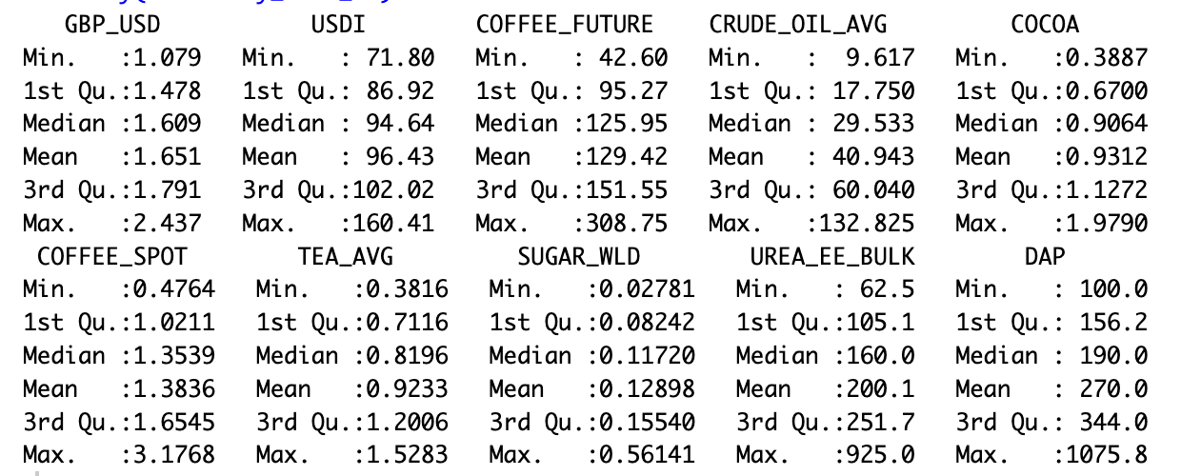

2. ADF Test results

ADF Test
 | Level (lag=20) |  |  | 1st Difference
S.no | Variable | Test_Statistic | P_Value | Test_Statistic | P_Value
1 | GBP_USD | -3.553591914 | 0.037153278 | -7.812590945 | 0.01
2 | USDI | -2.988185153 | 0.160024122 | -7.227718188 | 0.01
3 | COFFEE_FUTURE | -3.282999269 | 0.073619222 | -7.669099252 | 0.01
4 | CRUDE_OIL_AVG | -2.530599979 | 0.353712863 | -9.211466963 | 0.01
5 | COCOA | -2.588929199 | 0.329023005 | -7.486643348 | 0.01
6 | COFFEE_SPOT | -2.903754102 | 0.195762483 | -7.266540896 | 0.01
7 | TEA_AVG | -2.677469541 | 0.291545245 | -9.489408988 | 0.01
8 | SUGAR_WLD | -4.172212568 | 0.01 | -8.752529802 | 0.01
9 | UREA_EE_BULK | -3.311184661 | 0.068759671 | -7.947653715 | 0.01
10 | DAP | -3.408846347 | 0.051921449 | -8.534954495 | 0.01

3. Espirito Santo analysis

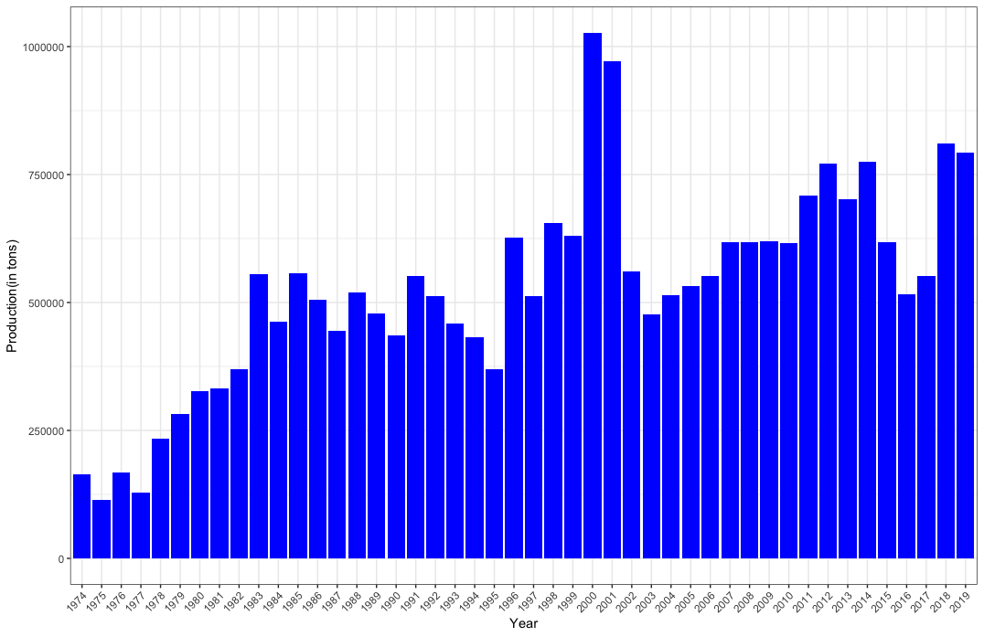
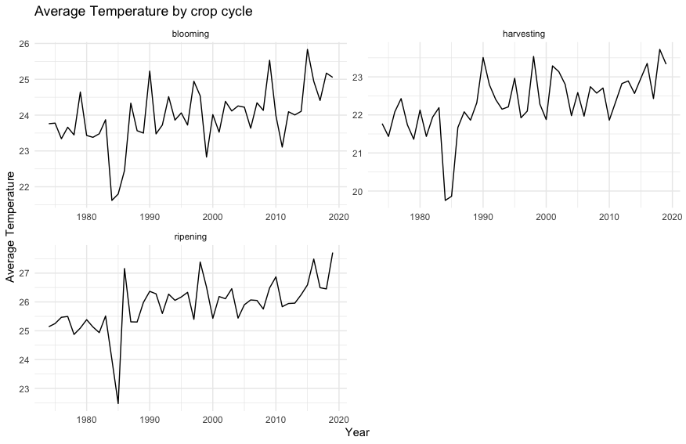 | 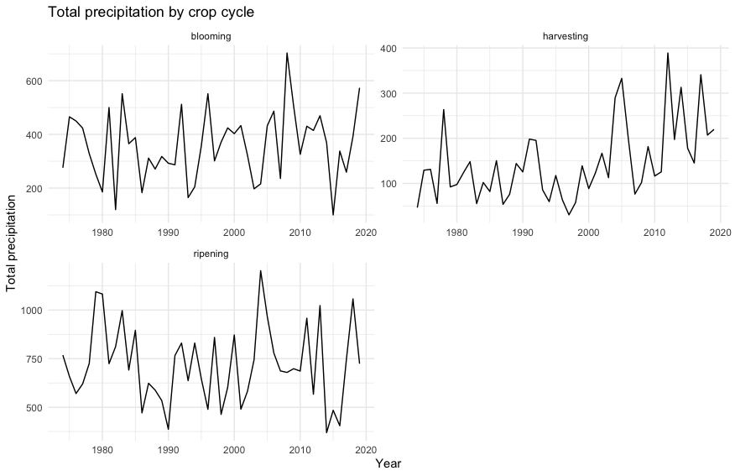

4. Correlation matrix for Brazil Monthly weather data

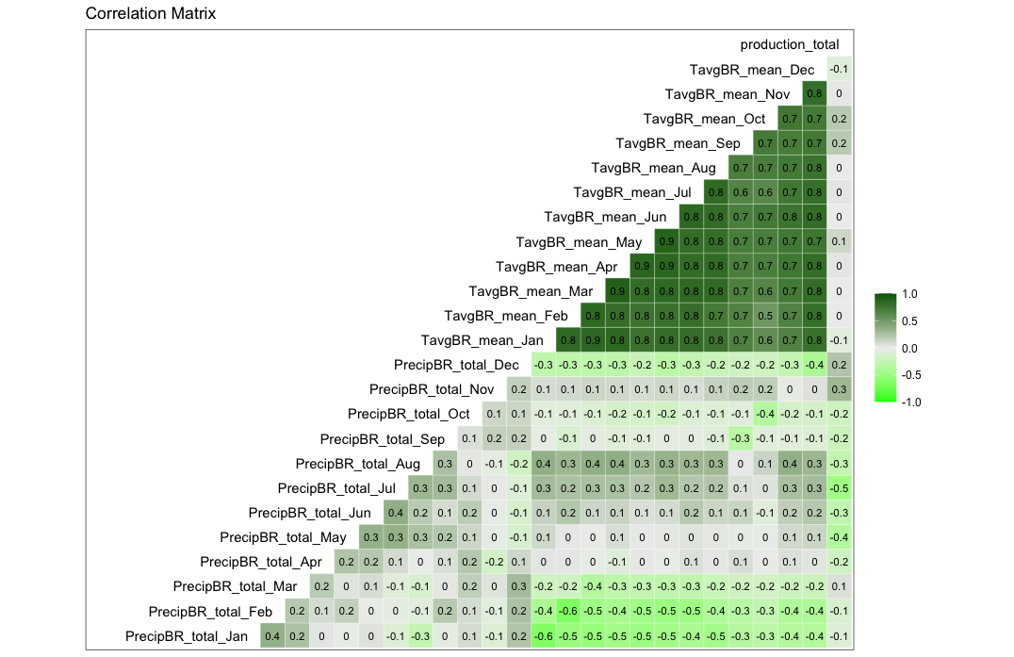

5. Colombia analysis

5.1 Climate vs. Coffee production plot for Colombia.

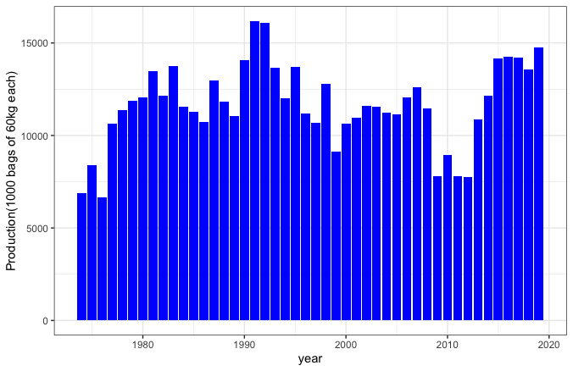
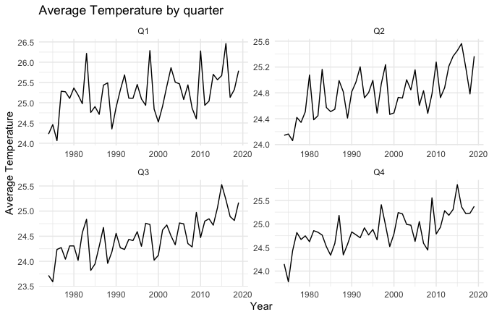 | 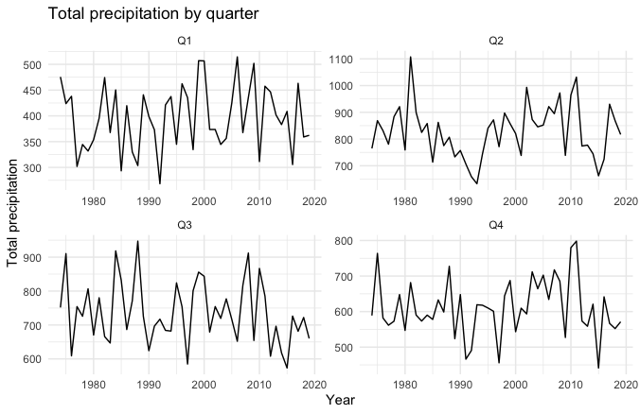
5.2 Correlation Matrix for Colombia

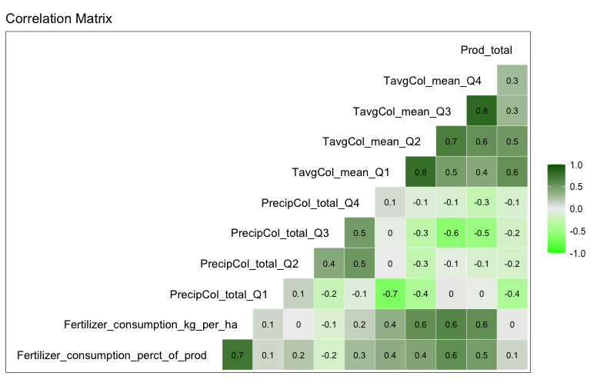

6. Brazil vs Colombia Fertiliser consumption kg per ha.

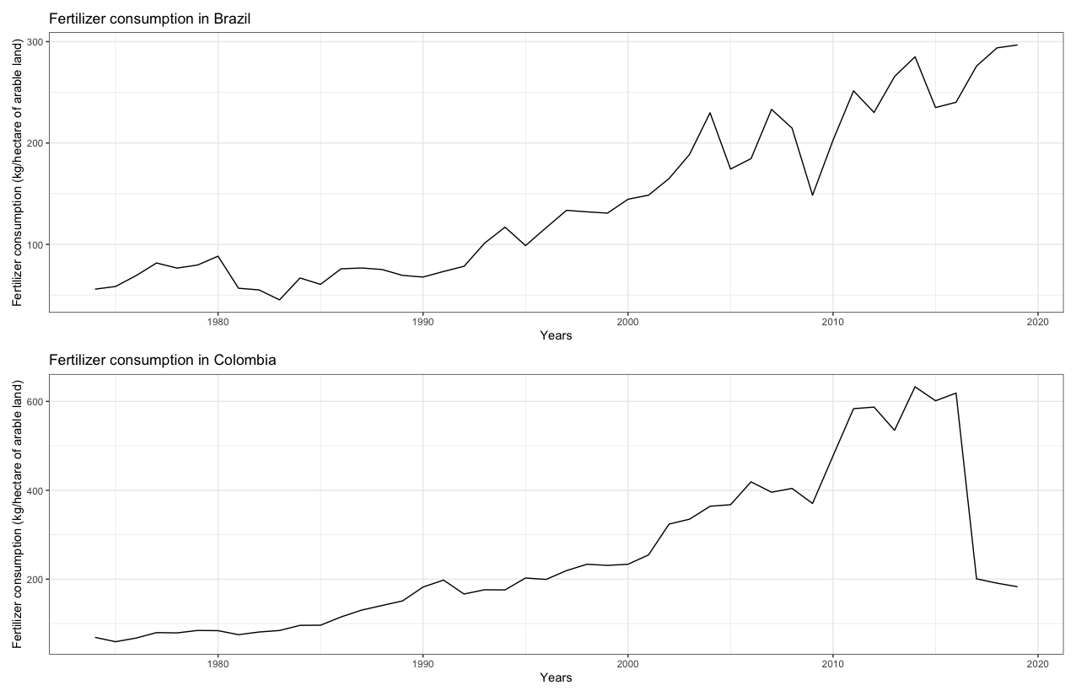
Note: Reducing fertiliser consumption doesn’t impact much on the production during the period 2015-2019

7. Cross-correlation plot of various Market Indicator on different lag

7.1 USDI vs COFFEE FUTURE

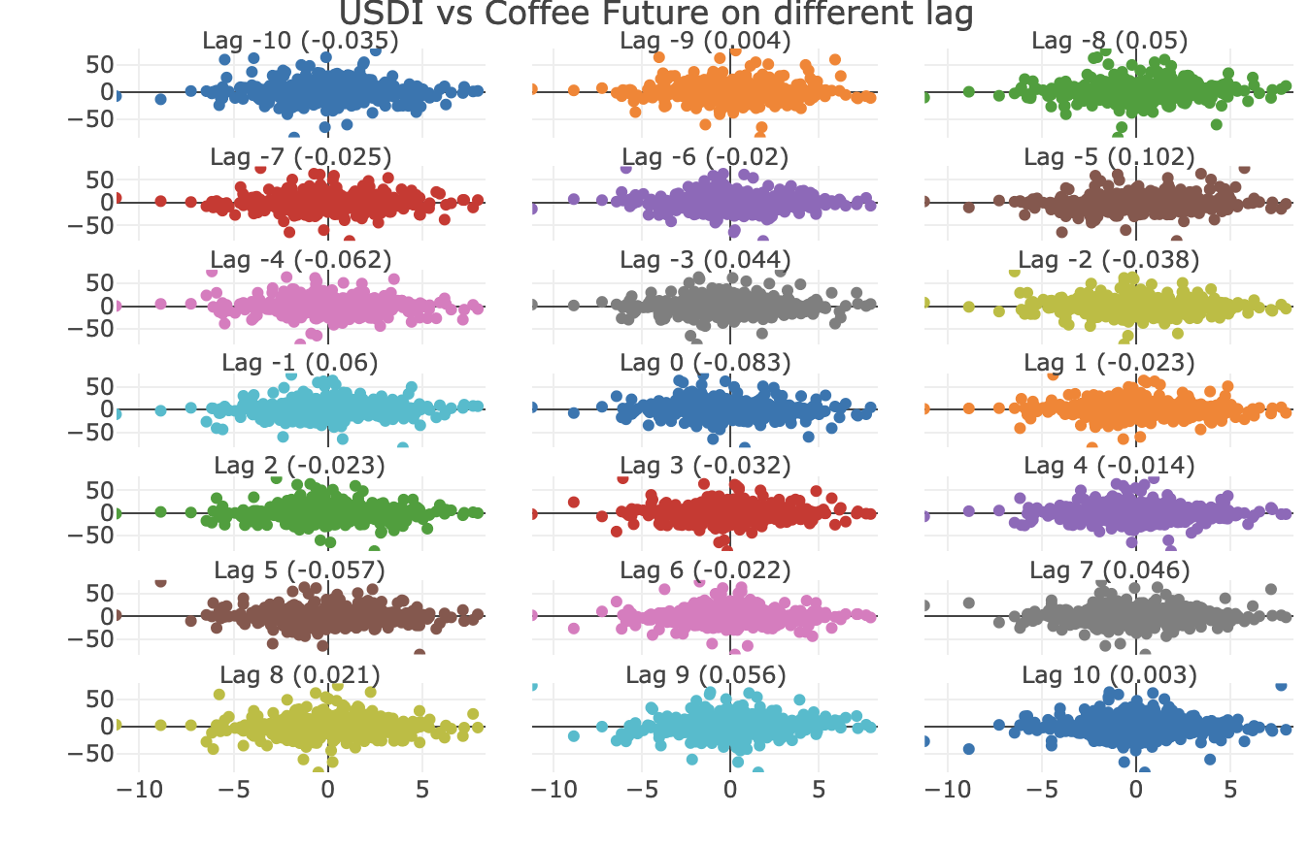

7.2 GBP_USD exchange rate vs COFFEE FUTURE

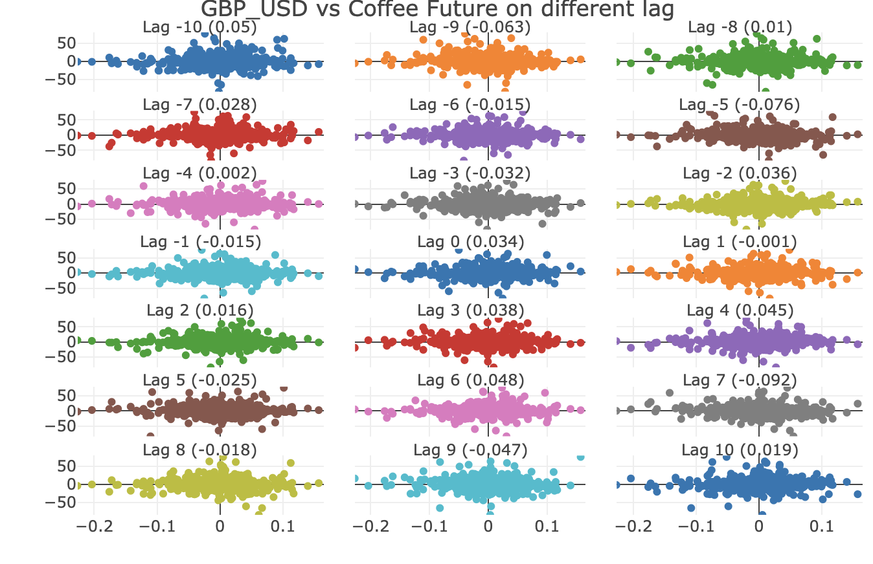

7.3 COCOA vs COFFEE FUTURE

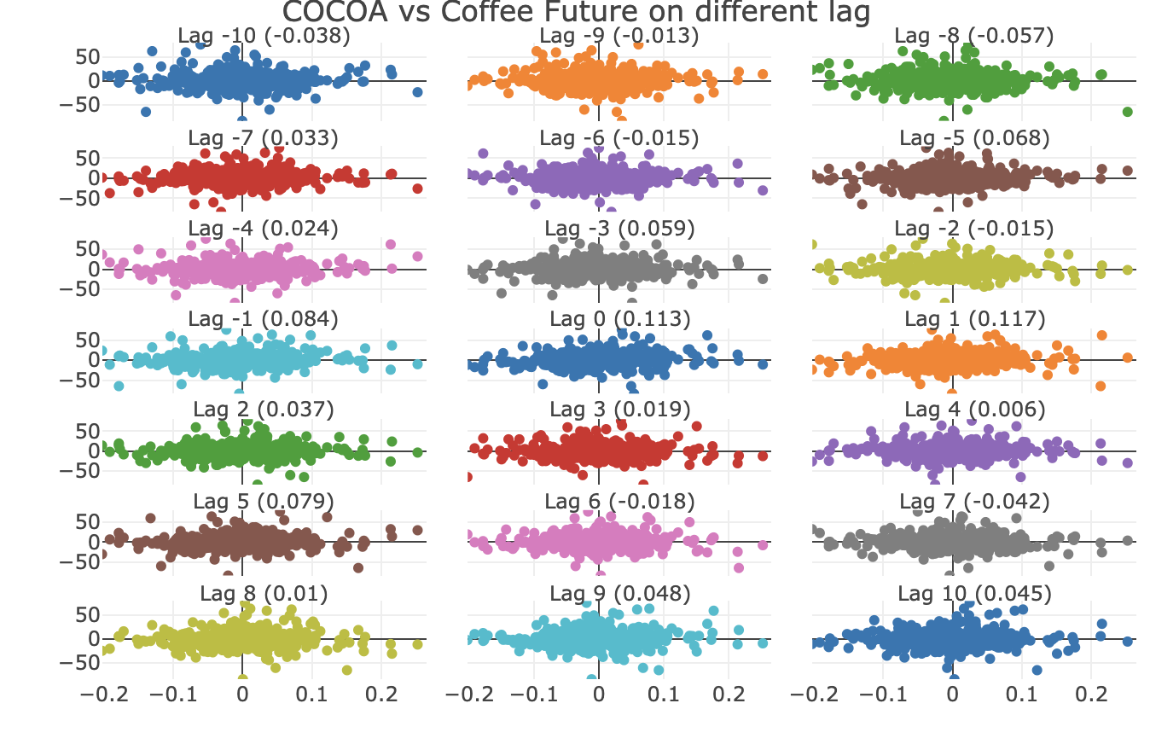

7.4 COFFEE SPOT vs COFFEE FUTURE

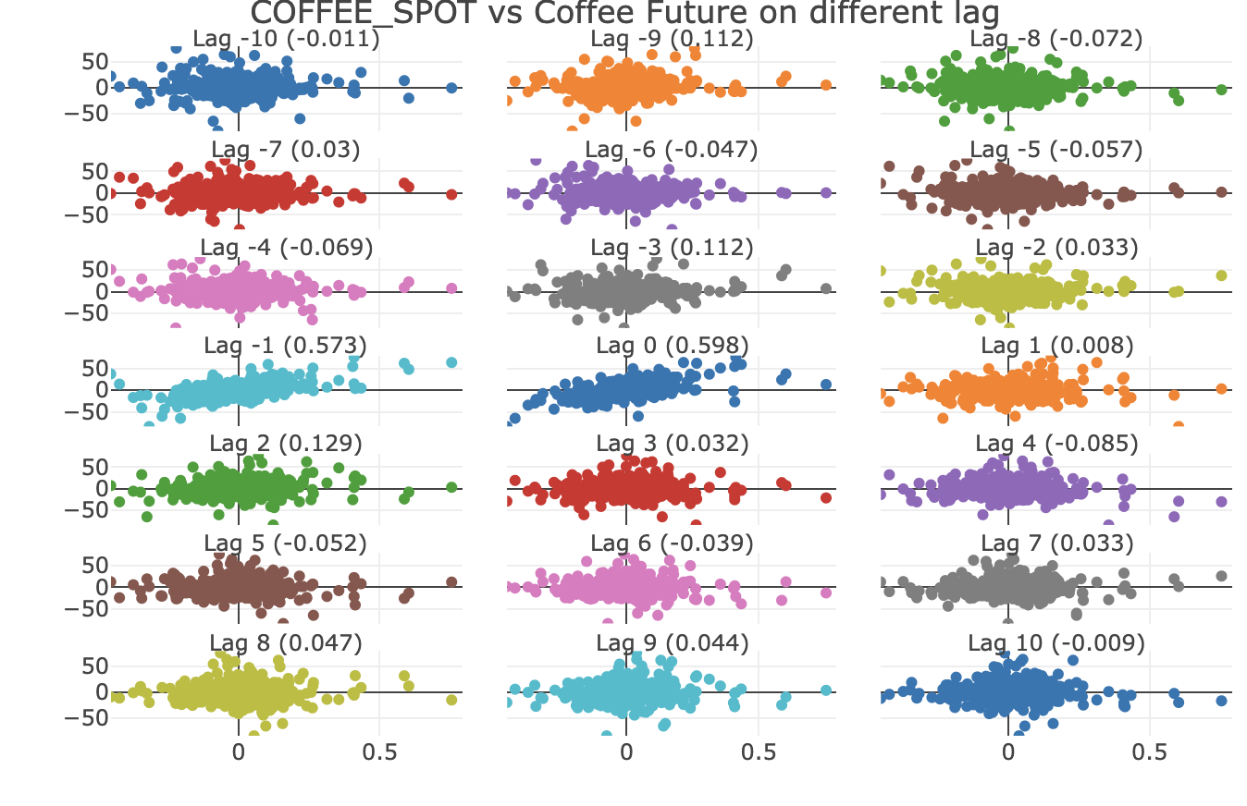

7.5 TEA_AVG vs COFFEE FUTURE
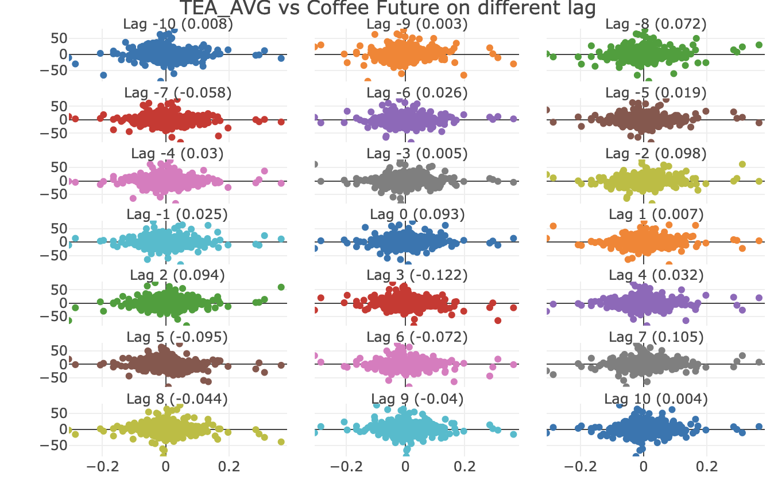

7.6 SUGAR vs COFFEE FUTURE

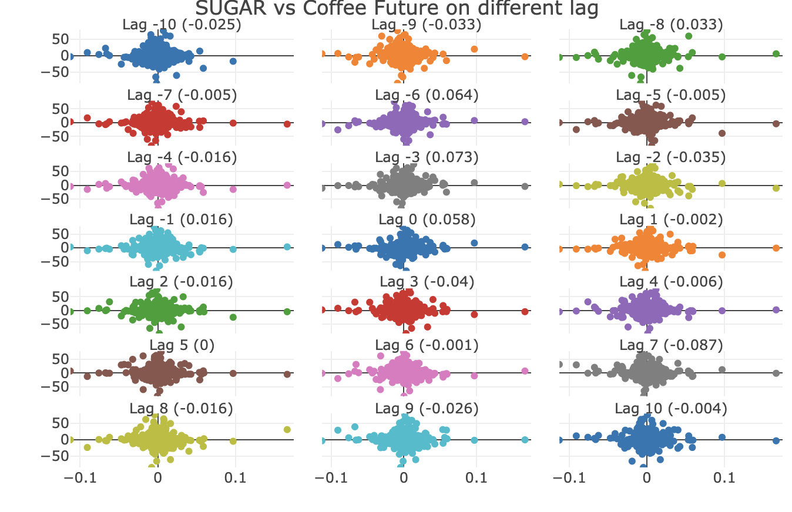
7.7 UREA vs COFFEE FUTURE

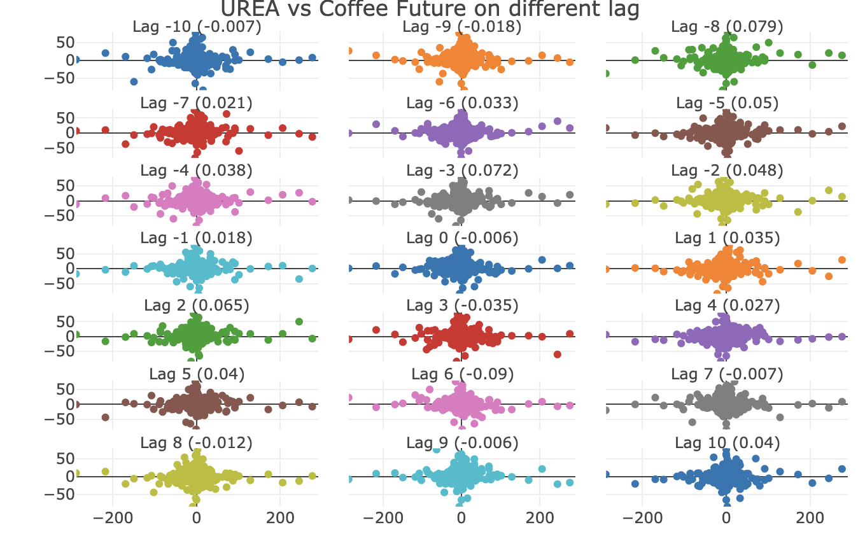
7.8 DAP vs COFFEE FUTURE

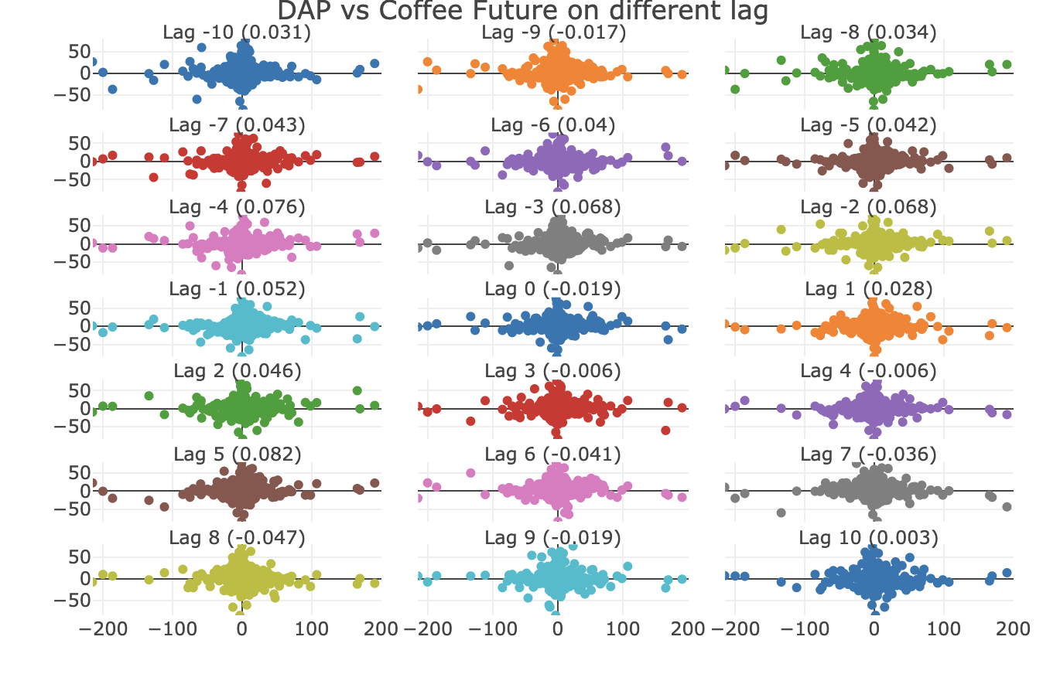

8. ARIMA vs Regression residual plot

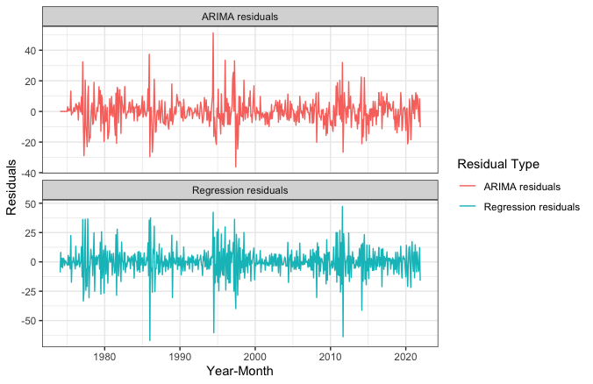

9. Coffee Future BoxCox Transformed Arima model forecasting

9.1 Residual Plot of Arima Transformed Model:

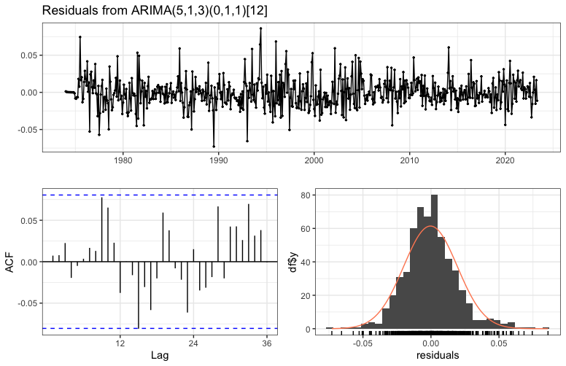

9.2 Coffee Future prediction for the next three years under 95% confidence interval (Highlighted in blue shade)

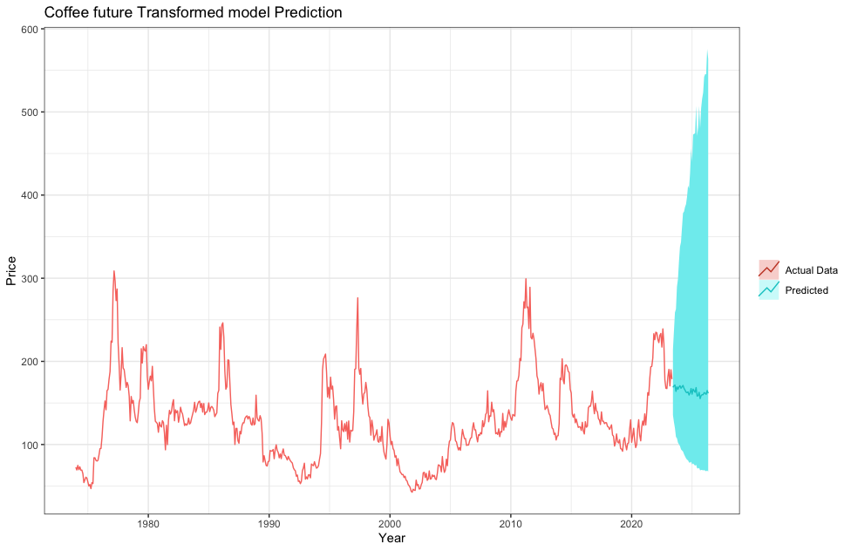

9.3 Point forecast value under 95% confidence interval

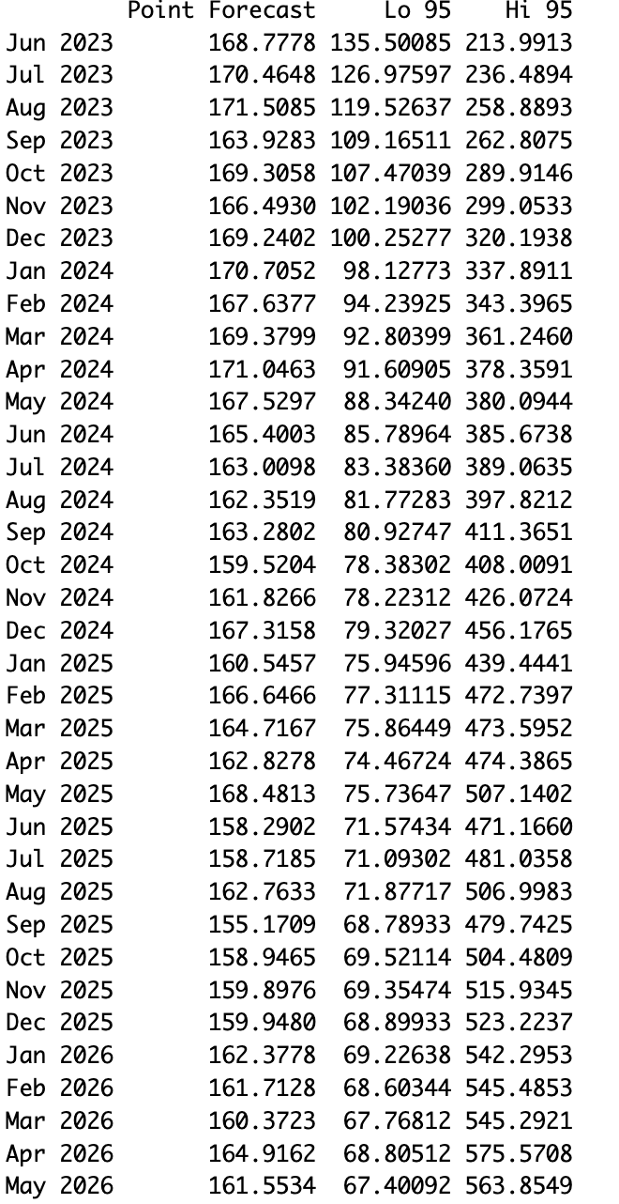

10. Coffee Future selected ARIMA (5,1,3) (1,1,1)12 model forecasting under 95% confidence interval:

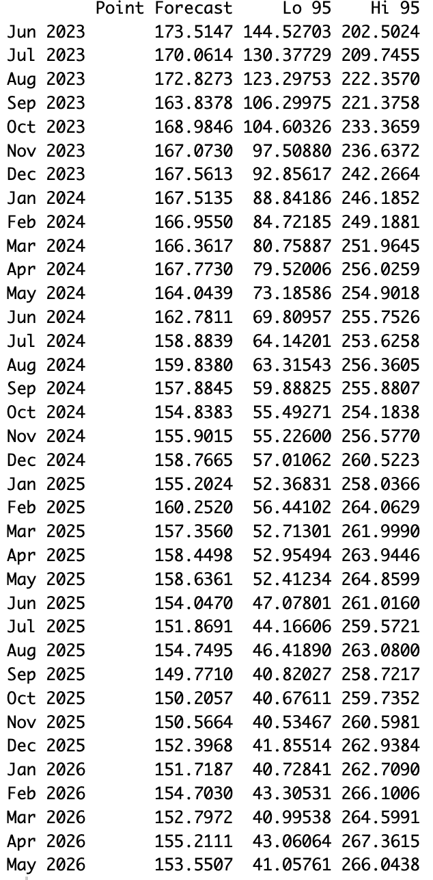

11. R-programming:

# Installed Libraries
library(readr)
library(lubridate)
library(readxl)
library(maps)
library(mapdata)
install.packages("geobr")
install.packages("geosf")
library(geobr)
library(sf)
library(patchwork)
library(corrplot)
library(dbplyr)
library(ggplot2)
library(cowplot)
library(tidytext)
library(DBI)
library(tidyr)
library(tidyselect)
library(tidyverse)
library(TSA)
library(tseries)
library(ggfortify)
library(zoo)
library(astsa)
library(GGally)
library(TSstudio)
library(tsibble)
library(MTS)
library(fUnitRoots)
library(forecast)
library(faraway)
library(xts)
library(car)
library(fable)
library(feasts)
library(tsfeatures)
library(urca)
library(timeSeries)
library(lmtest)
library(quantmod)
library(broom)
library(forecastHybrid)
library(DCCA)
library(Metrics)
library(MASS)

#Production and Weather Data load for Brazil and Colombia
Coffee_production_Brazil <- read_excel("Coffee production Brazil.xlsx")
weather_br2 <- read_delim("conventional_weather_stations_inmet_brazil_1961_2019.csv",
delim = ";", escape_double = FALSE, trim_ws = TRUE)
Colo_Production_monthly <- read_excel("Colo_Production_monthly.xlsx")
colo_daily_weather <- read_csv("col_weather_triangle.csv")
colBR_monthly_weather <- read_excel("col_monthly_weather.xlsx")
ws_c0 <- read_delim("CatalogoEstaçõesConvencionais.csv",
delim = ";", escape_double = FALSE, trim_ws = TRUE)
weather_stations_codes0 <- read_csv("weather_stations_codes.csv")
WeatherStationCode <- read_excel("WeatherStationCode.xlsx")
BRA_annual_climate <- read_excel("Annual_climate_Brazil_1901-2021_BRA.xls")
ES <- read_csv("ES2.csv")
Fertilizer_usage <- read_excel("Fertilizer_usage.xlsx")
ES_1984_85 <- read_delim("generatedBy_react-csv (5).csv",
delim = ";", quote = "\\\"", escape_backslash = TRUE,
locale = locale(), trim_ws = TRUE)

#Commodity Data load

Commodity_data <- read_excel("Commodity data.xlsx")
US_Coffee_C_Futures <- read_csv("US Coffee C Futures Historical Data (2).csv")
coffee_future_1970s <- read_csv("coffee-prices-historical-chart-data.csv",
skip = 13)
CF_ICE_KC1 <- read_csv("CHRIS-ICE_KC1 (1).csv")
USDI <- read_csv("US Dollar Index Historical Data.csv")
GBP_USD <- read_csv("GBP_USD Historical Data.csv")
View(Coffee_production_Brazil)
summary(Coffee_production_Brazil)

#Weather Data Preprocessing
head(Colo_Production_monthly)
summary(colo_daily_weather)
summary(colBR_monthly_weather)
head(colBR_monthly_weather)
col_monthly_weather2=subset(colBR_monthly_weather, select = c(Year,Month, Colombia_pr, colombia_temp_avg))
colo_daily_weathernew=subset(colo_daily_weather, select = c(DATE,STATION, NAME, LATITUDE, LONGITUDE, PRCP,TAVG,TMAX,TMIN,SNWD))
colo_daily_weathernew$DATE <- as.Date(colo_daily_weathernew$DATE, format = "%d/%m/%y")
colo_daily_weathernew$yearmonth <- floor_date(colo_daily_weathernew$DATE, unit = "month")
colo_daily_weathernew$year <- year(colo_daily_weathernew$DATE)
head(colo_daily_weathernew)
ws_c0 <- ws_c0 %>% rename(Name = DC_NOME, Code = 'CD_ESTACAO',
Latitude = 'VL_LATITUDE', Longitude = 'VL_LONGITUDE', Altitude = "VL_ALTITUDE")
ws_c0 <- subset(ws_c0,Code==83013)
ws_c0$Latitude <- ws_c0$Latitude/100000000
ws_c0$Longitude <- ws_c0$Longitude/100000000
ws_c0=subset(ws_c0, select = c(Name, Code, Latitude, Longitude, Altitude))
weather_sc0=subset(weather_stations_codes0, select = c(Nome, Código, Latitude, Longitude, Altitude))
weather_sc0 <- weather_sc0 %>% rename(Name = Nome, Code = 'Código')
ES$DATE <- as.Date(paste(ES$DATE, "01", sep = "-"))
weather_sc=subset(WeatherStationCode, select = c(Name, Code, Latitude, Longitude, Altitude))

## Removing null from Colombia Weather Data
colo_daily_weathernew$TAVG[is.na(colo_daily_weathernew$TAVG)] <-
(colo_daily_weathernew$TMAX[is.na(colo_daily_weathernew$TAVG)] +
colo_daily_weathernew$TMIN[is.na(colo_daily_weathernew$TAVG)]) / 2

## Calculating monthly climate data of Colombia
weather_Col_monthly <- colo_daily_weathernew %>%
group_by(STATION,year, yearmonth,LATITUDE,LONGITUDE,NAME) %>%
summarise(
PrecipCol_total = sum(PRCP, na.rm = TRUE),
SNWDCol_total = sum(SNWD, na.rm = TRUE),
TmaxCol_mean = mean(TMAX, na.rm = TRUE),
TminCol_mean = mean(TMIN, na.rm = TRUE),
TavgCol_mean = mean(TAVG, na.rm = TRUE)
)

## Calculating yearly climate data of Colombia
weather_Col_yearly <- colo_daily_weathernew %>%
group_by(STATION, year,LATITUDE,LONGITUDE,NAME) %>%
summarise(
PrecipCol_total = sum(PRCP, na.rm = TRUE),
SNWDCol_total = sum(SNWD, na.rm = TRUE),
TmaxCol_mean = mean(TMAX, na.rm = TRUE),
TminCol_mean = mean(TMIN, na.rm = TRUE),
TavgCol_mean = mean(TAVG, na.rm = TRUE)
)

# Removing null record if any:
weather_Col_yearly$TavgCol_mean[is.na(weather_Col_yearly$TavgCol_mean)] <-
(weather_Col_yearly$TmaxCol_mean[is.na(weather_Col_yearly$TavgCol_mean)] +
weather_Col_yearly$TminCol_mean[is.na(weather_Col_yearly$TavgCol_mean)]) / 2

## Calculating quarterly climate data of colombia
weather_Col_monthly$quarter=quarter(weather_Col_monthly$yearmonth)

##Transforming Quarterly Climate data of colombia
head(col_monthly_weather2,12)
weather_br3_monthlylatest <- col_monthly_weather2 %>%
mutate(quarter = ifelse(Month %in% c('Jan','Feb','Mar'), 'Q1',
ifelse(Month %in% c('Apr','May','Jun'), "Q2",
ifelse(Month %in% c('Jul','Aug','Sep'), "Q3",
"Q4"))))

weather_Col_quarterly2 <- weather_br3_monthlylatest %>%
group_by(Year,quarter) %>%
summarise(
PrecipCol_total = sum(Colombia_pr, na.rm = TRUE),
TavgCol_mean = mean(colombia_temp_avg, na.rm = TRUE)
)

### Extracting year from colombia daily weather data
colo_daily_weathernew$year <- year(colo_daily_weathernew$DATE)

### Extracting year from Colombia Production data
Colo_Production_monthly$year <- year(Colo_Production_monthly$MonthYear)
head(Colo_Production_monthly)

## Transforming monthly production into colombia yearly data
weather_Col_prod_yearly <- Colo_Production_monthly %>%
group_by(year) %>%
summarise(
Prod_total = sum(Production, na.rm = TRUE)
)

# Time alignment of Climate Data
weather_Col_prod_yearly2=subset(weather_Col_prod_yearly, year >= "1974" & year <= "2019")

### Quartely data analysing with station
weather_Col_quarterly <- weather_Col_monthly %>%
group_by(STATION,year,quarter) %>%
summarise(
PrecipCol_total = sum(PrecipCol_total, na.rm = TRUE),
SNWDCol_total = sum(SNWDCol_total, na.rm = TRUE),
TmaxCol_mean = mean(TmaxCol_mean, na.rm = TRUE),
TminCol_mean = mean(TminCol_mean, na.rm = TRUE),
TavgCol_mean = mean(TavgCol_mean, na.rm = TRUE)
)

### Quartely data analysing without station
weather_Col_quarterly_wostn <- weather_Col_quarterly %>%
group_by(year,quarter) %>%
summarise(
PrecipCol_total = mean(PrecipCol_total, na.rm = TRUE),
TmaxCol_mean = mean(TmaxCol_mean, na.rm = TRUE),
SNWDCol_total = mean(SNWDCol_total, na.rm = TRUE),
TminCol_mean = mean(TminCol_mean, na.rm = TRUE),
TavgCol_mean = mean(TavgCol_mean, na.rm = TRUE)
)

### Pivoting weather data
weather_Col_quarterly_new <- weather_Col_quarterly2 %>%
pivot_wider(
names_from = quarter,
values_from = c(3:4)
)

### Time alignment of quarterly weather data of colombia
weather_Col_quarterly_new_f=subset(weather_Col_quarterly_new, Year >= "1974" & Year <= "2019")

## Merging Production data with quarterly colombia data
Colombia_Prod_year <- merge(weather_Col_quarterly_new_f, weather_Col_prod_yearly2, by.x = "Year",by.y='year', all = TRUE)
head(Colombia_Prod_year)

## Transform Fertiliser Data
Fertilizer_usage2=rename(Fertilizer_usage, c(Fertilizer_consumption_perct_of_prod = 'Fertilizer consumption (% of fertilizer production)',
Fertilizer_consumption_kg_per_ha='Fertilizer consumption (kilograms per hectare of arable land)',
country='Country Name',country_code='Country Code'))

Fertilizer_usage2$Fertilizer_consumption_kg_per_ha <- as.numeric(Fertilizer_usage2$Fertilizer_consumption_kg_per_ha)
Fertilizer_usage2$Fertilizer_consumption_perct_of_prod <- as.numeric(Fertilizer_usage2$Fertilizer_consumption_perct_of_prod)

### Time alignment of Fertiliser Data and Visualisation of Brazil and Colombia fertiliser consumption
Plot_br=Fertilizer_usage2 %>% subset(country=='Brazil' & (Year >= 1974 & Year<=2019)) %>%
ggplot() +
geom_line(aes(x=Year,y=Fertilizer_consumption_kg_per_ha))+
xlab("Years") +
ylab("Fertilizer consumption (kg/hectare of arable land)")+
ggtitle("Fertilizer consumption in Brazil")

plot_col=Fertilizer_usage2 %>% subset(country=='Colombia' & (Year >= 1974 & Year<=2019)) %>%
ggplot() +
geom_line(aes(x=Year,y=Fertilizer_consumption_kg_per_ha))+
xlab("Years") +
ylab("Fertilizer consumption (kg/hectare of arable land)")+
ggtitle("Fertilizer consumption in Colombia")

Plot_br/plot_col

## Filter Colombia fertiliser conumption
Fertilizer_usage2_Col=Fertilizer_usage2 %>% subset(country=='Colombia' & (Year >= 1974 & Year<=2019))

## Merging fertiliser data with production and weather data
Col_Prod_year_fert <- merge(Fertilizer_usage2_Col, Colombia_Prod_year, by.x = "Year", by.y = "Year", all.x = TRUE)

### Removing date and categorical column
Colombia_Prod_year2 = subset(Col_Prod_year_fert,select = -c(1:3))

## Correlation Matrix of Colombia data
corr_plotCol <- ggcorr(Colombia_Prod_year2, method = c("pairwise", "spearman"),label = TRUE, label_size = 3, hjust = 1, layout.exp = 6, low = "green", high = "darkgreen") +
ggtitle('Correlation Matrix')
corr_plotCol

### Time alignment
weather_Col_quarterly_wostn_f=subset(weather_Col_quarterly2, Year >= "1974" & Year <= "2019")

## Visualisation of Production Data of Colombia
ggplot(weather_Col_prod_yearly2, aes(x=year,y=Prod_total)) +
geom_bar(fill='blue',stat = "identity")+
ylab('Production(1000 bags of 60kg each)')

# Visualisation of Quarterly climate data of colombia
ggplot(weather_Col_quarterly_wostn_f, aes(x = Year, y = TavgCol_mean, group = quarter)) +
geom_line() +
facet_wrap(~quarter, ncol = 2, scales = "free") +
labs(x = "Year", y = "Average Temperature", title = "Average Temperature by quarter") +
theme_minimal()

ggplot(weather_Col_quarterly_wostn_f, aes(x = Year, y = PrecipCol_total, group = quarter)) +
geom_line() +
facet_wrap(~quarter, ncol = 2, scales = "free") +
labs(x = "Year", y = "Total precipitation", title = "Total precipitation by quarter") +
theme_minimal()

#Brazil Analysis *************************************************************************

## Adding missing weather station in Brazil
weather_sc2 <- weather_sc %>%
ungroup() %>%
add_row(ws_c0)

## Transforming Espirito Santos data
ES$year=year(ES$DATE)
ES <- ES %>% rename(Stationid = STATION, date = DATE, PrecipBR = PRCP,
Latitude = LATITUDE, Longitude = LONGITUDE,Name=NAME)

#Weather station map
states <- read_state()
states

#Data cleansing missing of ES data
ES_1984_85 <- ES_1984_85 %>% rename(date = '"Data', PrecipBR = '""Chuva [Diaria] (mm)""",',
TmaxBR = '""Temp. Max. [Diaria] (h)""', TminBr = '""Temp. Min. [Diaria] (h)""', TavgBR = '""Temp. [Hora] (C)""')

ES_1984_85_new=subset(ES_1984_85, select = c(date, TmaxBR, TminBr, TavgBR))

## Data Transformation of missing ES data
ES_1984_85_new$date <- as.Date(gsub("\"", "", ES_1984_85_new$date), format = "%d/%m/%Y")

# Convert numeric columns to numeric format
ES_1984_85_new$TmaxBR <- as.numeric(gsub("\"|,", "", ES_1984_85_new$TmaxBR))/10
ES_1984_85_new$TminBr <- as.numeric(gsub("\"|,", "", ES_1984_85_new$TminBr))/10
ES_1984_85_new$TavgBR <- as.numeric(gsub("\"|,", "", ES_1984_85_new$TavgBR))/10
ES_1984_85_new$yearmonth <- floor_date(ES_1984_85_new$date, unit = "month")
ES_1984_85_new$year <- year(ES_1984_85_new$date)

## Calculating Daily average Temperature missing data
ES_1984_85_new_daily <- ES_1984_85_new %>%
group_by(date,yearmonth,year) %>%
summarise(
TmaxBR_mean = mean(TmaxBR, na.rm = TRUE),
TminBr_mean = mean(TminBr, na.rm = TRUE),
TavgBR_mean = mean(TavgBR, na.rm = TRUE)
)

### Removing Null record from Espiritos Santos daily weather data
ES_1984_85_new_daily$TavgBR_mean[is.na(ES_1984_85_new_daily$TavgBR_mean)] <-
(ES_1984_85_new_daily$TmaxBR_mean[is.na(ES_1984_85_new_daily$TavgBR_mean)] +
ES_1984_85_new_daily$TminBr_mean[is.na(ES_1984_85_new_daily$TavgBR_mean)]) / 2

### Adding missing weather station id for ES data
ES_1984_85_new_daily$Stationid=83013

## Data Cleansing of Brasil weather data
weather_br2 <- weather_br2 %>% rename(Stationid = Estacao, date = Data, PrecipBR = Precipitacao,
TmaxBR = TempMaxima, TminBr = TempMinima, TavgBR = "Temp Comp Media")

## summarise weather data
summary(weather_br2)

## subset of weather Brazil Data
weather_br3=subset(weather_br2, select = c(Stationid, date, PrecipBR, TmaxBR, TminBr, TavgBR))

# Convert the "date" column to date format
weather_br3$date <- as.Date(weather_br3$date, format = "%d/%m/%Y")
weather_br3$PrecipBR <- as.numeric(weather_br3$PrecipBR)
weather_br3$TminBr <- as.numeric(weather_br3$TminBr)

# Create a new column for the year and month
weather_br3$yearmonth <- floor_date(weather_br3$date, unit = "month")
weather_br3$year <- year(weather_br3$date)

# Calculate daily climate data of Brazil
weather_br3_daily <- weather_br3 %>%
group_by(Stationid,date,yearmonth,year) %>%
summarise(
PrecipBR_total = sum(PrecipBR, na.rm = TRUE),
TmaxBR_mean = mean(TmaxBR, na.rm = TRUE),
TminBr_mean = mean(TminBr, na.rm = TRUE),
TavgBR_mean = mean(TavgBR, na.rm = TRUE)
)

## Removing Null record from Brazil daily data
weather_br3_daily$TavgBR_mean[is.na(weather_br3_daily$TavgBR_mean)] <-
(weather_br3_daily$TmaxBR_mean[is.na(weather_br3_daily$TavgBR_mean)] +
weather_br3_daily$TminBr_mean[is.na(weather_br3_daily$TavgBR_mean)]) / 2

### Adding missing Espirito Santos daily data
weather_br3_daily2 <- weather_br3_daily %>%
ungroup() %>%
add_row(ES_1984_85_new_daily)

## Group the Brazil weather data by stationid and yearmonth
weather_br3_monthly <- weather_br3_daily2 %>%
group_by(Stationid, yearmonth) %>%
summarise(
PrecipBR_total = sum(PrecipBR_total, na.rm = TRUE),
TmaxBR_mean = mean(TmaxBR_mean, na.rm = TRUE),
TminBr_mean = mean(TminBr_mean, na.rm = TRUE),
TavgBR_mean = mean(TavgBR_mean, na.rm = TRUE)
)

## Creating phenological coffee cycle from Brazil monthly weather data
weather_br3_monthly$month=month(weather_br3_monthly$yearmonth)
head(weather_br3_monthly)
weather_br3_monthlylatest <- weather_br3_monthly %>%
mutate(phenology = ifelse(month >= 9 & month <= 11, "blooming",
ifelse(month %in% c(12,1,2,3,4,5), "ripening",
"harvesting")))

## derived month from Espiritos santos data
ES$month=month(ES$date)

### Creating phenological coffee cycle from newly added ES monthly weather data
ES_latest <- ES %>%
mutate(phenology = ifelse(month >= 9 & month <= 11, "blooming",
ifelse(month %in% c(12,1,2,3,4,5), "ripening",
"harvesting")))

unique(weather_sc$Name)

#joining weather station for three state

weather_br3_monthlylatest2 <- weather_br3_monthlylatest %>% inner_join( weather_sc2,
by=c('Stationid'='Code'))

#joining weather station for all state
weather_br3_monthlylatest_all <- weather_br3_monthlylatest %>% inner_join( weather_sc0,
by=c('Stationid'='Code'))

## Extracting year from transformed monthly data
weather_br3_monthlylatest2$year=year(weather_br3_monthlylatest2$yearmonth)

## Labled monthly data into monthname
weather_br3_monthly_name <- weather_br3_monthlylatest2 %>%
mutate(month_name = month(1:12, label = TRUE, abbr = TRUE)[month])
head(weather_br3_monthly_name)

### grouped climate monthly data by monthname
weather_br3_yearly_mn <- weather_br3_monthly_name %>%
group_by(Name,year,month_name) %>%
summarise(
PrecipBR_total = sum(PrecipBR_total, na.rm = TRUE),
TmaxBR_mean = mean(TmaxBR_mean, na.rm = TRUE),
TminBr_mean = mean(TminBr_mean, na.rm = TRUE),
TavgBR_mean = mean(TavgBR_mean, na.rm = TRUE)
)

## Extracting coffee belt's monthly weather data
weather_br3_yearly_mn$State <- ifelse(grepl("- MG", weather_br3_yearly_mn$Name), "Minas Gerais",
ifelse(grepl("- SP", weather_br3_yearly_mn$Name), "São Paulo", "Espírito Santo"))

## grouped monthly weather data state wise
weather_br3_yearly_mn_wostn <- weather_br3_yearly_mn %>%
group_by(State,year,month_name) %>%
summarise(
PrecipBR_total = mean(PrecipBR_total, na.rm = TRUE),
TmaxBR_mean = mean(TmaxBR_mean, na.rm = TRUE),
TminBr_mean = mean(TminBr_mean, na.rm = TRUE),
TavgBR_mean = mean(TavgBR_mean, na.rm = TRUE)
)

### labeling latest Espiritos santos monthly data as month name
ES_latest_monthly_name <- ES_latest %>%
mutate(month_name = month(1:12, label = TRUE, abbr = TRUE)[month])

### labeling state name
ES_latest_monthly_name$State <- "Espírito Santo"

### Grouped Espiritos Santo by month name
ES_latest_monthly_name_wostn <- ES_latest_monthly_name %>%
group_by(State,year,month_name) %>%
summarise(
PrecipBR_total = mean(PrecipBR, na.rm = TRUE))

## Added Espiritos santos data to the original monthly weather data
weather_br3_yearly_mn_wostn2 <- weather_br3_yearly_mn_wostn %>%
ungroup() %>%
add_row(ES_latest_monthly_name_wostn)

## Grouped Brazil monthly weather data year and month wise
weather_br3_yearly_mn_wostn3 <- weather_br3_yearly_mn_wostn2 %>%
group_by(State,year,month_name) %>%
summarise(
PrecipBR_total = mean(PrecipBR_total, na.rm = TRUE),
TmaxBR_mean = mean(TmaxBR_mean, na.rm = TRUE),
TminBr_mean = mean(TminBr_mean, na.rm = TRUE),
TavgBR_mean = mean(TavgBR_mean, na.rm = TRUE)
)

## Extract required feature like Average Temperature and Total Precipitation from Brazily monthly data
weather_br3_yearly_mn_wostn3_TP <- subset(weather_br3_yearly_mn_wostn3,
select=c(State,year,month_name,PrecipBR_total,TavgBR_mean))

## Pivoting monthly weather data to yearly, month as a column name
weather_br3_yearly_mn_new <- weather_br3_yearly_mn_wostn3_TP %>%
pivot_wider(
names_from = month_name,
values_from = c(4:5)
)

### Extracting Minas Greais monthly weather data from Brazil weather data
weather_br3_monthlylatest2_MG <- weather_br3_monthlylatest2[grepl("MG", weather_br3_monthlylatest2$Name, fixed = TRUE), ]

### Grouped MG mothly weather data by year and phenological coffee cycle
weather_br3_phenology_MG <- weather_br3_monthlylatest2_MG %>%
group_by(Stationid,year,phenology) %>%
summarise(
PrecipBR_total = sum(PrecipBR_total, na.rm = TRUE),
TmaxBR_mean = mean(TmaxBR_mean, na.rm = TRUE),
TminBr_mean = mean(TminBr_mean, na.rm = TRUE),
TavgBR_mean = mean(TavgBR_mean, na.rm = TRUE)
)

### Grouped MG mothly weather data by year and phenological coffee cycle without station
weather_br3_phenology_MG_wostn <- weather_br3_phenology_MG %>%
group_by(year,phenology) %>%
summarise(
PrecipBR_total = mean(PrecipBR_total, na.rm = TRUE),
TmaxBR_mean = mean(TmaxBR_mean, na.rm = TRUE),
TminBr_mean = mean(TminBr_mean, na.rm = TRUE),
TavgBR_mean = mean(TavgBR_mean, na.rm = TRUE)
)

### Pivoting Minas Greais pheological coffee cycle into column
weather_br3_phenology_MGNew <- weather_br3_phenology_MG_wostn %>%
pivot_wider(
names_from = phenology,
values_from = c(3:6)
)

### Time Alignment of MG coffee data
weather_br3_phenology_MGNew2=subset(weather_br3_phenology_MGNew,year >= "1974" & year <= "2019")

### Time Alignment of MG coffee data without station
weather_br3_phenology_MGNew_f=subset(weather_br3_phenology_MG_wostn,year >= "1974" & year <= "2019")

### Visualisation of MG Average Temp Data
ggplot(weather_br3_phenology_MGNew_f, aes(x = year, y = TavgBR_mean, group = phenology)) +
geom_line() +
facet_wrap(~phenology, ncol = 2, scales = "free") +
labs(x = "Year", y = "Average Annual Temperature", title = "Average Annual Temperature by Coffee phenological stage") +
theme_minimal()

### Visualisation of MG Total Precipitation Data
ggplot(weather_br3_phenology_MGNew_f, aes(x = year, y = PrecipBR_total, group = phenology)) +
geom_line() +
facet_wrap(~phenology, ncol = 2, scales = "free") +
labs(x = "Year", y = "Total Annual precipitation (mm)", title = "Total Annual precipitation by Coffee phenological stage") +
theme_minimal()

### Extracting Sao Paulo data from Brazil monthly weather data
weather_br3_monthlylatest2_SP <- weather_br3_monthlylatest2[grepl("- SP", weather_br3_monthlylatest2$Name, fixed = TRUE), ]

### Grouped Sao paulo yearly weather data by phenological coffee cycle
weather_br3_phenology_SP <- weather_br3_monthlylatest2_SP %>%
group_by(Stationid,year,phenology) %>%
summarise(
PrecipBR_total = sum(PrecipBR_total, na.rm = TRUE),
TmaxBR_mean = mean(TmaxBR_mean, na.rm = TRUE),
TminBr_mean = mean(TminBr_mean, na.rm = TRUE),
TavgBR_mean = mean(TavgBR_mean, na.rm = TRUE)
)

### Grouped Sao paulo yearly weather data by phenological coffee cycle without station
weather_br3_phenology_SP_wostn <- weather_br3_phenology_SP %>%
group_by(year,phenology) %>%
summarise(
PrecipBR_total = mean(PrecipBR_total, na.rm = TRUE),
TmaxBR_mean = mean(TmaxBR_mean, na.rm = TRUE),
TminBr_mean = mean(TminBr_mean, na.rm = TRUE),
TavgBR_mean = mean(TavgBR_mean, na.rm = TRUE)
)

### Pivoting Sao Paulo pheological coffee cycle into column
weather_br3_phenology_SPNew <- weather_br3_phenology_SP_wostn %>%
pivot_wider(
names_from = phenology,
values_from = c(3:6)
)

### Time alignment of SP data
weather_br3_phenology_SPNew2=subset(weather_br3_phenology_SPNew,year >= "1974" & year <= "2019")

### Time alignment of SP data without station
weather_br3_phenology_SPNew_f=subset(weather_br3_phenology_SP_wostn,year >= "1974" & year <= "2019")

### Visualisation of SP Average Temp Data
ggplot(weather_br3_phenology_SPNew_f, aes(x = year, y = TavgBR_mean, group = phenology)) +
geom_line() +
facet_wrap(~phenology, ncol = 2, scales = "free") +
labs(x = "Year", y = "Average Annual Temperature", title = "Average Annual Temperature by Coffee phenological stage") +
theme_minimal()

### Visualisation of SP Total Precipitation Data
ggplot(weather_br3_phenology_SPNew_f, aes(x = year, y = PrecipBR_total, group = phenology)) +
geom_line() +
facet_wrap(~phenology, ncol = 2, scales = "free") +
labs(x = "Year", y = "Total Annual precipitation (mm)", title = "Total Annual precipitation by Coffee phenological stage") +
theme_minimal()

### Extracting Espiritos Santos weather data from Brazil weather dataset
weather_br3_monthlylatest2_ES <- weather_br3_monthlylatest2[grepl("- ES$|^MUNIZ FREIRE$", weather_br3_monthlylatest2$Name), ]

### Grouped ES yearly weather data by phenological coffee cycle
weather_br3_phenology_ES <- weather_br3_monthlylatest2_ES %>%
group_by(Stationid,year,phenology) %>%
summarise(
PrecipBR_total = sum(PrecipBR_total, na.rm = TRUE),
TmaxBR_mean = mean(TmaxBR_mean, na.rm = TRUE),
TminBr_mean = mean(TminBr_mean, na.rm = TRUE),
TavgBR_mean = mean(TavgBR_mean, na.rm = TRUE)
)

### Grouped newly added ES data by phenological coffee cycle
ES_latest_phenology <- ES_latest %>%
group_by(Stationid,year,phenology) %>%
summarise(
PrecipBR_total = sum(PrecipBR, na.rm = TRUE) )

### Adding newly added ES data to the exisitng ES data in order to compensate missing value
ES_latest_phenology$Stationid <- as.numeric(ES_latest_phenology$Stationid)
weather_br3_phenology_ES2 <- weather_br3_phenology_ES %>%
ungroup() %>%
add_row(ES_latest_phenology)

### Grouped ES yearly weather data by phenological coffee cycle without station
weather_br3_phenology_ES_wostn <- weather_br3_phenology_ES2 %>%
group_by(year,phenology) %>%
summarise(
PrecipBR_total = mean(PrecipBR_total, na.rm = TRUE),
TmaxBR_mean = mean(TmaxBR_mean, na.rm = TRUE),
TminBr_mean = mean(TminBr_mean, na.rm = TRUE),
TavgBR_mean = mean(TavgBR_mean, na.rm = TRUE)
)

### Pivoting ES pheological coffee cycle into column
weather_br3_phenology_ESNew <- weather_br3_phenology_ES_wostn %>%
pivot_wider(
names_from = phenology,
values_from = c(3:6)
)

### Time Alignment of ES yearly weather data
weather_br3_phenology_ESNew2=subset(weather_br3_phenology_ESNew,year >= "1974" & year <= "2019")

### Time Alignment of ES yearly weather data without station
weather_br3_phenology_ESNew_f=subset(weather_br3_phenology_ES_wostn,year >= "1974" & year <= "2019")

### Visualisation of SP Average Temp Data
ggplot(weather_br3_phenology_ESNew_f, aes(x = year, y = TavgBR_mean, group = phenology)) +
geom_line() +
facet_wrap(~phenology, ncol = 2, scales = "free") +
labs(x = "Year", y = "Average Temperature", title = "Average Temperature by crop cycle") +
theme_minimal()

### Visualisation of SP Total Precipitation Data
ggplot(weather_br3_phenology_ESNew_f, aes(x = year, y = PrecipBR_total, group = phenology)) +
geom_line() +
facet_wrap(~phenology, ncol = 2, scales = "free") +
labs(x = "Year", y = "Total precipitation", title = "Total precipitation by crop cycle") +
theme_minimal()

weather_br3_phenology <- weather_br3_monthlylatest2 %>%
group_by(Stationid,year,phenology) %>%
summarise(
PrecipBR_total = sum(PrecipBR_total, na.rm = TRUE),
TmaxBR_mean = mean(TmaxBR_mean, na.rm = TRUE),
TminBr_mean = mean(TminBr_mean, na.rm = TRUE),
TavgBR_mean = mean(TavgBR_mean, na.rm = TRUE)
)

## Extracting Brazil's coffee belt production data
Coffee_production_Brazilnew <- subset(Coffee_production_Brazil,State %in% c("Minas Gerais","Espírito Santo","São Paulo") )

## Cleansing of Brazil total production data
Coffee_production_Br3 <- Coffee_production_Brazilnew %>%
mutate(`Quantity(tones)` = as.numeric(`Quantity(tones)`)) %>%
group_by(Year,State) %>%
summarise(
production_total = sum(`Quantity(tones)`, na.rm = TRUE)
)
head(Coffee_production_Br3)

### Extracting ES total Production from Brazil production data
Coffee_production_Br3_ES <- subset(Coffee_production_Br3,State %in% c("Espírito Santo") )
Coffee_production_Br3_ES_f <- subset(Coffee_production_Br3_ES,Year >= "1974" & Year <= "2019")

### Visualisation of ES total production
ggplot(Coffee_production_Br3_ES_f, aes(x=Year,y=production_total)) +
geom_bar(fill='blue',stat = "identity")+
ylab('Production(in tons)') +
theme(axis.text.x = element_text(angle = 45, hjust = 1))

### Extracting MG total Production from Brazil production data
Coffee_production_Br3_MG <- subset(Coffee_production_Br3,State %in% c("Minas Gerais") )
Coffee_production_Br3_MG_f <- subset(Coffee_production_Br3_MG,Year >= "1974" & Year <= "2019")

### Visualisation of MG total production
ggplot(Coffee_production_Br3_MG_f, aes(x=Year,y=production_total)) +
geom_bar(fill='blue',stat = "identity")+
ylab('Production(in tons)') +
ggtitle("Yearly Coffee Production in Minas Gerais") +
theme(axis.text.x = element_text(angle = 45, hjust = 1))

### Extracting SP total Production from Brazil production data
Coffee_production_Br3_SP <- subset(Coffee_production_Br3,State %in% c("São Paulo") )
Coffee_production_Br3_SP_f <- subset(Coffee_production_Br3_SP,Year >= "1974" & Year <= "2019")

### Visualisation of SP total production
ggplot(Coffee_production_Br3_SP_f, aes(x=Year,y=production_total)) +
geom_bar(fill='blue',stat = "identity")+
ylab('Production(in tons)') +
ggtitle("Yearly Coffee Production in Sao Paulo") +
theme(axis.text.x = element_text(angle = 45, hjust = 1))

### labeling state name of coffee belt
weather_br3_phenology_ESNew2$State='Espírito Santo'
weather_br3_phenology_SPNew2$State='São Paulo'
weather_br3_phenology_MGNew2$State='Minas Gerais'

### Binding all three states weather data together
weather_br3_phenologyall <- bind_rows(weather_br3_phenology_MGNew2, weather_br3_phenology_SPNew2, weather_br3_phenology_ESNew2)

### Merge the binded date with production data based on state and year
Brazil_Prod_year <- merge(weather_br3_phenologyall, Coffee_production_Br3, by.x = c("year",'State'),by.y=c('Year','State'), all = TRUE)

### calculate perivious year lag of blooming phase
Brazil_Prod_yearNew <- Brazil_Prod_year %>%
arrange(year) %>%
mutate(
PrecipBR_total_blooming_PY = lag(PrecipBR_total_blooming),
TmaxBR_mean_blooming_PY = lag(TmaxBR_mean_blooming),
TminBr_mean_blooming_PY = lag(TminBr_mean_blooming),
TavgBR_mean_blooming_PY = lag(TavgBR_mean_blooming)

)

### removing Null if any
Brazil_Prod_yearNew=Brazil_Prod_yearNew[complete.cases(Brazil_Prod_yearNew),]

### Preparing data for correlation plot
Brazil_Prod_year3=subset(Brazil_Prod_yearNew,select=c(year,production_total,TavgBR_mean_harvesting,TavgBR_mean_ripening,
TavgBR_mean_blooming,PrecipBR_total_blooming,PrecipBR_total_harvesting,
PrecipBR_total_ripening,PrecipBR_total_blooming_PY,TavgBR_mean_blooming_PY
))

### Removing Year column from Brazil data
Brazil_Prod_year33 = subset(Brazil_Prod_year3,select = -c(year))

### Correlation of Brazil total production and phenological weather data
corr_plotBRp <- ggcorr(Brazil_Prod_year33, label = TRUE, label_size = 3, hjust = 1, layout.exp = 6, low = "#cc0099", high = "black") +
ggtitle('Correlation Matrix')
corr_plotBRp

### Time alignment of monthly data where monthname as a column name
weather_br3_yearly_mn_new <- subset(weather_br3_yearly_mn_new,year >= "1974" & year <= "2019")
Brazil_Prod_year2 <- merge(weather_br3_yearly_mn_new, Coffee_production_Br3, by.x = c("year",'State'),by.y=c('Year','State'), all = TRUE)

### removing year from the data
Brazil_Prod_year22 = subset(Brazil_Prod_year2,select = -c(year,State))

### Correlation of Brazil total production and Monthly weather data
corr_plotBRm <- ggcorr(Brazil_Prod_year22, method = c("pairwise", "spearman"),label = TRUE, label_size = 3, hjust = 1, layout.exp = 6, low = "green", high = "darkgreen") +
ggtitle('Correlation Matrix')
corr_plotBRm

#Line graph

weather_br3_monthlylatest2_f=subset(weather_br3_monthlylatest2,yearmonth >= "1974-01-01" & yearmonth <= "2019-12-01")

weather_br3_monthlylatest2_f_wostn <- weather_br3_monthlylatest2_f %>%
group_by(yearmonth) %>%
summarise(
PrecipBR_total = mean(PrecipBR_total, na.rm = TRUE),
TmaxBR_mean = mean(TmaxBR_mean, na.rm = TRUE),
TminBr_mean = mean(TminBr_mean, na.rm = TRUE),
TavgBR_mean = mean(TavgBR_mean, na.rm = TRUE)
)

head(weather_br3_monthlylatest2_f_wostn)
summary(weather_br3_monthlylatest2_f_wostn)

#yearly Brazil weather data with lat,long and selected station in three states of Coffee belt
weather_br3_yearlynew <- weather_br3_monthlylatest2 %>%
group_by(Stationid, year,Latitude,Longitude,Name) %>%
summarise(
PrecipBR_total = sum(PrecipBR_total, na.rm = TRUE),
TmaxBR_mean = mean(TmaxBR_mean, na.rm = TRUE),
TminBr_mean = mean(TminBr_mean, na.rm = TRUE),
TavgBR_mean = mean(TavgBR_mean, na.rm = TRUE)
)

#Yearly Brazil weather data with lat, long and for all station in Brasil
weather_br3_monthlylatest_all$year= year(weather_br3_monthlylatest_all$yearmonth)
weather_br3_yearlynew_all <- weather_br3_monthlylatest_all %>%
group_by(Stationid, year,Latitude,Longitude,Name) %>%
summarise(
PrecipBR_total = sum(PrecipBR_total, na.rm = TRUE),
TmaxBR_mean = mean(TmaxBR_mean, na.rm = TRUE),
TminBr_mean = mean(TminBr_mean, na.rm = TRUE),
TavgBR_mean = mean(TavgBR_mean, na.rm = TRUE)
)

### yearly ES weather data with lat,long and station
ES_yearly<- ES %>%
group_by(Stationid, year,Latitude,Longitude,Name) %>%
summarise(
PrecipBR_total = sum(PrecipBR, na.rm = TRUE))

### Extracting necessary features from weather data
ES_yearly<-subset(ES_yearly,select=c(year,Latitude,Longitude,Name,PrecipBR_total))

### Adding ES data to Brasil existing dataset for selected station in three states of coffee belt
weather_br3_yearlynew2 <- weather_br3_yearlynew %>%
ungroup() %>%
add_row(ES_yearly)

### Adding ES data to Brasil existing dataset for all stations in Brasil
weather_br3_yearlynew_all2 <- weather_br3_yearlynew_all %>%
ungroup() %>%
add_row(ES_yearly)

## Time alignment of Brasil weather data for all stations in Brasil
weather_br3_1991<- subset(weather_br3_yearlynew_all2, year == '1991')
weather_br3_2016<- subset(weather_br3_yearlynew_all2, year == '2016')

weather_br3_1991$TavgBR_mean <- as.numeric(weather_br3_1991$TavgBR_mean)
weather_br3_2016$TavgBR_mean <- as.numeric(weather_br3_2016$TavgBR_mean)

## Calculating Temp range
overall_min <- min(c(weather_br3_1991$TavgBR_mean, weather_br3_2016$TavgBR_mean), na.rm = TRUE)
overall_max <- max(c(weather_br3_1991$TavgBR_mean, weather_br3_2016$TavgBR_mean), na.rm = TRUE)

## Preparing Brasil map visuals
class(states)
head(states)
Brazil_states <- as.data.frame(states)
filtered_states_Br <- subset(Brazil_states, name_state %in% c("Minas Gerais", "Espirito Santo", "São Paulo"))
filtered_states_sf <- sf::st_as_sf(filtered_states_Br)

## Extract the state label coordinates
filtered_states_centroids <- sf::st_centroid(filtered_states_sf)
label_coords <- sf::st_coordinates(filtered_states_centroids)

## Create a data frame with the coordinates and state abbreviations
label_df <- data.frame(x = label_coords[, "X"], y = label_coords[, "Y"], abbrev_state = filtered_states_sf$abbrev_state)
label_df$x <- as.numeric(label_df$x)
label_df$y <- as.numeric(label_df$y)

## Visualisation of Brasil temp data of 1991 in map
plot_1991 <- ggplot() +
geom_sf(data=states, fill ="#2D3E50", color="#FEBF57", size=.15,show.legend=FALSE) +
geom_point(data = weather_br3_1991, aes(x = Longitude, y = Latitude,color=TavgBR_mean), size = 1.5) +
geom_text(data = label_df, aes(label = abbrev_state,x = x, y = y), size = 2.5, color = "white") +
scale_colour_viridis_c(name="Avg Temperature (deg Celsius)", option="C",limits = c(overall_min, overall_max),na.value = "transparent") +
theme(axis.text.x=element_text(size=8))+ ggtitle("Brazil Temperature 1991") +
labs(subtitle="States", size=8) +
theme_minimal()+
coord_sf(datum = sf::st_crs("+proj=latlong +datum=WGS84"))

## Visualisation of Brasil temp data of 2016 in map
plot_2016 <- ggplot() +
geom_sf(data = states, fill = "#2D3E50", color = "#FEBF57", size = 0.15, show.legend = FALSE) +
geom_point(data = weather_br3_2016, aes(x = Longitude, y = Latitude, color = TavgBR_mean), size = 1.5) +
geom_text(data = label_df, aes(label = abbrev_state, x = x, y = y), size = 2.5, color = "white") +
scale_colour_viridis_c(name = "Avg Temperature (deg Celsius) ", option = "C", limits = c(overall_min, overall_max), na.value = "transparent") +
theme(axis.text.x = element_text(size = 8)) +
ggtitle("Brazil Temperature 2016") +
labs(subtitle = "States", size = 8) +
theme_minimal() +
coord_sf(datum = sf::st_crs("+proj=latlong +datum=WGS84"))

# Arrange the plots vertically
combined_plot <- plot_1991 / plot_2016

# Display the combined plot
combined_plot

## Calculating Precip range
overall_minp <- min(c(weather_br3_1991$PrecipBR_total, weather_br3_2016$PrecipBR_total), na.rm = TRUE)
overall_maxp <- max(c(weather_br3_1991$PrecipBR_total, weather_br3_2016$PrecipBR_total), na.rm = TRUE)

## Visualisation of Brasil precipitation data of 1991 in map
plot_1991p <- ggplot() +
geom_sf(data=states, fill="#2D3E50", color="#FEBF57", size=.15) +
geom_point(data = weather_br3_1991, aes(x = Longitude, y = Latitude,color=PrecipBR_total), size = 1) +
geom_text(data = label_df, aes(label = abbrev_state, x = x, y = y), size = 2.5, color = "white") +
scale_colour_viridis_c(name="Precipitation Total (mm)", option="C",limits = c(overall_minp, overall_maxp),direction=-1,na.value = "transparent") +
theme(axis.text.x=element_text(size=8))+ ggtitle("Brazil Precipitation 1991") +
labs(subtitle="States", size=8,color="Precipitation Total (mm)") +
theme_minimal()+
coord_sf(datum = sf::st_crs("+proj=latlong +datum=WGS84"))

## Visualisation of Brasil precipitation data of 2016 in map
plot_2016p <- ggplot() +
geom_sf(data=states, fill="#2D3E50", color="#FEBF57", size=.15) +
geom_point(data = weather_br3_2016, aes(x = Longitude, y = Latitude,color=PrecipBR_total),size = 1) +
geom_text(data = label_df, aes(label = abbrev_state, x = x, y = y), size = 2.5, color = "white") +
scale_colour_viridis_c(name="Precipitation Total (mm)", option="C",limits = c(overall_minp, overall_maxp),direction=-1,na.value = "transparent") +
theme(axis.text.x=element_text(size=8))+ ggtitle("Brazil Precipitation 2016") +
labs(subtitle="States", size=8,color="Precipitation Total (mm)") +
theme_minimal()+
coord_sf(datum = sf::st_crs("+proj=latlong +datum=WGS84"))

# Arrange the plots vertically
combined_plotp <- plot_1991p / plot_2016p

# Displaying the combined plot
combined_plotp

### merge Brasil Production data with the states of Brazil
brazil_states_production <- merge(states, Coffee_production_Brazil, by.x = "code_state", by.y = "Code", all.x = TRUE)
brazil_states_productionNew <- as.data.frame(brazil_states_production)

### remove null record
brazil_states_productionNew <- na.omit(brazil_states_productionNew)

### renaming column name
brazil_states_productionNew=rename(brazil_states_productionNew, Production_total = 'Quantity(tones)')

### Extracting 1991 and 2016 production data
brazil_states_productionNew_1991<- subset(brazil_states_productionNew, Year == '1991')
brazil_states_productionNew_2016<- subset(brazil_states_productionNew, Year == '2016')
brazil_states_productionNew_1991$Production_total <- as.numeric(brazil_states_productionNew_1991$Production_total)
brazil_states_productionNew_2016$Production_total <- as.numeric(brazil_states_productionNew_2016$Production_total)

### Visualising 1991 coffee production in Brasil map
plot1991_prod<-ggplot() +
geom_sf(data = brazil_states_productionNew_1991, aes(geometry = geometry,fill = Production_total)) +
scale_fill_gradient(name = "Production(in tons)",
low = "yellow", high = "brown",
na.value = "transparent",
limits = c(1,2000000),
labels = function(x) format(x, scientific = FALSE)) +
geom_text(data = label_df, aes(label = abbrev_state, x = x, y = y), size = 2.5, color = "white") +
theme(axis.text.x=element_text(size=8))+ ggtitle("Map of Brazil for Year 1991") +
labs(subtitle="States", size=8,x='Longitude',y='Latitude')

### Visualising 2016 coffee production in Brasil map
plot2016_prod<-ggplot() +
geom_sf(data = brazil_states_productionNew_2016, aes(geometry = geometry,fill = Production_total)) +
scale_fill_gradient(name = "Production(in tons)",
low = "yellow", high = "brown",
na.value = "transparent",
limits = c(1,2000000),
labels = function(x) format(x, scientific = FALSE)) +
geom_text(data = label_df, aes(label = abbrev_state, x = x, y = y), size = 2.5, color = "white") +
theme(axis.text.x=element_text(size=8))+ ggtitle("Map of Brazil for Year 2016") +
labs(subtitle="States", size=8,x='Longitude',y='Latitude')

# Arrange the plots vertically
combined_plot_prod <- plot1991_prod / plot2016_prod
# Displaying combined plot
combined_plot_prod

### Filter Brasil fertiliser consumption
Fertilizer_usage2_BR=Fertilizer_usage2 %>% subset(country=='Brazil' & (Year >= 1974 & Year<=2019))

### merging Brasil Fertiliser data with production and weather data
Brazil_Prod_year_fert3 <- merge(Fertilizer_usage2_BR, Brazil_Prod_year3, by.x = "Year", by.y = "year", all.x = TRUE)

### Preparing Dataset for Correlation matrix
Brazil_Prod_year_Fert = subset(Brazil_Prod_year_fert3,select = c(production_total,TavgBR_mean_harvesting,TavgBR_mean_ripening,
TavgBR_mean_blooming,PrecipBR_total_blooming,PrecipBR_total_harvesting,
PrecipBR_total_ripening,PrecipBR_total_blooming_PY,TavgBR_mean_blooming_PY,
Fertilizer_consumption_perct_of_prod,Fertilizer_consumption_kg_per_ha
))

### Correlation matrix of Brasil data
corr_plotBR <- ggcorr(Brazil_Prod_year_Fert, method=c('pairwise','spearman'),label = TRUE, label_size = 3, hjust = 1, layout.exp = 6, low = "green", high = "darkgreen") +
ggtitle('Correlation Matrix')
corr_plotBR

#Coffee Future Preprocessing

CF_ICE_KC1$Year <- format(CF_ICE_KC1$Date, "%Y")
CF_ICE_KC1$Month <- format(CF_ICE_KC1$Date, "%m")
CF_ICE_KC1$Date <- floor_date(CF_ICE_KC1$Date, unit = "month")
CF_ICE_KC1_new=CF_ICE_KC1 %>% subset(Year >= 1974 & Year<=1979)
CF_ICE_KC1_new2 = subset(CF_ICE_KC1_new,select = c("Date","Settle"))
CF_ICE_KC1_new2=rename(CF_ICE_KC1_new2, c(Price='Settle'))
CF_ICE_KC1_new2= CF_ICE_KC1_new2 %>% arrange(CF_ICE_KC1_new2$Date)

## Correcting commodity date format
US_Coffee_C_Futures$Date <- as.Date(US_Coffee_C_Futures$Date,format = "%d/%m/%Y")
USDI$Date <- as.Date(USDI$Date,format = "%d/%m/%Y")
GBP_USD$Date <- as.Date(GBP_USD$Date,format = "%d/%m/%Y")
US_Coffee_C_Futures2=US_Coffee_C_Futures %>% subset(Date > '1979-12-01')

### appendinf missing future data
US_Coffee_C_Futures3 <- US_Coffee_C_Futures2 %>% add_row(CF_ICE_KC1_new2,
.before=1)

### Extracting date and price from commodity data
US_Coffee_C_Futures_new = subset(US_Coffee_C_Futures3,select = c("Date","Price"))
USDI_new = subset(USDI,select = c("Date","Price"))
GBP_USD_new = subset(GBP_USD,select = c("Date","Price"))

### Renaming column name
US_Coffee_C_Futures_new=rename(US_Coffee_C_Futures_new, c(COFFEE_FUTURE='Price'))
USDI_new=rename(USDI_new, c(USDI='Price'))
GBP_USD_new=rename(GBP_USD_new, c(GBP_USD='Price'))

### Commodity data transformation
Commodity_data <- Commodity_data %>%
mutate_at(vars(CRUDE_OIL_AVG, COCOA, COFFEE_ARABIC,TEA_AVG,SUGAR_WLD,UREA_EE_BULK,DAP), as.numeric)

Commodity_data$YearMonth <- ymd(paste0(Commodity_data$YearMonth, '01'))

### Removing null record
Commodity_data=Commodity_data[complete.cases(Commodity_data),]

summary(Commodity_data)

# Conversion factor from usd/kg to usd/lbs
conversion_factor <- 2.20462 # 1 kilogram = 2.20462 pounds

# Convert specific columns from usd/kg to usd/lbs
Commodity_data <- Commodity_data %>%
mutate(across(c(3:6), ~ as.numeric(.) / conversion_factor))

### Time alignment of data
Commodity_data_New<- subset(Commodity_data, YearMonth >= '1974-01-01')
Commodity_data_New=rename(Commodity_data_New, c(COFFEE_SPOT='COFFEE_ARABIC'))

### merging Future data with commodity market indicator
Commodity_data_New0 <- merge(US_Coffee_C_Futures_new, Commodity_data_New, by.x = "Date", by.y = "YearMonth", all.x = TRUE)
Commodity_data_New1 <- merge(USDI_new, Commodity_data_New0, by.x = "Date", by.y = "Date", all.x = TRUE)
Commodity_data_New3 <- merge(GBP_USD_new, Commodity_data_New1, by.x = "Date", by.y = "Date", all.x = TRUE)

### Remove null record if any
Commodity_data_New3=Commodity_data_New3[complete.cases(Commodity_data_New3),]

### converting commodity data into time series
Commodity_data_New2 = subset(Commodity_data_New3,select = -c(Date))
Commodity_data_ts <- ts(Commodity_data_New2,frequency = 12,
start = c(1974, 1))

### plotting time series data
plot(Commodity_data_ts)

#Time series decomposition
dcmp = stl(Commodity_data_ts[,'COFFEE_FUTURE'], s.window='periodic')
dcmp %>% autoplot() + ggtitle("Coffee future STL Decomposition")

### correlation matrix of commodity data with coffee future
Commodity_data_New2 %>%
as.data.frame() %>%
GGally::ggpairs()

#TS Linear Regression model*************************************************************

### adf TEST commodity time series to check stationarity
adf_test0<- apply(Commodity_data_ts, 2, function(column) {
adf.test(column, k = 20)
})

results_adf0_diff <- data.frame(Variable = character(), Test_Statistic = numeric(), P_Value = numeric(), stringsAsFactors = FALSE)

# Loop through the list and extract the relevant information
for (i in seq_along(adf_test0)) {
results_adf0_diff <- rbind(results_adf0_diff, c(names(adf_test0)[i], adf_test0[[i]]$statistic, adf_test0[[i]]$p.value))
}

# Rename the columns for clarity
colnames(results_adf0_diff) <- c("Variable", "Test_Statistic", "P_Value")

# Print the table
print(results_adf0_diff)

### KPSS test of commodity time series for stationarity
z=apply(Commodity_data_ts, 2, kpss.test)
results_df <- data.frame(Variable = character(), Test_Statistic = numeric(), P_Value = numeric(), stringsAsFactors = FALSE)

# Loop through the list and extract the relevant information
for (i in seq_along(z)) {
results_df <- rbind(results_df, c(names(z)[i], z[[i]]$statistic, z[[i]]$p.value))
}

# Rename the columns for clarity
colnames(results_df) <- c("Variable", "Test_Statistic", "P_Value")

# Print the table
print(results_df)

kpss.test(Commodity_data_ts[,'COFFEE_FUTURE'],null='Level',lshort = FALSE)
summary(z)

### Differencing commodity time series to make it stationary
commodity_stnry = diffM(Commodity_data_ts)#difference operation on a vector of time series. Default order of differencing is 1.
commodity_data_diff=ts(commodity_stnry,frequency = 12,
start = c(1974, 2))

### Plotting differenced Time series data
plot(commodity_data_diff)

### ADF test of differenced commodity time series for stationarity
adf_result <- apply(commodity_data_diff, 2, adf.test)

results_adf_diff <- data.frame(Variable = character(), Test_Statistic = numeric(), P_Value = numeric(), stringsAsFactors = FALSE)

# Loop through the list and extract the relevant information
for (i in seq_along(adf_result)) {
results_adf_diff <- rbind(results_adf_diff, c(names(adf_result)[i], adf_result[[i]]$statistic, adf_result[[i]]$p.value))
}

# Rename the columns for clarity
colnames(results_adf_diff) <- c("Variable", "Test_Statistic", "P_Value")

# Print the table
print(results_adf_diff)

### KPSS test of differenced commodity time series for stationarity
z2<-apply(commodity_data_diff, 2, kpss.test)
results_df_diff <- data.frame(Variable = character(), Test_Statistic = numeric(), P_Value = numeric(), stringsAsFactors = FALSE)

# Loop through the list and extract the relevant information
for (i in seq_along(z2)) {
results_df_diff <- rbind(results_df_diff, c(names(z2)[i], z2[[i]]$statistic, z2[[i]]$p.value))
}

# Rename the columns for clarity
colnames(results_df_diff) <- c("Variable", "Test_Statistic", "P_Value")

# Print the table
print(results_df_diff)

### converting time series into data frame
CF_df_ts <- as.data.frame(commodity_stnry, as.numeric(time(Commodity_data_ts)))

CF_ts <- ts(CF_df_ts$COFFEE_FUTURE,frequency = 12,
start = c(1974, 2))

commodity_data_diff_df <- as.data.frame(commodity_data_diff)

### relocating coffee future column for correlation matrix
dependent_var_index <- 'COFFEE_FUTURE'
dependent_var_column <- which(names(commodity_data_diff_df) == dependent_var_index)

commodity_data_diff2 <- commodity_data_diff_df %>%
relocate(dependent_var_index, .before = everything())

commodity_data_diff2 <- as.ts(commodity_data_diff2)

# Create a correlation plot matrix using GGally::ggpairs()
commodity_data_diff2 %>%
as.data.frame() %>%
GGally::ggpairs()

summary(commodity_data_diff2)

skewness(commodity_data_diff2[,'COFFEE_FUTURE'])

### Cross correlation of commodity market indicator agaisnt coffee future on different lag
ccf_plot(commodity_data_diff2[,'USDI'],commodity_data_diff2[,'COFFEE_FUTURE'],
title='USDI vs Coffee Future on different lag',lags=-10:10)
ccf_plot(commodity_data_diff2[,'GBP_USD'],commodity_data_diff2[,'COFFEE_FUTURE'],
title='GBP_USD vs Coffee Future on different lag',lags=-10:10)
ccf_plot(commodity_data_diff2[,'COCOA'],commodity_data_diff2[,'COFFEE_FUTURE'],
title='COCOA vs Coffee Future on different lag',lags=-10:10)
ccf_plot(commodity_data_diff2[,'COFFEE_SPOT'],commodity_data_diff2[,'COFFEE_FUTURE'],
title='COFFEE_SPOT vs Coffee Future on different lag',lags=-10:10)
ccf_plot(commodity_data_diff2[,'TEA_AVG'],commodity_data_diff2[,'COFFEE_FUTURE'],
title='TEA_AVG vs Coffee Future on different lag',lags=-10:10)
ccf_plot(commodity_data_diff2[,'SUGAR_WLD'],commodity_data_diff2[,'COFFEE_FUTURE'],
title='SUGAR vs Coffee Future on different lag',lags=-10:10)
ccf_plot(commodity_data_diff2[,'UREA_EE_BULK'],commodity_data_diff2[,'COFFEE_FUTURE'],
title='UREA vs Coffee Future on different lag',lags=-10:10)
ccf_plot(commodity_data_diff2[,'DAP'],commodity_data_diff2[,'COFFEE_FUTURE'],
title='DAP vs Coffee Future on different lag',lags=-10:10)
ccf_result <- ccf(commodity_data_diff2[,'CRUDE_OIL_AVG'],commodity_data_diff2[,'COFFEE_FUTURE'])

# Print the cross-correlation result
print(ccf_result)
cross_correlation_values <- ccf_result$acf

# Calculate the number of observations
n <- length(commodity_data_diff2[,'CRUDE_OIL_AVG'])

# Calculate the standard error of the cross-correlation
standard_error <- 1 / sqrt(n)

# Calculate the t-statistic
t_statistic <- cross_correlation_values / standard_error

# Calculate the degrees of freedom
degrees_of_freedom <- n - 2 # Assuming you're calculating Pearson's correlation

# Calculate the two-sided p-values
p_values <- 2 * pt(-abs(t_statistic), df = degrees_of_freedom)

# Print the cross-correlation values and associated p-values
print(data.frame(CrossCorrelation = cross_correlation_values, PValue = p_values))

#Splitting train and test data for timeseries linear regression model
#Data splitting
h2 <- 17L
traintslm <- head(CF_df_ts, round(nrow(CF_df_ts) - h2))
CF_tslm<-ts(traintslm$COFFEE_FUTURE,frequency=12,start=c(1974,2))
tail(CF_tslm,1)
testtslm <- tail(CF_df_ts, h2)
test_tslm<-ts(testtslm$COFFEE_FUTURE,frequency=12,start=c(2022,1))
tail(test_tslm)
head(traintslm)
# **************************************************************************
# Create a new data frame with the time series train data and additional predictor variables
CF_dataTSLM <- data.frame(
CF = CF_tslm,
GBP_USD = traintslm$GBP_USD,
USDI = traintslm$USDI,
CRUDE_OIL_AVG = traintslm$CRUDE_OIL_AVG,
COCOA = traintslm$COCOA,
COFFEE_SPOT = traintslm$COFFEE_SPOT,
TEA_AVG = traintslm$TEA_AVG,
SUGAR_WLD = traintslm$SUGAR_WLD,
UREA_EE_BULK = traintslm$UREA_EE_BULK,
DAP = traintslm$DAP
)

### time series linear regression model started with all feature reduced to only two feature

## Best subset regression to calculate best predictor based on AIC
CF_fittrn2 <- tslm(
CF ~ .,
data=CF_dataTSLM,biasadj = T)

summary(CF_fittrn2)

tslm_model <- tslm(CF ~ GBP_USD + USDI + CRUDE_OIL_AVG + COCOA + COFFEE_SPOT + TEA_AVG +
SUGAR_WLD + UREA_EE_BULK + DAP + trend + season, data = CF_dataTSLM)

# Initialize variables to keep track of best model and its AIC
best_model <- NULL
best_aic <- Inf

# Create a list of predictor variables to consider in the model
predictor_list <- c("GBP_USD", "USDI", "CRUDE_OIL_AVG", "COCOA", "COFFEE_SPOT",
"TEA_AVG", "SUGAR_WLD", "UREA_EE_BULK", "DAP", "trend", "season")

# Iterate through different combinations of predictors
for (i in 1:length(predictor_list)) {
predictors <- combn(predictor_list, i, simplify = FALSE)

for (j in 1:length(predictors)) {
formula <- as.formula(paste("CF ~", paste(predictors[[j]], collapse = " + ")))
current_model <- tslm(formula, data = CF_dataTSLM)
current_aic <- AIC(current_model)

if (current_aic < best_aic) {
best_model <- current_model
best_aic <- current_aic
}
}
}

# Print the summary of the best selected model
summary(best_model)

### fiting multivariable time series linear regression model based on best model
CF_fittrn <- tslm(
CF ~ USDI + COFFEE_SPOT,
data=CF_dataTSLM,biasadj = T)

CF_fittrn
summary(CF_fittrn)

## residual plots
checkresiduals(CF_fittrn)
skewness(CF_fittrn$residuals)
kurtosis(CF_fittrn$residuals)
mean(CF_fittrn$residuals)
sd(CF_fittrn$residuals)
## qq plot to check normality and tail of residuals
qqnorm(CF_fittrn$residuals);qqline(CF_fittrn$residuals,col=2)
shapiro.test(residuals(CF_fittrn))
summary(CF_fittrn2)
jarque.bera.test(residuals(CF_fittrn))

## Box test to check autocorrelation among residuals
Box.test(CF_fittrn$residuals,lag =20,type="Ljung-Box")

## calculating stats of fitted model
Stats_reg<-CF_fittrn %>% glance()
# Extract variable names from the model summary
variable_names <- summary(CF_fittrn)$call$formula[[3]]

### preparing test data for prediction
test_data2 <- data.frame(
CF = test_tslm,
GBP_USD = testtslm$GBP_USD,
USDI = testtslm$USDI,
CRUDE_OIL_AVG = testtslm$CRUDE_OIL_AVG,
COCOA = testtslm$COCOA,
COFFEE_SPOT = testtslm$COFFEE_SPOT,
TEA_AVG = testtslm$TEA_AVG,
SUGAR_WLD = testtslm$SUGAR_WLD,
UREA_EE_BULK = testtslm$UREA_EE_BULK,
DAP = testtslm$DAP
)
#Forecasting the tslm model
fcasttrn_ts2<-ts(predict(CF_fittrn,newdata=test_data2[,c('USDI','COFFEE_SPOT')],level=0.95),frequency=12,start=c(2022,1))
fcasttrn_ts2

#Inverse transformation of prediction and test data
inverted_seriestrn01 <- diffinv((fcasttrn_ts2), xi = tail(head(Commodity_data_ts[,'COFFEE_FUTURE'], round(nrow(Commodity_data_ts) - h2)),1))
inverted_seriestrn01
inverted_test_series01 <- diffinv((test_tslm), xi = tail(head(Commodity_data_ts[,'COFFEE_FUTURE'], round(nrow(Commodity_data_ts) - h2)),1))
inverted_test_series01

#Residual precision RMSE AND MAPE
rmse_regtslm <- rmse(inverted_test_series01[-1],inverted_seriestrn01[-1])
print(rmse_regtslm)
MAPE_regtslm <- mape(inverted_test_series01[-1],inverted_seriestrn01[-1])
print(MAPE_regtslm)

#Inverse transformation of Actual differenced coffee data
initial_CF<-head(Commodity_data_New2$COFFEE_FUTURE,1)
Actual_CF<-(CF_dataTSLM[,'CF'])
Actual_CF2<-diffinv((Actual_CF),xi=initial_CF)

# Inverse transform of fitted data
Fitted_CF2<-diffinv((CF_fittrn$fit),xi=initial_CF)
Actual_CF2_ts<-ts(Actual_CF2,frequency = 12, start=c(1974,1))

#PLOT Actual vs prediction
autoplot(Actual_CF2_ts, series="Actual Train") +
autolayer(Fitted_CF2, series="Fitted Train") +
autolayer(inverted_test_series01, series="Actual Test") +
autolayer(inverted_seriestrn01, series="Predicted Test") +
xlab("Year") + ylab("Price (UScent/lb)") +
ggtitle("Coffee future") +
guides(colour=guide_legend(title=" "))

## PLOT Actual test vs predicted Test
autoplot(inverted_test_series01, series="Actual Test") +
autolayer(inverted_seriestrn01, series="Predicted Test") +
xlab("Year") + ylab("Price (UScent/lb)") +
ggtitle("Coffee future (Test Data only)") +
guides(colour=guide_legend(title=" "))

## Actual Data vs Fitted plot
cbind(Data = Actual_CF2_ts,
Fitted = Fitted_CF2) %>%
as.data.frame() %>%
ggplot(aes(x=Data, y=Fitted)) +
geom_point() +
ylab("Fitted (predicted values)") +
xlab("Data (actual values)") +
ggtitle("COFFEE FUTURE") +
geom_abline(intercept=0, slope=1)

fitted_values <- fitted(CF_fittrn)
residuals <- residuals(CF_fittrn)

# Create a data frame with fitted values and residuals
plot_data <- data.frame(Fitted = fitted_values, Residuals = residuals)

# Create a scatter plot using ggplot
ggplot(plot_data, aes(x = Fitted, y = Residuals)) +
geom_point() +
labs(x = "Fitted", y = "Residuals") +
ggtitle('Residual vs fitted plot')

residuals_df <- as.data.frame(residuals)
commodity_data_diff_df <- as.data.frame(commodity_data_diff)
res_df<-residuals_df %>% mutate(yearmonth = (seq(as.Date("1974-02-01"), by = "1 month", length.out = nrow(.))))
commodity_diff_df <- commodity_data_diff_df %>% mutate(yearmonth = (seq(as.Date("1974-02-01"), by = "1 month", length.out = nrow(.))))
# Join data frames based on 'month'
combined_data <- commodity_diff_df %>%
left_join(res_df, by = "yearmonth")

# Pivot data for plotting
plot_data <- combined_data %>%
pivot_longer(cols = c('USDI', 'COFFEE_SPOT'),
names_to = "regressor", values_to = "x2"
)# names_repair = "unique"
plot_data
# Create the Residual plot against predictor
ggplot(plot_data, aes(x = x2, y = x)) +
geom_point() +
facet_wrap(. ~ regressor, scales = "free_x") +
labs(y = "Residuals", x = "")

#END****************************************************************************

## Hybrid(Dynamic Regression)
str(traintslm)
acf(CF_tslm)
pacf(CF_tslm)
xregtrn <- as.matrix(traintslm[, -3])
xregtest <- as.matrix(testtslm[, -3])

## Fitting auto arima model with best subset regressor
fit2trn <- auto.arima(CF_tslm, xreg =xregtrn[,c( "USDI", "COFFEE_SPOT" )],stepwise = FALSE)#[,c( "CRUDE_OIL_AVG", "COFFEE_ARABIC", "SUGAR_WLD" )]
fit2trn

#check the estimated coefficient
coeftest(fit2trn)

## residual plot
checkresiduals(fit2trn)

## Box test for autcorrelation check
Box.test(fit2trn$residuals,lag =20,type="Ljung-Box")

### stats of the fitted model
Stats_reg<- glance(arima(CF_tslm, order=c(1, 0, 2),seasonal = list(order = c(0,0,1),period=12),method="ML",xreg =xregtrn[,c('CRUDE_OIL_AVG','COFFEE_SPOT')]))

## forecasting on Test data predictor
fcast_test12auto <- forecast(fit2trn,
xreg = xregtest[,c( "USDI", "COFFEE_SPOT" )],level=c(95))
fcast_test12auto

#Inverse transformation of prediction and test data
inverted_hybridtrn01 <- diffinv((fcast_test12auto$mean), xi = tail(head(Commodity_data_ts[,'COFFEE_FUTURE'], round(nrow(Commodity_data_ts) - h2)),1))
inverted_hybridtrn01
invertedhybrid_test_series01 <- diffinv((test_tslm), xi = tail(head(Commodity_data_ts[,'COFFEE_FUTURE'], round(nrow(Commodity_data_ts) - h2)),1))
invertedhybrid_test_series01

#Residual precision RMSE AND MAPE
rmse_hybtslm <- rmse(invertedhybrid_test_series01[-1],inverted_hybridtrn01[-1])
print(rmse_hybtslm)
MAPE_hybtsl <- mape(invertedhybrid_test_series01[-1],inverted_hybridtrn01[-1])
print(MAPE_hybtsl)

#Inverse transformation of Actual differenced coffee data
initial_CF<-head(Commodity_data_New2$COFFEE_FUTURE,1)
Actual_CF<-(CF_dataTSLM[,'CF'])
Actual_CF2<-diffinv((Actual_CF),xi=initial_CF)

#Inverse transformation of train fitted data
Fitted_hybrid_trnCF2<-diffinv((fit2trn$fit),xi=initial_CF)
## converting data into timeseries
Actual_CF2_ts<-ts(Actual_CF2,frequency = 12, start=c(1974,1))

#PLOT Actual vs prediction
autoplot(Actual_CF2_ts, series="Actual Train") +
autolayer(Fitted_hybrid_trnCF2, series="Fitted Train") +
autolayer(invertedhybrid_test_series01, series="Actual Test") +
autolayer(inverted_hybridtrn01, series="Predicted Test") +
xlab("Year") + ylab("Price (UScent/lb)") +
ggtitle("Coffee future") +
guides(colour=guide_legend(title=" "))

#PLOT Actual Test vs predicted test
autoplot(invertedhybrid_test_series01, series="Actual Test") +
autolayer(inverted_hybridtrn01, series="Predicted Test") +
xlab("Year") + ylab("Price (UScent/lb)") +
ggtitle("Coffee future") +
guides(colour=guide_legend(title=" "))

# ***************************************************************************************

## Fitted desired Arima model based on RMSE and best subset regressor
fit53trn <- Arima(CF_tslm, order=c(1,0,2),
seasonal = list(order = c(1,1,1),period=12),method='ML',
xreg =xregtrn[,c('USDI','COFFEE_SPOT')])
summary(fit53trn)
coeftest(fit53trn)

## residual plot
checkresiduals(fit53trn)
skewness(fit53trn$residuals)

## Box test to check autocorrelation among residuals
Box.test(fit53trn$residuals,lag =20,type="Ljung-Box")

## fitted model stats
Stats_regh<- glance(arima(CF_tslm, order=c(2, 0, 3),seasonal = list(order = c(1,1,1),period=12),method="ML",xreg =xregtrn[,c('USDI','COFFEE_SPOT')]))

## foreasting future data based upon the test predictor
fcast_test53 <- forecast(fit53trn,
xreg = xregtest[,c('USDI','COFFEE_SPOT')],level=c(95)) #
print(fcast_test53)
#Inverse transformation of prediction and test data
inverted_hybridtrn53 <- diffinv((fcast_test53$mean), xi = tail(head(Commodity_data_ts[,'COFFEE_FUTURE'], round(nrow(Commodity_data_ts) - h2)),1))
inverted_hybridtrn53
invertedhybrid_test_series01 <- diffinv((test_tslm), xi = tail(head(Commodity_data_ts[,'COFFEE_FUTURE'], round(nrow(Commodity_data_ts) - h2)),1))
invertedhybrid_test_series01

#Residual precision RMSE AND MAPE
rmse_hybtslm <- rmse(invertedhybrid_test_series01[-1],inverted_hybridtrn53[-1])
rmse_hybtslm
MAPE_hybtsl <- mape(invertedhybrid_test_series01[-1],inverted_hybridtrn53[-1])
MAPE_hybtsl

#Inverse transformation of Actual differenced coffee data
initial_CF<-head(Commodity_data_New2$COFFEE_FUTURE,1)
Actual_CF<-(CF_dataTSLM[,'CF'])
Actual_CF2<-diffinv((Actual_CF),xi=initial_CF)

## Inverse transformation of fitted train data
Fitted_hybrid_trn53<-diffinv((fit53trn$fit),xi=initial_CF)
Actual_CF2_ts<-ts(Actual_CF2,frequency = 12, start=c(1974,1))
tail(Actual_CF2_ts,1)

#PLOT Actual vs prediction
autoplot(Actual_CF2_ts, series="Actual Train") +
autolayer(Fitted_hybrid_trn53, series="Fitted Train") +
autolayer(invertedhybrid_test_series01, series="Actual Test") +
autolayer(inverted_hybridtrn01, series="Predicted Test") +
xlab("Year") + ylab("Price (UScent/lb)") +
ggtitle("Coffee future") +
guides(colour=guide_legend(title=" "))

#PLOT Actual Test vs predicted Test
autoplot(invertedhybrid_test_series01, series="Actual Test") +
autolayer(inverted_hybridtrn01, series="Predicted Test") +
xlab("Year") + ylab("Price (UScent/lb)") +
ggtitle("Coffee future Forecasting (Test Data only)") +
guides(colour=guide_legend(title=" "))

## Arima and Regression residual preparation for ploting
reg_resid <- as_tibble(residuals(fit53trn, type = "regression"))
arima_resid <- as_tibble(residuals(fit53trn, type = "innovation"))
reg_resid$type <- "Regression residuals"
arima_resid$type <- "ARIMA residuals"
residuals_df <- bind_rows(reg_resid, arima_resid) %>%
mutate(yearmonth = rep(seq(as.Date("1974-02-01"), by = "1 month", length.out = nrow(.) / 2), 2)) %>%
arrange(type, yearmonth)

## Plot Arima and regression residuals
ggplot(residuals_df, aes(x = yearmonth, y = x, color = type, group = type)) +
geom_line() +
facet_wrap(~ type, scales = "free_y",dir='v') +
labs(x = "Year-Month", y = "Residuals", color = "Residual Type")

#end*************************************************************************

#ARIMA model ******************************************************************************

commodity_coffee_f <- subset(Commodity_data_New3, select= c('Date','COFFEE_FUTURE'))

Coffee_Future_ts <- ts(commodity_coffee_f$COFFEE_FUTURE,frequency=12,start=c(1974,1))

# splitting train and test data of coffee future timeseries
train = window(Coffee_Future_ts, start=1974, end=c(2021,12))

### test set
### use remaining data from 1957 to 1960 to test accuracy

test = window(Coffee_Future_ts, start=2022, end=c(2023,5))

## ACF and PACF plots
acf(train,lag=40)
pacf(train,lag=40)
acf(Coffee_Future_ts)
pacf(Coffee_Future_ts)
acf(difference(commodity_coffee_f$COFFEE_FUTURE,1), lag.max=36,na.action = na.pass)
pacf(difference(commodity_coffee_f$COFFEE_FUTURE,1), lag.max=36,na.action = na.pass)

ggtsdisplay(diff(train),
plot.type = "partial",
main = "ACF & PACF plot for 'Coffee Future Training data' Time-Series",
lag=40,
smooth = TRUE)

ggtsdisplay(diff(Coffee_Future_ts),
plot.type = "partial",
main = "ACF & PACF plot for `CF' Time-Series",
lag=40,
smooth = TRUE)

#Decomposing coffee future training time series
train_dc <- decompose(train)
autoplot(train_dc)

## Coffee future differenced time series stats
table <- data.frame(
"Statistic" = c("Mean", "Standard deviation", "Variance", "Skewness", "Kurtosis"),
"Value" = c(mean(diff(Coffee_Future_ts),na.rm = TRUE), sd(diff(Coffee_Future_ts),na.rm = TRUE), var(diff(Coffee_Future_ts),na.rm = TRUE), skewness(diff(Coffee_Future_ts),na.rm = TRUE), kurtosis(diff(Coffee_Future_ts),na.rm = TRUE))
)
print(table)

## Coffee future log transformed time series stats
table_log <- data.frame(
"Statistic" = c("Mean", "Standard deviation", "Variance", "Skewness", "Kurtosis"),
"Value" = c(mean(diff(log(Coffee_Future_ts))), sd(diff(log(Coffee_Future_ts))), var(diff(log(Coffee_Future_ts))), skewness(diff(log(Coffee_Future_ts))), kurtosis(diff(log(Coffee_Future_ts))))
)
print(table_log)

# Normality test
jb_test<-jarque.bera.test((Coffee_Future_ts))
print(jb_test)

## Density plot of coffee future differenced time series
qplot(diff(Coffee_Future_ts) , geom = 'density') + geom_density(fill = 'blue' , alpha = 0.4) +
geom_vline(xintercept = mean(diff(Coffee_Future_ts),na.rm = TRUE) , color = 'red' , size = 1) +
labs(x = 'value', y='Density',title='Density plot CF')

qplot(Coffee_Future_ts_log , geom = 'density') + geom_density(fill = 'blue' , alpha = 0.4) +
geom_vline(xintercept = mean(Coffee_Future_ts_log) , color = 'red' , size = 1) +
labs(x = 'value', y='Density',title='Density plot CF return')

#ARIMA (5,1,3)(1,0,0)12*****************************************
CF_ARMA_fit_5_3s <- Arima(train, order=c(5, 1, 3),seasonal = list(order = c(1,0,0),period=12),method="ML")
CF_ARMA_fit_5_3s
#Residual graph
Box.test(CF_ARMA_fit_5_3s$residuals,lag =20,type="Ljung-Box") #BoX-test for residuals
CF_ARMA_fit_5_3s %>% checkresiduals()
coeftest(CF_ARMA_fit_5_3s)
jarque.bera.test(CF_ARMA_fit_5_3s$residuals)

fitnew53s<-fitted(CF_ARMA_fit_5_3s)
stage5_3s<-glance(arima(train, order=c(5, 1, 3),seasonal = list(order = c(1,0,0),period=12),method="ML"))

# forecasted future data
futurVal53s <- forecast(CF_ARMA_fit_5_3s,h=17, level=c(95)) #confidence level 95%
futurVal53s

# rmse and mape calculation
rmse53s<-rmse(futurVal53s$mean,test)
rmse53s
mape53s <- mape(futurVal53s$mean,test)
mape53s

# Actual vs Prediction
autoplot(train, series="train") +
autolayer(fitnew53s, series="fitted") +
autolayer(test, series="Test") +
autolayer(futurVal53s$mean, series="predicted test") +
xlab("Year") + ylab("Price") +
ggtitle("Coffee future") +
guides(colour=guide_legend(title=" "))

#end**************************************************************************

## ARIMA(5,1,3)(0,0,1)12
CF_ARMA_fit_5_3train2 <- Arima(train, order=c(5, 1, 3),seasonal = list(order = c(0,0,1),period=12),method="ML")
CF_ARMA_fit_5_3train2

Box.test(CF_ARMA_fit_5_3train2$residuals,lag =20,type="Ljung-Box",fitdf=8) #BoX-test for residuals
#Residual graph
CF_ARMA_fit_5_3train2 %>% checkresiduals()
coeftest(CF_ARMA_fit_5_3train2)
skewness(CF_ARMA_fit_5_3train2$residuals)

fitnew53train<-fitted(CF_ARMA_fit_5_3train2)
## calculate r2 score
ord_r2<-cor(fitnew53train,train)^2
## fitted stats
glance_53s<-glance(arima(train,order=c(5, 1, 3),seasonal = list(order = c(0,0,1),period=12),method="ML"))

## forecasted future data
futurVal53trns <- forecast(CF_ARMA_fit_5_3train2,h=12, level=c(95)) #confidence level 99%
futurVal53trns

## RMSE AND MAPE calculation
rmse23<-rmse(futurVal53trns$mean,test)
rmse23
mape23 <- mape(futurVal53trn$mean,test)
mape23

## PLOT ACTUAL vs PREDICTED
autoplot(train, series="Actual train") +
autolayer(fitnew53train, series="fitted train") +
autolayer(test, series="Actual Test") +
autolayer(futurVal53trns$mean, series="Predicted test") +
xlab("Year") + ylab("Price") +
ggtitle("Coffee future") +
guides(colour=guide_legend(title=" "))

## PLOT ACTUAL TEST vs PREDICTED TEST
autoplot(test, series="Actual Test") +
autolayer(futurVal53trns$mean, series="Predicted test") +
xlab("Year") + ylab("Price") +
ggtitle("Coffee future (Test data only)") +
guides(colour=guide_legend(title=" "))

# *****************************************************************************

#ARIMA(2,1,3)(0,1,1)12****************************************************
CF_ARMA_fit_2_3s <- Arima(train, order=c(2, 1, 3),seasonal = list(order = c(0,1,1),period=12),method="ML")
CF_ARMA_fit_2_3s

Box.test(CF_ARMA_fit_2_3s$residuals,lag =20,type="Ljung-Box") #BoX-test for residuals

#Residual graph
CF_ARMA_fit_2_3s %>% checkresiduals()
coeftest(CF_ARMA_fit_2_3s)

#Normality test
jarque.bera.test(CF_ARMA_fit_2_3s$residuals)

fitnew_23s<-CF_ARMA_fit_2_3s$fitted

#Forecasted future data
futurVal23s <- forecast(CF_ARMA_fit_2_3s,h=17, level=c(95)) #confidence level 99%
futurVal23s

#Fitted stats
glance_23s<-glance(arima(train, order=c(2, 1, 3),seasonal = list(order = c(0,1,1),period=12),method="ML"))

## RMSE AND MAPE calculation
rmse23s<-rmse(futurVal23s$mean,test)
rmse23s
mape23s <- mape(futurVal23s$mean,test)
mape23s

# Actual vs prediction
autoplot(train, series="Actual train") +
autolayer(fitnew_23s, series="fitted train") +
autolayer(test, series="Actual Test") +
autolayer(futurVal23s$mean, series="Predicted test") +
xlab("Year") + ylab("Price") +
ggtitle("Coffee future") +
guides(colour=guide_legend(title=" "))

# Actual Test vs predicted Test
autoplot(test, series="Actual Test") +
autolayer(futurVal23s$mean, series="Predicted test") +
xlab("Year") + ylab("Price (UScent/lb") +
ggtitle("Coffee future (Test data only)") +
guides(colour=guide_legend(title=" "))
# *****************************************************************************
#ARIMA(5,1,3)(0,1,1)12*********************************************
CF_ARMA_fit_5_1_3_ssma <- Arima(train, order=c(5, 1, 3),seasonal = list(order = c(0,1,1),period=12),method="ML")
CF_ARMA_fit_5_1_3_ssma

Box.test(CF_ARMA_fit_5_1_3_ssma$residuals,lag =20,type="Ljung-Box") #BoX-test for residuals

#Residual graph
CF_ARMA_fit_5_1_3_ssma %>% checkresiduals()

coeftest(CF_ARMA_fit_5_1_3_ssma)

fit_513_ssma<-CF_ARMA_fit_5_1_3_ssma$fitted

#Forecasted future value
futurVal513ssma <- forecast(CF_ARMA_fit_5_1_3_ssma,h=17, level=c(95)) #confidence level 99%
futurVal513ssma

glance_53ssma<-glance(arima(train, order=c(5, 1, 3),seasonal = list(order = c(0,1,1),period=12),method="ML"))

# RMSE AND MAPE calculation
rmse53ssma<-rmse(futurVal513ssma$mean,test)
rmse53ssma
mape53ssma <- mape(futurVal513ssma$mean,test)
mape53ssma

# Actual vs Prediction
autoplot(train, series="Actual train") +
autolayer(fit_513_ssma, series="fitted train") +
autolayer(test, series="Actual Test") +
autolayer(futurVal513ssma$mean, series="Predicted test") +
xlab("Year") + ylab("Price") +
ggtitle("Coffee future") +
guides(colour=guide_legend(title=" "))

# Actual Test vs Predicted Test
autoplot(test, series="Actual Test") +
autolayer(futurVal513ssma$mean, series="Predicted test") +
xlab("Year") + ylab("Price (UScent/lb") +
ggtitle("Coffee future (Test data only)") +
guides(colour=guide_legend(title=" "))
# end*******************************************************************

#ARMA(2,3) non zero mean*************************************************
CF_ARMA_fit_2_3ws <- Arima(train, order=c(2, 0, 3),method="ML")
CF_ARMA_fit_2_3ws

Box.test(CF_ARMA_fit_2_3ws$residuals,lag =20,type="Ljung-Box") #BoX-test for residuals

#Residual graph
CF_ARMA_fit_2_3ws %>% checkresiduals()
coeftest(CF_ARMA_fit_2_3ws)

fitnew_23ws<-CF_ARMA_fit_2_3ws$fitted

glance_23ws<-glance(arima(train, order=c(2, 0, 3),method="ML"))

# Forecasted Future data
futurVal23wstrn <- forecast(CF_ARMA_fit_2_3ws,h=17, level=c(95)) #confidence level 99%
futurVal23wstrn

# RMSE vs MAPE calculation
rmse23<-rmse(futurVal23wstrn$mean,test)
rmse23
mape23 <- mape(futurVal23wstrn$mean,test)
mape23

#Actual vs Prediction
autoplot(train, series="Actual train") +
autolayer(fitnew_23ws, series="fitted train") +
autolayer(test, series="Actual Test") +
autolayer(futurVal23wstrn$mean, series="Predicted test") +
xlab("Year") + ylab("Price") +
ggtitle("Coffee future") +
guides(colour=guide_legend(title=" "))

#Actual Test vs Predicted Test
autoplot(test, series="Actual Test") +
autolayer(futurVal23wstrn$mean, series="Predicted test") +
xlab("Year") + ylab("Price (UScent/lb") +
ggtitle("Coffee future (Test data only)") +
guides(colour=guide_legend(title=" "))
#END*****************************************************************
#ARIMA(5,1,3) TRAIN without seasonal*****************************************
CF_ARMA_fit_5_3ws <- Arima(train, order=c(5, 1, 3),method="ML")
CF_ARMA_fit_5_3ws

Box.test(CF_ARMA_fit_5_3ws$residuals,lag =20,type="Ljung-Box") #BoX-test for residuals

#Residual graph
CF_ARMA_fit_5_3ws %>% checkresiduals()
coeftest(CF_ARMA_fit_5_3ws)

fitnew_53ws<-CF_ARMA_fit_5_3ws$fitted
glance_53ws<-glance(arima(train, order=c(5, 1, 3),method="ML"),method="ML")

# forecasted future data
futurVal53wstrn <- forecast(CF_ARMA_fit_5_3ws,h=17, level=c(95)) #confidence level 99%
futurVal53wstrn

# rmse and mape calculation
rmse53ws<-rmse(futurVal53wstrn$mean,test)
rmse53ws
mape53ws <- mape(futurVal53wstrn$mean,test)
mape53ws

# ACTUAL vs Prediction
autoplot(train, series="Actual train") +
autolayer(fitnew_53ws, series="fitted train") +
autolayer(test, series="Actual Test") +
autolayer(futurVal53wstrn$mean, series="Predicted test") +
xlab("Year") + ylab("Price") +
ggtitle("Coffee future") +
guides(colour=guide_legend(title=" "))

# ACTUAL test vs Predicted Test
autoplot(test, series="Actual Test") +
autolayer(futurVal53wstrn$mean, series="Predicted test") +
xlab("Year") + ylab("Price (UScent/lb") +
ggtitle("Coffee future (Test data only)") +
guides(colour=guide_legend(title=" "))
#END*************************************************************

#ARIMA(5,1,3)(1,1,0)12 seasonal ************************************************************
CF_ARMA_fit_5_3sar <- Arima(train, order=c(5, 1, 3),seasonal = list(order = c(1,1,0),period=12),method="ML")
CF_ARMA_fit_5_3sar

Box.test(CF_ARMA_fit_5_3sar$residuals,lag =20,type="Ljung-Box") #BoX-test for residuals

#Residual graph
CF_ARMA_fit_5_3sar %>% checkresiduals()
coeftest(CF_ARMA_fit_5_3sar)

fitnew_53sar<-CF_ARMA_fit_5_3sar$fitted

# fitted stats
glance_53sar<-glance(arima(train, order=c(5, 1, 3),seasonal = list(order = c(1,1,0),period=12),method="ML"))

# forecasting future data
futurVal53sartrn <- forecast(CF_ARMA_fit_5_3sar,h=17, level=c(95)) #confidence level 99%
futurVal53sartrn

# rmse vs mape calculation future data
rmse53sar<-rmse(futurVal53sartrn$mean,test)
rmse53sar
mape53sar <- mape(futurVal53sartrn$mean,test)
mape53sar

#Actual vs Prediction
autoplot(train, series="Actual train") +
autolayer(fitnew_53sar, series="fitted train") +
autolayer(test, series="Actual Test") +
autolayer(futurVal53sartrn$mean, series="Predicted test") +
xlab("Year") + ylab("Price") +
ggtitle("Coffee future") +
guides(colour=guide_legend(title=" "))

# Actual Test vs Predicted Test
autoplot(test, series="Actual Test") +
autolayer(futurVal53sartrn$mean, series="Predicted test") +
xlab("Year") + ylab("Price (UScent/lb") +
ggtitle("Coffee future(Test data only)") +
guides(colour=guide_legend(title=" "))

#ARIMA(5,1,3)(1,1,1)12*********************************

CF_ARMA_fit_5_3sstrain <- Arima(train, order=c(5, 1, 3),seasonal = list(order = c(1,1,1),period=12),method="ML")
CF_ARMA_fit_5_3sstrain
CF_ARMA_fit_5_3sstrain %>% checkresiduals()

# Autocorrelation check
Box.test(CF_ARMA_fit_5_3sstrain$residuals,lag =20,type="Ljung-Box")

coeftest(CF_ARMA_fit_5_3sstrain)
# Normality check
jarque.bera.test(residuals(CF_ARMA_fit_5_3sstrain))
qqnorm(CF_ARMA_fit_5_3sstrain$residuals);qqline(CF_ARMA_fit_5_3sstrain$residuals,col=2)

fitnew_53ss<-CF_ARMA_fit_5_3sstrain$fitted
glance_53ss<-glance(arima(train, order=c(5, 1, 3),seasonal = list(order = c(1,1,1),period=12),method="ML"))

# forecasted future data
futurVal53sstrn <- forecast(CF_ARMA_fit_5_3sstrain,h=17, level=c(95)) #confidence level 99%
futurVal53sstrn

# rmse vs mape calculation
rmse53ss<-rmse(futurVal53sstrn$mean,test)
rmse53ss
mape53ss <- mape(futurVal53sstrn$mean,test)
mape53ss

# Actual vs Prediction
autoplot(train, series="Actual train") +
autolayer(fitnew_53ss, series="fitted train") +
autolayer(test, series="Actual Test") +
autolayer(futurVal53sstrn$mean, series="Predicted test") +
xlab("Year") + ylab("Price (UScent/lb)") +
ggtitle("Coffee Future forecasting") +
guides(colour=guide_legend(title=" "))

# Actual test vs Predicted test
autoplot(test, series="Actual Test") +
autolayer(futurVal53sstrn$mean, series="Predicted Test") +
xlab("Year") + ylab("Price (UScent/lb)") +
ggtitle("Coffee Future forecasting (Test Data only)") +
guides(colour=guide_legend(title=" "))
#end*****************************************************************************

#end*****************************************************************
#Auto_Arima on coffee future entire time series
CF_arima_auto <- auto.arima(Coffee_Future_ts,stepwise = FALSE, trace = T,method="ML")
CF_arima_auto

Box.test(CF_arima_auto$residuals,lag =20,type="Ljung-Box") #BoX-test for residuals

#Residual graph
CF_arima_auto %>% checkresiduals()
coeftest(CF_arima_auto)

fitnew_autoarma<-CF_arima_auto$fitted

#Normality test
jarque.bera.test(residuals(CF_arima_auto))

# Future prediction
futurVal_autoarma <- forecast(CF_arima_auto,h=36, level=c(95)) #confidence level 99%
#futurVal_autoarma2 <-InvBoxCox(futurVal_autoarma$mean, lambda)
futurVal_autoarma

#Coffee future prediction plot
autoplot(Coffee_Future_ts, series="Data") +
# autolayer(fitnew_autoarma, series="fitted") +
autolayer(futurVal_autoarma, series="predicted") +
xlab("Year") + ylab("Price") +
ggtitle("Coffee future") +
guides(colour=guide_legend(title=" "))

#end ***********************************************************************

#Auto Arima Train data:**************************************
CF_arima_autotrain <- auto.arima(train,stepwise = FALSE, trace = T,method="ML")
CF_arima_autotrain

Box.test(CF_arima_autotrain$residuals,lag =20,type="Ljung-Box") #BoX-test for residuals

#Residual graph
CF_arima_autotrain %>% checkresiduals()
coeftest(CF_arima_autotrain)
fitnew_autoarmatrain<-CF_arima_autotrain$fitted

# Normality check
jarque.bera.test(residuals(CF_arima_autotrain))
glance_autotrn<-glance(arima(train, order=c(1, 0, 3),method="ML"))

# Forecasting future data
futurVal_auto_trn <- forecast(CF_arima_autotrain,h=17, level=c(95)) #confidence level 99%
futurVal_auto_trn

# rmse vs mape calculation
rmse_autotrn<-rmse(futurVal_auto_trn$mean,test)
rmse_autotrn
mape_autotrn <- mape(futurVal_auto_trn$mean,test)
mape_autotrn

#Actual vs prediction
autoplot(train, series="Actual train") +
autolayer(fitnew_autoarmatrain, series="fitted train") +
autolayer(test, series="Actual Test") +
autolayer(futurVal_auto_trn$mean, series="Predicted test") +
xlab("Year") + ylab("Price") +
ggtitle("Coffee future") +
guides(colour=guide_legend(title=" "))

# Actual Test vs Predicted Test
autoplot(test, series="Actual Test") +
autolayer(futurVal_auto_trn$mean, series="Predicted test") +
xlab("Year") + ylab("Price (UScent/lb") +
ggtitle("Coffee future(Test data only)") +
guides(colour=guide_legend(title=" "))
#end*********************************************************************************

#Difference model using Arma(5,1)*****************
CF_ARMA_fit_5_3diffws <- Arima(train, order=c(5, 1, 0),method="ML")
CF_ARMA_fit_5_3diffws
#Residual graph
Box.test(CF_ARMA_fit_5_3diffws$residuals,lag =20,type="Ljung-Box") #BoX-test for residuals

# #Residual graph
CF_ARMA_fit_5_3diffws %>% checkresiduals()
coeftest(CF_ARMA_fit_5_3diffws)

fitnew_diff53diffws<-CF_ARMA_fit_5_3diffws$fitted
glance_53ws<-glance(arima(train, order=c(5, 1, 0),method="ML"))

# forecasted future data
futurVal_51 <- forecast(CF_ARMA_fit_5_3diffws,h=17, level=c(95)) #confidence level 99%
futurVal_51

# rmse and mape calculation
rmse51<-rmse(futurVal_51$mean,test)
rmse51
mape51 <- mape(futurVal_51$mean,test)
mape51

# Actual vs prediction plot
autoplot(train, series="Actual train") +
autolayer(fitnew_diff53diffws, series="fitted train") +
autolayer(test, series="Actual Test") +
autolayer(futurVal_51$mean, series="Predicted test") +
xlab("Year") + ylab("Price") +
ggtitle("Coffee future") +
guides(colour=guide_legend(title=" "))

# Actual test vs Predicted Test
autoplot(test, series="Actual Test") +
autolayer(futurVal_51$mean, series="Predicted test") +
xlab("Year") + ylab("Price (UScent/lb") +
ggtitle("Coffee future(Test Data only)") +
guides(colour=guide_legend(title=" "))

# **************************************************************************************
acf(diff(BoxCox(train,lambda = -0.3403054),difference=1),lag.max=40)
pacf(diff(BoxCox(train,lambda = -0.3403054),difference=1),lag.max=40)
#ARIMA(5,1,3)(0,1,1)12 BOX COX TRANSFORMED model on train*************************************************
CF_ARMA_fit_5_3tmas <- Arima(train, order=c(5, 1, 3),seasonal = list(order = c(0,1,1),period=12),method="ML",lambda='auto')
CF_ARMA_fit_5_3tmas

Box.test(CF_ARMA_fit_5_3tmas$residuals,lag =20,type="Ljung-Box") #BoX-test for residuals

#Residual graph
CF_ARMA_fit_5_3tmas %>% checkresiduals()
coeftest(CF_ARMA_fit_5_3tmas)
jarque.bera.test(CF_ARMA_fit_5_3tmas$residuals)

fitnew53mas<-fitted(CF_ARMA_fit_5_3tmas)

# forecasted future data
futurenew53tmas <- forecast(CF_ARMA_fit_5_3tmas,h=12, level=c(95)) #confidence level 99%
futurenew53tmas

# rmse and mape calculation
rmse53tmas<-rmse(futurenew53tmas$mean,test)
rmse53tmas
mape53tmas <- mape(futurenew53tmas$mean,test)
mape53tmas

# Actual Test vs Predicted Test
autoplot(test, series="Actual Test") +
autolayer(futurenew53tmas$mean, series="Predicted Test") +
xlab("Year") + ylab("Price") +
ggtitle("Coffee future") +
guides(colour=guide_legend(title=" "))
# end*****************************************************************

# Coffee future prediction without seasonality***********************************************
CF_ARMA_fit_1_3ws <- Arima(Coffee_Future_ts, order=c(1, 0, 3),method="ML",include.mean = TRUE)
CF_ARMA_fit_1_3ws

Box.test(CF_ARMA_fit_1_3ws$residuals,lag =20,type="Ljung-Box") #BoX-test for residuals
#Residual graph
CF_ARMA_fit_1_3ws %>% checkresiduals()
coeftest(CF_ARMA_fit_1_3ws)

#Normality test
jarque.bera.test(CF_ARMA_fit_1_3ws$residuals)

fitnew13ws<-fitted(CF_ARMA_fit_1_3ws)

#forecasted future dta
futurenew13ws <- forecast(CF_ARMA_fit_1_3ws,h=60, level=c(95)) #confidence level 99%
futurenew13ws

# Coffee future prediction
autoplot(Coffee_Future_ts, series="Actual Data") +
autolayer(futurenew13ws, series="predicted") +
xlab("Year") + ylab("Price") +
ggtitle("Coffee future") +
guides(colour=guide_legend(title=" "))

# **********************************************************************************
#Boxcox transformed ARIMA(5,1,3)(0,1,1)12model*********************************

CF_ARMA_fit_5_3tsCF <- Arima(Coffee_Future_ts, order=c(5, 1, 3),seasonal = list(order = c(0,1,1),period=12),method="ML",lambda='auto')
CF_ARMA_fit_5_3tsCF

#Residual Graph
CF_ARMA_fit_5_3tsCF %>% checkresiduals()

#check Autocorrelation among residuals
Box.test(CF_ARMA_fit_5_3tsCF$residuals,lag =20,type="Ljung-Box")

#Normality check
skewness(CF_ARMA_fit_5_3tsCF$residuals)
kurtosis(CF_ARMA_fit_5_3tsCF$residuals)
mean(CF_ARMA_fit_5_3tsCF$residuals)
kurtosis(CF_ARMA_fit_5_3tsCF$residuals)
jarque.bera.test(residuals(CF_ARMA_fit_5_3tsCF))
qqnorm(CF_ARMA_fit_5_3tsCF$residuals);qqline(CF_ARMA_fit_5_3tsCF$residuals,col=2)

#Coefficient checked
coeftest(CF_ARMA_fit_5_3tsCF)
fitnew_53tsCF<-CF_ARMA_fit_5_3tsCF$fitted

# forecasted future data
futurVal53tssCF <- forecast(CF_ARMA_fit_5_3tsCF,h=36, level=c(95)) #confidence level 99%
futurVal53tssCF

# coffee future Prediciton
autoplot(Coffee_Future_ts, series="Actual Data") +
autolayer(futurVal53tssCF, series="Predicted") +
xlab("Year") + ylab("Price") +
ggtitle("Coffee future Transformed model Prediction") +
guides(colour=guide_legend(title=" "))
# end**********************************************************************************

# Coffee future Prediction using best model ARIMA(5,1,3)(1,1,1)12 *************************************************
CF_ARMA_fit_5_3sCF <- Arima(Coffee_Future_ts, order=c(5, 1, 3),seasonal = list(order = c(1,1,1),period=12),method="ML")
CF_ARMA_fit_5_3sCF

#Residual graph
CF_ARMA_fit_5_3sCF %>% checkresiduals()

#Autocorrelation check among residuals
Box.test(CF_ARMA_fit_5_3sCF$residuals,lag =20,type="Ljung-Box")

# normality test
skewness(CF_ARMA_fit_5_3sCF$residuals)
kurtosis(CF_ARMA_fit_5_3sCF$residuals)
mean(CF_ARMA_fit_5_3sCF$residuals)
kurtosis(CF_ARMA_fit_5_3sCF$residuals)
coeftest(CF_ARMA_fit_5_3sCF)
jarque.bera.test(residuals(CF_ARMA_fit_5_3sCF))
qqnorm(CF_ARMA_fit_5_3sCF$residuals);qqline(CF_ARMA_fit_5_3sCF$residuals,col=2)

#Forecasting Coffee future data
futurVal53ssCF <- forecast(CF_ARMA_fit_5_3sCF,h=36, level=c(95)) #confidence level 99%
futurVal53ssCF

# Coffee future prediction for next 3 year
autoplot(Coffee_Future_ts, series="Actual Data") +
autolayer(futurVal53ssCF, series="predicted") +
xlab("Year") + ylab("Price") +
ggtitle("Coffee future") +
guides(colour=guide_legend(title=" "))

# *******************************end************************************************************

Coffee Roasting is the process of taking green and ripe coffee beans and turning them into black or brown coffee beans which are then ground and used to produce coffee. The machine or device that carried out this process is called Roaster, but the term can also be used to refer to the company and business that engage in the process of roasting coffee beans as their primary activity (Christensen, 2023).
Arabica beans are highly valued in the coffee industry, accounting for approximately 70% of the market. These beans come from the Coffea Arabica plant species, which is widely cultivated for its flavourful and aromatic coffee beans.
Robusta is a species coming from the Coffea canephore plant. This variety of coffee accounts for approximately 30% of the global coffee production, representing a significant portion of the market.
“The Coffee C contract is the world benchmark for Arabica coffee. The contract prices physical delivery of exchange-grade green beans, from one of 20 countries of origin in a licensed warehouse to one of several ports in the U. S. and Europe, with stated premiums/discounts for ports and growths” (ICE, 2023).
The concept of hedonic pricing is a captivating one that delves into the intricate relationship that exists between the price of a product and its attributes (Nguyen, 2017).
Volatility is a statistical indicator of how frequently the price of an item changes over time. The variance typically captures it.
OECD stands for Organisation for Economic Co-operation and Development.
The Brazilian food supply company CONAB (Companhia Nacional de Abastecimento) issues a report known as the 'Crop Assessment Report,' which furnishes details about the status of crops and predictions concerning the coffee harvest in Brazil (CONAB, 2023).
The report from the United States Department of Agriculture (USDA) comprises balance sheets that provide details pertaining to global trade and market analysis.
The analysis utilizes a sequence of Spot prices, consisting of monthly data points for ICO indicator prices of the four groups (Colombian Milds, Other Milds, Brazilian naturals and Robustas) (ICO,2023).
IBGE - Instituto Brasileiro de Geografia e Estatística (Brazilian Institute of Geography and Statistics).
INMET - Instituto Nacional de Meteorologia (National Institute of Meteorology).
NOAA - National Oceanic and Atmospheric Administration.
Level refers to the original time series data. It represents the underlying patterns and trends in the data.
STL is an acronym for “Seasonal and Trend decomposition using Loess”, while loess is a method for estimating nonlinear relationships (Cleveland et al., 1990).
A stationary series refers to a dataset in which statistical characteristics like mean, variance, covariance, and standard deviation remain constant over time (Chaudhari, 2022).
A stochastic trend experiences a consistent average increase over time but in any given period the trend deviates from the average by some random amount (Stock & Watson, 1988).
Representative Concentration Pathways (RCPs) is a greenhouse gas concentration whereas RCP8.5 is a scenario where greenhouse gas emissions continue to grow unmitigated (Pachauri et al., 2014).
“Spearman’s correlation coefficient is a nonparametric statistical measure of the strength of a monotonic relationship between paired data” (Frost, 2023).
ACF (Auto Correlation Function) measures the correlation between a time series and its lagged values.
PACF (Partial Auto Correlation Function) and measures the correlation between a time series and its lagged values after removing the effect of the intermediate lag.
Root Mean Square Error (RMSE) = $\sqrt{mean(\left(Actual-forecast\right)}$²)
Mean Absolute Percentage Error (MAPE) = mean (abs ((Actual – forecast) / Actual)), abs denoted absolute value.
“A statistical test that calculates the sum of squared autocorrelations of the residuals up to a certain lag and compares it to a chi-squared distribution with a specific number of degrees of freedom” (Stephanie, 2023).

